WORK FLOW
Understanding the audio features
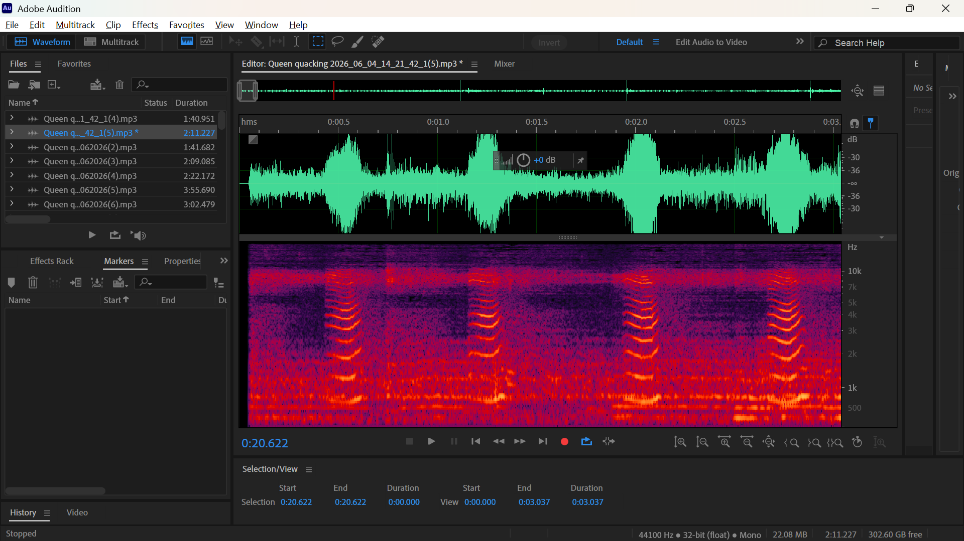
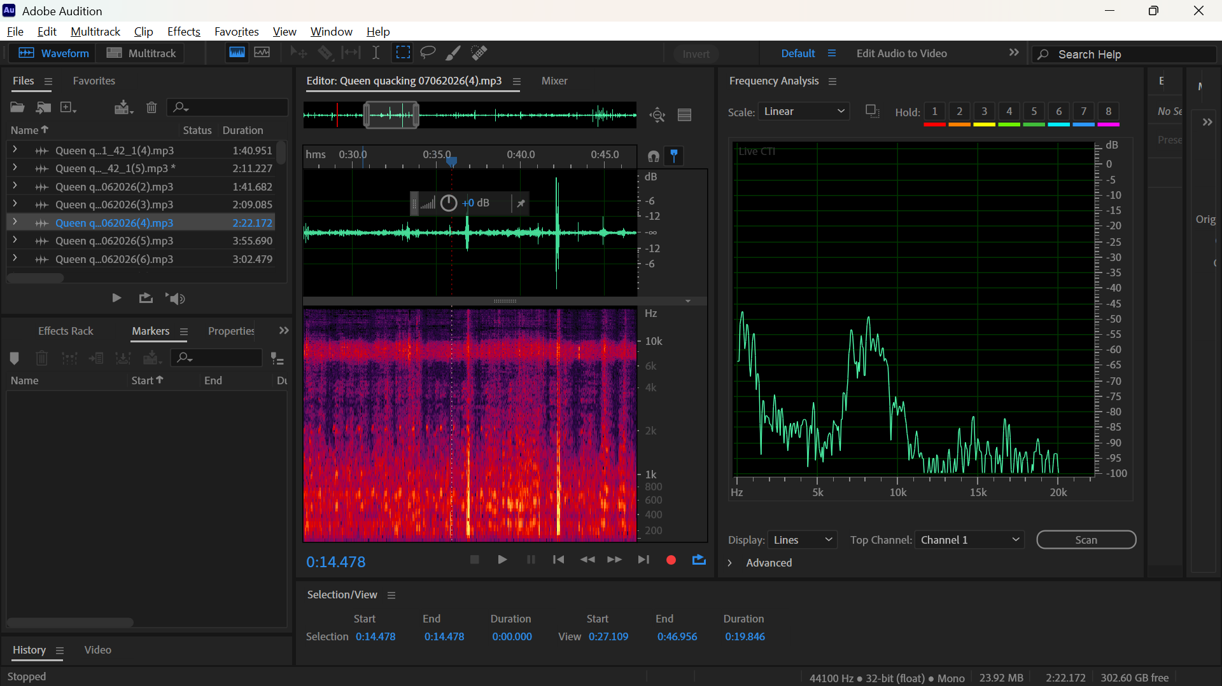

Removing unwanted noise like birds,knocking the hive,strong wind and others
- Deleting unwanted section
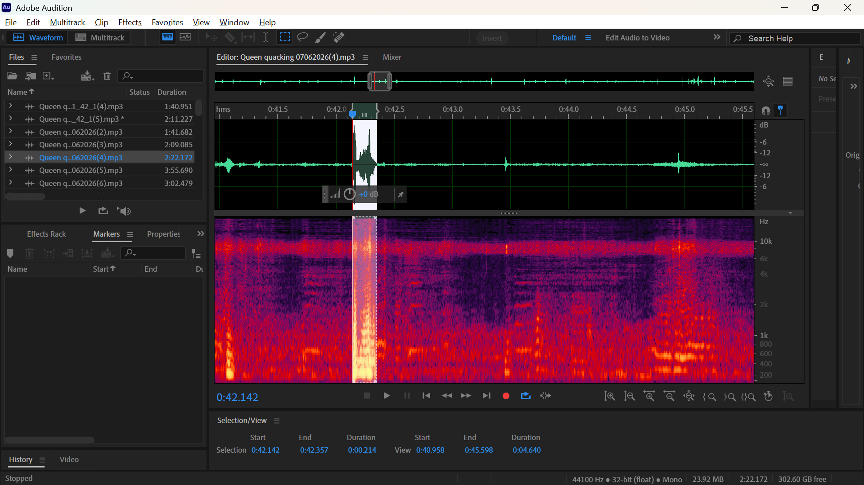
- Reduce amplitude using the brush
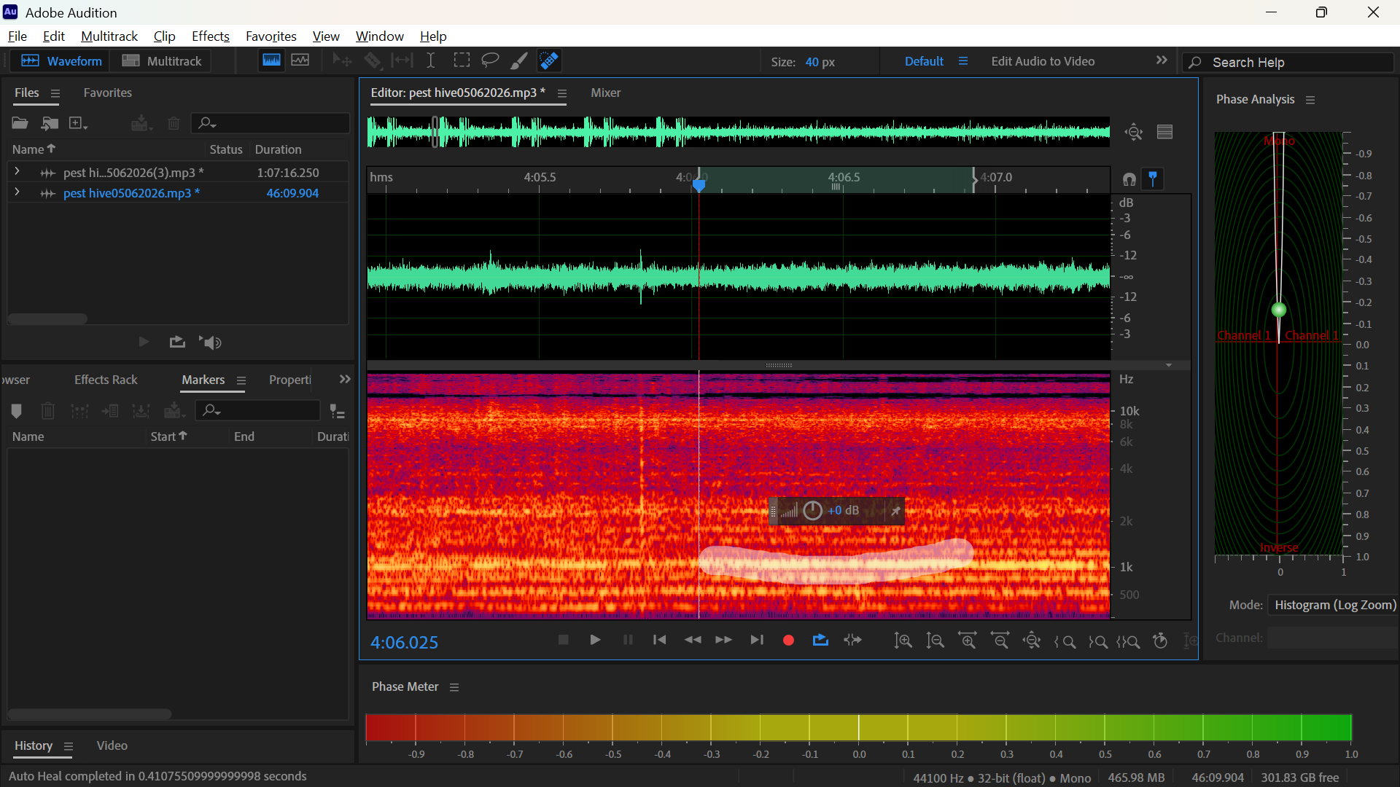

- Deleting rectangular noise “like that of the bird ”
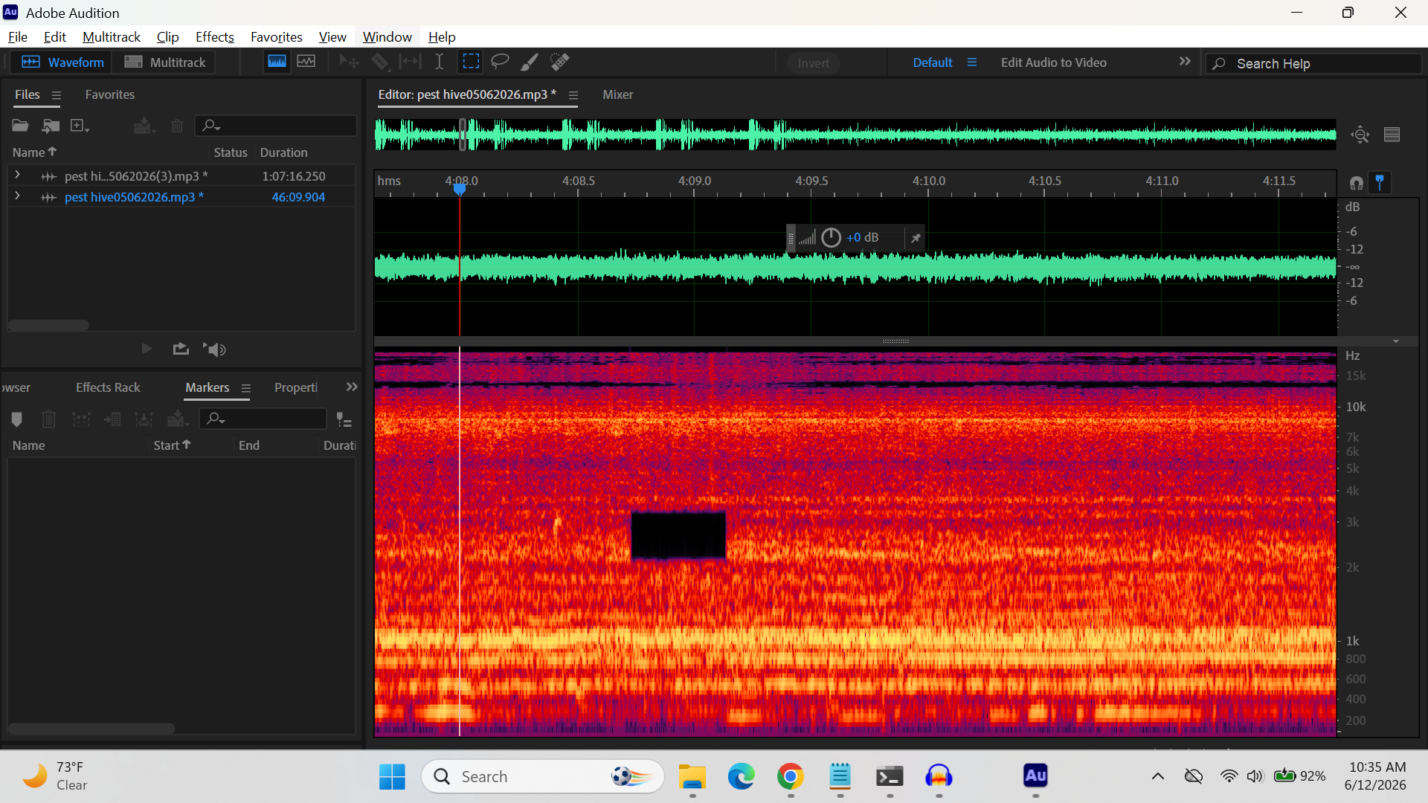

Cutting out small cleaned categorised groups
