Name: Akshay Jaiswal
Roll no: 57.
Subject: FSD Assignment 3

1. Write a program to demonstrate call back function.
Aim: To write a program to demonstrate the use of a call back function in Node.js.
Objective: To understand how call back functions work in Node.js and how they allow a function to be passed as an argument to another function for execution after a task is completed.
Code: const name = (fnm,lnm,callback) => {
console.log(`my FIrst name is ${fnm} and last Name is ${lnm} `);
callback();
}

function greet(){ console.log("Hello everyone")};

name("Akshay","Jaiswal",greet);
Output:
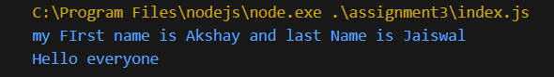
2. Write a program to demonstrate synchronous programming in Node JS.
Aim: To write a program to demonstrate synchronous programming in Node.js.
Objective: To understand how synchronous execution works where tasks are executed sequentially, and the next task starts only after the previous one is completed.
Code:

for(i=0;i<3;i++){
console.log("Hello");
}
const name = (fnm,lnm,callback) => {
console.log(`my FIrst name is ${fnm} and last Name is ${lnm} `);
callback();
}

function greet(){ console.log("Hello everyone")};

name("Akshay","Jaiswal",greet);
Output:
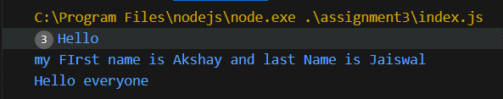

3. Write a program to demonstrate asynchronous programming in Node JS.
Aim: To write a program to demonstrate asynchronous programming in Node.js.
Objective: To understand how asynchronous programming allows multiple operations to run without blocking the execution of other tasks.
const name = (fnm, lnm, callback) => {
return new Promise((resolve, reject) => {
console.log(`My first name is ${fnm} and last name is ${lnm}`);
resolve();
}).then(() => {
callback();
});
};

function greet() {
console.log("Hello everyone");
}

name("Akshay", "Jaiswal", greet);

for (let i = 0; i < 3; i++) {
console.log("Hello");
}
Output:
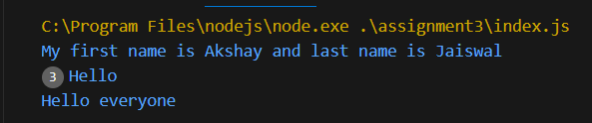

4. Write a program to demonstrate any one core module of Node JS (fs, http, path, os).
Aim: To write a program to demonstrate the use of a core module in Node.js (such as fs, http, path, or os).
Objective: To understand how built-in Node.js modules can be used to perform system-related tasks like file handling, server creation, and path management.
Code:
const fs = require("fs")
fs.writeFileSync("text.txt","Hello this is sample file.")
console.log("File created.")

Output:
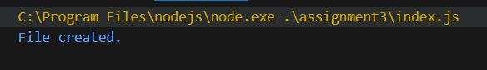

5. Write a program to demonstrate local modules in Node JS.
Aim: To write a program to demonstrate the use of local modules in Node.js.
Objective: To understand how custom modules can be created and imported in Node.js to organize code into reusable components.
Code:
Localmodule.js
function name (fnm,lnm) {
console.log(`my FIrst name is ${fnm} and last Name is ${lnm} `);
}

module.exports = {
name
}
Index.js
const localmodule = require("./localmodule")
localmodule.name("Akshay","Jaiswal")
Output:
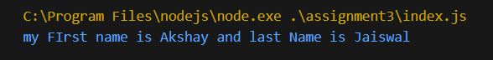
6. Write a program to create a local module math Operations that performs all mathematical operations.
Aim: To create a local module named math Operations that performs basic mathematical operations.
Objective: To understand how to create and export functions from a local module and import them into another file for performing operations like addition, subtraction, multiplication, and division.
Code: index.js
const localmath = require("./localmath")
console.log(localmath.add(13,11))
console.log(localmath.sub(13,11))
console.log(localmath.multi(13,11))
console.log(localmath.div(13,11))
localmath.js
function add(a,b) {
return a + b
}
function sub(a,b) {
return a - b
}
function multi(a,b) {
return a * b
}
function div(a,b) {
return a / b
}

module.exports = {
add,
sub,
multi,
div
}

Output:
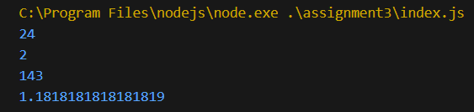

7. Write a program to create a http server and display messages.
Aim: To write a program to create an HTTP server and display messages in the browser.
Objective: To understand how Node.js can be used to create a web server and send responses to client requests using the HTTP module.
Code:
Code: const http = require("http")

const server = http.createServer((req,res) => {
res.write("Welcome")
res.end()
})
server.listen(3000,()=>{
console.log("server is running..")
})

Output:
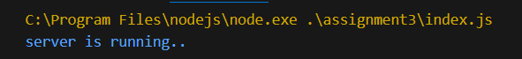
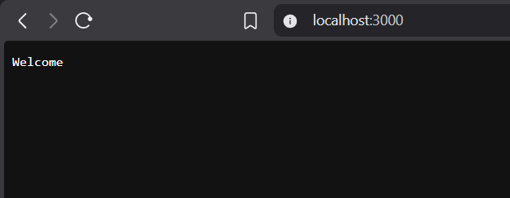
8. Write a program to create separate index.html page and display the same using node.js
Aim: To write a program to create a separate index.html file and display it using Node.js.
Objective: To understand how Node.js reads an HTML file from the filesystem and sends it as a response to the browser.
Code:
Output:

9. Write a program to create 3 different HTTP requests and display the content accordingly.
Aim: To write a program to create three different HTTP requests and display content accordingly.
Objective: To understand how routing can be implemented in Node.js to serve different content based on different request URLs.
Code:
Output:

10.Create a website that displays at least 3 html pages. Also create a navigation menu and perform a routing process.
Aim: To create a website that displays at least three HTML pages with a navigation menu and routing process.
Objective: To understand how multiple web pages can be connected through routing and navigation in a Node.js server.
Code:
Output:

11. Write a program to create a form and display the submitted information on the same page.
Aim: To write a program to create a form and display the submitted information on the same page.
Objective: To understand how form data is collected from users and processed by a Node.js server.
Code:
Output:

12.Write a program to create a registration form and display the submitted information on the next page.
Aim: To write a program to create a registration form and display the submitted information on the next page.
Objective: To understand how form data can be sent to another page and processed by the server.
Code:
Output:

13.Write a program to demonstrate a third-party module (express).
Aim: To write a program to demonstrate the use of a third-party module Express in Node.js.
Objective: To understand how Express simplifies web server creation and routing in Node.js applications.
Code:
Output:

14.Create a website that displays at least 3 html pages. Also create a navigation menu and perform a routing process using express.
Aim: To create a website with at least three HTML pages and navigation menu using Express routing.
Objective: To understand how routing can be implemented easily using the Express framework.
Code:
Output:

15.Write a program to create a registration form and display the submitted information on the page using express.
Aim: To write a program to create a registration form and display the submitted information using Express.
Objective: To understand how Express handles form data and routing for dynamic web applications.
Code:
Output:

