

Gene Expression–Based Molecular Generation Using Deep Learning

Group6
Dong Yizhe, Liu Hongxi, Tian Yi, Wen Yuxin, Wang Yikai

YONG LOO LIN SCHOOL OF MEDICINE
DEPARTMENT OF BIOMEDICAL INFORMATICS
2026-4-9

Gene Expression–Based Molecular Generation Using Deep Learning

Group6
Dong Yizhe, Liu Hongxi, Tian Yi, Wen Yuxin, Wang Yikai

Yong Loo Lin School of Medicine

A thesis submitted to the National University of Singapore
in partial fulfilment of the requirement for the degree of
Master of Science in Biomedical Informatics

2026-3-15
Statement of Originality

I hereby certify that the work embodied in this thesis is the result of original research, is free of plagiarised materials, and has not been submitted for a higher degree to any other University or Institution.

2026-3-15 Dong Yizhe, Liu Hongxi,
Tian Yi, Wen Yuxin, Wang Yikai

. . . . . . . . . . . . . . . . . . . . . . . . . . . . . . . . . . . . . . . . . . . .
Date Name

Supervisor Declaration Statement

I have reviewed the content and presentation style of this thesis and declare it is free of plagiarism and of sufficient grammatical clarity to be examined. To the best of my knowledge, the research and writing are those of the candidate. I confirm that the investigations were conducted in accord with the ethics policies and integrity standards of National University of Singapore and that the research data are presented honestly and without prejudice.

. . . . . . . . . . . . . . . . . . . . . . . . . . . . . . . . . . . . . . . . . . . .
Date Supervisor Name

Abstract

We present a transcriptome-conditioned framework for de novo molecular generation that integrates a Gene Regulatory Representation Module (GRRM) with an Adaptive FiLM layer. Gene expression profiles are encoded into compact embeddings and used to modulate SMILES representations during generation. The model achieves high validity and stable training, outperforming baseline approaches in valid SMILES generation. Across ten therapeutic targets, the generated molecules show competitive structural similarity to known ligands, with top performance on multiple targets. These results suggest that incorporating transcriptomic information provides a biologically informed strategy for molecular design, although further validation is required to assess functional relevance.Available at https://github.com/TIMTIAN66/Group6

Table of Contents
1.Introduction
2.Methodology
3.Results
4.Conclusion
5. Discussion and Future Directions
6.References list in NLM style

Introduction
The development of new drugs requires identifying a small number of promising candidates from an immense “drug-like” chemical space exceeding 10⁶⁰ possible compounds. (1) Conventional screening approaches, including high-throughput screening (2,3) and DNA-encoded libraries (4–7), remain resource-intensive and insufficient for efficiently exploring this space.
Most existing molecular design models primarily focus on optimizing physicochemical properties or target-binding affinity, while often lacking direct integration of cellular biological context. In practical drug discovery, however, the ultimate objective is not merely to design molecules with favorable chemical properties, but to induce desired biological responses within living cells. Gene expression profiling provides a comprehensive snapshot of cellular states and regulatory activities, capturing how cells respond to genetic perturbations or chemical treatments. Large-scale resources such as the Library of Integrated Network-Based Cellular Signatures (LINCS) have systematically characterized transcriptional responses to thousands of compounds and genetic perturbations, revealing consistent relationships between small molecules, target proteins, and downstream transcriptomic signatures. These observations suggest that gene expression patterns can serve as a powerful bridge linking molecular structures to their functional biological effects. Consequently, incorporating transcriptomic information into molecular generation models offers a promising strategy for guiding the design of compounds that reproduce desired cellular responses. By conditioning molecule generation on gene expression signatures associated with specific targets or perturbations, generative models may be able to explore chemical space in a biologically informed manner, producing candidate molecules that more closely align with the underlying mechanisms of target modulation.
Computation-driven de novo molecular design provides a promising solution to this challenge by enabling the direct generation of novel molecules with desired properties, thereby improving the efficiency of early drug discovery. In this field, deep generative models, such as Variational Autoencoders (8–10), Generative Adversarial Networks (11,12), Diffusion Models (13–16), and Autoregressive Models (17–19), have become core tools for generating molecular structures.
However, these models are mostly "chemistry-centric". They primarily focus on generating or optimizing simple chemical properties that can be calculated directly from molecular structure, such as drug-likeness, but cannot integrate comprehensive functional response information from within biological systems. Although some studies have attempted to combine molecular generation with Quantitative Structure-Activity Relationship models or molecular docking simulations (20,21), these strategies still have significant limitations, particularly when training data is scarce or three-dimensional structural information of the target is incomplete, which significantly constrains their generation effectiveness and practical utility.
To bridge the gap between chemical structure and biological function, researchers have begun to explore "omics-based" generative strategies, particularly utilizing gene expression profiles to guide molecular design. The fundamental hypothesis is that molecules capable of inducing a specific biological effect will produce transcriptomic signatures similar to those caused by targeted genetic perturbations. Although this approach is promising, existing methods for effectively utilizing transcriptomic information to directly generate molecules still have major shortcomings.
Early pioneering work attempted to use Conditional Generative Adversarial Networks to generate molecules directly from gene expression signatures. (22) Although innovative, this model faced significant stability challenges, with only about 8.5% of its generated molecules being chemically valid SMILES strings. The direct mapping from the high-dimensional biological space to the discrete chemical space in this model was relatively unstable. To circumvent these stability issues, subsequent studies, TRIOMPHE (23) and TRIOMPHE-BOA (24), proposed a two-stage strategy. Such methods first use gene expression profiles to screen for one or more "source molecules", and then use models like VAEs to explore or fuse structures around these source molecules to generate new ones. The fundamental flaw of this approach is that the transcriptomic information is used only in the "screening" stage and does not directly guide the construction of the chemical structure during the "generation" stage. Consequently, the diversity and novelty of the generated molecules are severely limited to the chemical neighborhood of the "source molecules", preventing the model from generating new molecules that are significantly improved compared to the source molecules, and the method may fail when the scaffolds of the source molecules differ too greatly.
To address the shortcomings of the previous two types of methods, recent work, such as GxRNN, reverted to direct conditional generation and attempted to solve the stability problem. (25) This method uses a single RNN, conditioning it by concatenating the gene expression vector with the SMILES token embedding at each generation step. Although this approach is more concise and significantly improves the validity rate, the simple "concatenation" is a weak conditioning mechanism. The model lacks a dedicated module to explicitly parse the biological regulatory signals and control how these signals specifically modulate the chemical structure generation process.
Inspired by these observations, we propose a novel gene expression–conditioned architecture for de novo molecular design that addresses the limitations of existing transcriptome-guided generative models. The proposed framework incorporates a Gene Regulatory Representation Module (GRRM) to hierarchically encode high-dimensional gene expression profiles into compact regulatory embeddings. These embeddings are used to condition an adaptive feature-wise linear modulation (FiLM) layer, enabling gene-derived signals to dynamically modulate SMILES token embeddings throughout the generation process. The FiLM-modulated molecular embeddings are then concatenated with the regulatory embeddings and passed to a three-layer LSTM decoder to generate molecular structures. Across ten therapeutic targets, the proposed framework consistently generates molecules with higher structural similarity to known ligands than existing gene expression–conditioned approaches, establishing a new state of the art in transcriptome-driven molecular generation.

Methodology

Biological Rationale
When a target protein gene is transcriptionally perturbed (e.g., by knockdown or overexpression), the resulting gene expression profile reflects the cellular response to reduced or enhanced target activity. Similarly, treatment with inhibitory or activating compounds produces characteristic transcriptomic signatures that correlate with these genetic perturbations. (23,26) Building upon this relationship, we aim to generate new small molecules that reproduce a given target-specific gene expression pattern, thereby mimicking the biological effects of target inhibition or activation.
Recent advances in large-scale transcriptomic profiling technologies have enabled systematic measurement of cellular responses to both genetic perturbations and chemical treatments. Datasets such as the Library of Integrated Network-Based Cellular Signatures (LINCS) provide comprehensive collections of gene expression signatures induced by thousands of compounds and gene perturbations across multiple cell lines. These resources reveal that compounds targeting the same protein or pathway often produce transcriptional signatures that resemble those induced by direct genetic perturbations of the corresponding targets. Consequently, gene expression profiles can serve as informative functional readouts linking small molecules to their biological mechanisms of action. Leveraging this insight, transcriptomic signatures can be used not only for mechanism-of-action analysis but also as guiding signals for molecular design. By conditioning generative models on gene expression patterns associated with specific targets or perturbations, it becomes possible to search the vast chemical space in a biologically informed manner and generate candidate molecules that are more likely to reproduce the desired cellular response.

Datasets
All datasets used in this study were prepared following the same protocol described by Matsukiyo et al. (25)
Chemically induced gene expression data were obtained from the LINCS L1000 resource, which provides large-scale perturbational transcriptomic profiles. (27) In this study, we utilized Level 5 consensus data, representing aggregated gene expression signatures across experimental replicates. Missing values were imputed using a tensor decomposition–based approach. After preprocessing, the dataset comprised 13,755 gene expression profiles corresponding to the MCF7 cell line treated with compounds at a concentration of 10 micromolar. Molecules with SMILES sequences longer than 80 characters were excluded, and canonical SMILES representations were retrieved from PubChem. (28) The resulting dataset was randomly divided into training and validation subsets using a 9:1 split ratio.
Target-specific perturbation profiles were also extracted from the LINCS database. Knockdown expression signatures were collected for AKT1, AKT2, AURKB, CTSK, EGFR, HDAC1, MTOR, and PIK3CA, while overexpression signatures were obtained for SMAD3 and TP53. All perturbation profiles corresponded to the MCF7 cell line. When multiple experiments were available for the same target, expression signatures measured under different experimental conditions were averaged to generate a single representative perturbation profile.
Known ligand data for each target were retrieved from the ExCAPE database. To minimize redundancy and prevent data leakage, invalid SMILES strings and molecules overlapping with the training or validation sets were removed. The final ligand datasets contained 2,133, 1,276, 2,099, 1,601, 2,272, 991, 1,505, 1,185, 12,394, and 6,741 compounds for AKT1, AKT2, AURKB, CTSK, EGFR, HDAC1, MTOR, PIK3CA, SMAD3, and TP53, respectively.
Collectively, these datasets establish a unified benchmark linking transcriptomic perturbation profiles with ligand activity, providing a consistent foundation for training and evaluating gene expression–conditioned molecular generation models.

Evaluation Metrics
Chemical structural similarity was evaluated using the Tanimoto coefficient based on Morgan fingerprints. For each molecule, a 2048-bit fingerprint with a radius of 2 was generated to represent its structural features. The similarity between two molecules was computed as the ratio of shared fingerprint features to the total number of features present in either molecule. Values close to zero indicate low structural similarity, whereas values close to one indicate high similarity. All fingerprints and similarity scores were calculated using the RDKit library.

Main Methodology
Figure 1 outlines the proposed framework, a conditional recurrent neural network for gene-expression-guided molecule generation. The model includes a Gene Regulatory Representation Module (GRRM) that compresses high-dimensional gene data into a regulatory vector, and an Adaptive FiLM layer that modulates SMILES embeddings according to this vector. The modulated embeddings are concatenated with the regulatory features and then processed by a three-layer LSTM decoder to generate molecules whose properties align with the target transcriptional signature.
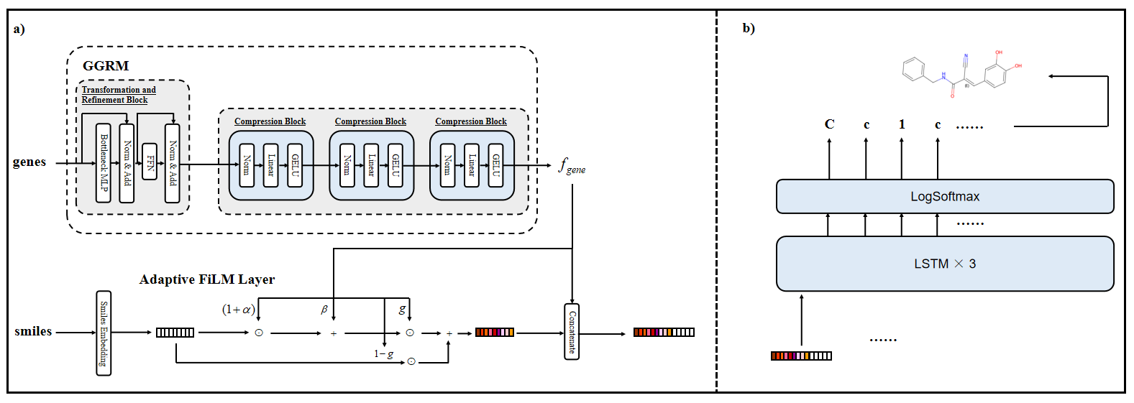
Figure 1. Overview of the Proposed Framework for Gene-Expression-Guided Molecular Generation.
To encode high-dimensional transcriptomic profiles, we design a Gene Regulatory Representation Module (GRRM) that transforms gene expression vectors into compact regulatory embeddings. The input gene expression vector (978 genes) is first processed by a transformation and refinement block consisting of multi-head linear projections, feed-forward layers, residual connections, and layer normalization. This design enables the model to capture complex gene–gene interactions and refine the raw transcriptomic signal. The resulting representation is then passed through a progressive gene encoder, which gradually compresses the high-dimensional input into a dense regulatory feature using sequential normalization–linear–GELU–dropout blocks, preserving essential biological information while reducing dimensionality.
The encoded gene features are used as conditioning signals through an Adaptive Feature-wise Linear Modulation (FiLM) layer, which dynamically modulates SMILES token embeddings during generation. Specifically, gene-dependent affine transformations generate feature-wise scaling and shifting parameters that adjust the molecular representation. In addition, a sigmoid-based gating mechanism controls the extent to which gene-derived information influences each token. This design allows flexible and fine-grained integration of transcriptomic signals into the molecular embedding space.
The FiLM-modulated token embeddings are concatenated with the gene-derived regulatory features and provided as inputs to a multi-layer LSTM decoder for autoregressive sequence generation. The hidden and cell states of the decoder are initialized using learned projections of the regulatory embedding, ensuring that the generation process is conditioned on biologically relevant information from the outset.At each decoding step, the model takes the previously generated token as input and updates its hidden states based on both the sequence context and the gene-conditioned features. The LSTM outputs are passed through a linear projection followed by a softmax function to obtain a probability distribution over the SMILES vocabulary. The next token is then sampled or selected according to this distribution, and the process is repeated until a termination token is produced or a predefined sequence length is reached.Through this autoregressive mechanism, the model sequentially constructs molecular structures while continuously incorporating transcriptomic conditioning, enabling the generation of molecules whose structural patterns are aligned with the target gene expression signature.
The optimization objective is the negative log-likelihood loss between the predicted and true next-token distributions. For a mini-batch of size 𝐵 and sequence length 𝑇, the training objective is expressed as:
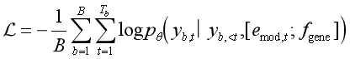

Results
The GRRM-FiLM-LSTM model was trained using molecular SMILES strings paired with their chemically induced gene-expression profiles. Figure 2 shows the proportion of valid SMILES generated from validation profiles across epochs. The validity ratio rapidly increased during the early training stage and stabilized around 90% after approximately 30 epochs. We selected the 400th epoch for evaluation because the model had converged with a minimal loss (0.049) while maintaining a balance between structural validity (99.3%) and diversity (77.3%). This point reflects a stable regime where further training yielded negligible improvement in molecular quality.
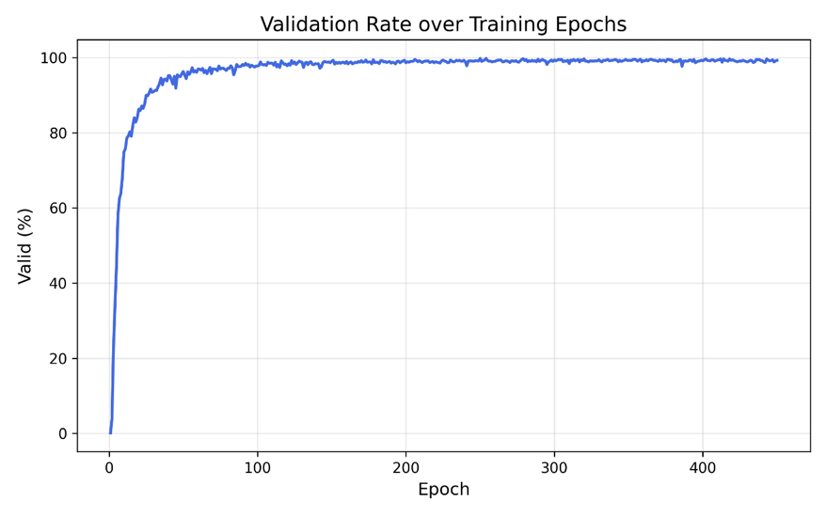
Figure 2. Ratio of valid SMILES generated from chemically induced profiles in the validation data set at each epoch.
To further evaluate the biological consistency of the generated molecules, a structural comparison was performed between the generated compounds and known ligands across ten representative therapeutic targets previously studied. For inhibitory targets (AKT1, AKT2, AURKB, CTSK, EGFR, HDAC1, MTOR, and PIK3CA), gene knockdown expression profiles were used as inputs, whereas for activatory targets (SMAD3 and TP53), overexpression profiles were applied. Each generated molecule was compared against ligand entries in the ExCAPE database, with any compounds present in the training or validation sets excluded to minimize potential data leakage. Figure 3 illustrates pairwise structural alignments between the most similar generated molecules and their corresponding known ligands for each target.
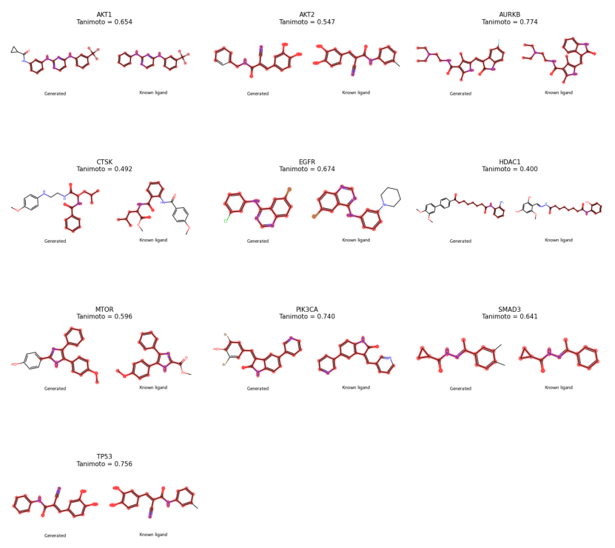
Figure 3. Structural comparison of molecules generated by the proposed method and known ligands
We compared the performance of our proposed method (GRRM-FiLM-LSTM) with those of multiple previous state-of-the-art methods that share the same objective. As the primary performance measure, we evaluated the maximum structural similarities (Tanimoto coefficient) between the newly generated molecules and known ligands.
For a rigorous performance comparison, we selected four previous methods that share the same experimental conditions (e.g., the same 10 target proteins and the known ligand data set from the ExCAPE database): transcriptome GAN, TRIOMPHE, TRIOMPHE-BOA, and GxRNN. The structural similarity scores for these baseline models were obtained from the values reported in Matsukiyo et al. (2024).
The comparative results are listed in Table 1. Our proposed method (Ours) yielded molecules exhibiting the highest structural similarity for six out of the ten target proteins (AKT1, AKT2, CTSK, EGFR, PIK3CA, and SMAD3). Notably, our model achieved substantial performance gains on several key targets, such as PIK3CA (0.740 vs. 0.446 for the next-best, GxRNN), EGFR (0.674 vs. 0.479), and AKT1 (0.654 vs. 0.423), demonstrating a clear superiority over all existing approaches for these targets.
Table 1. Comparison of Structural Similarities between the Generated Molecules and Known Ligands
target protein | transcriptome GAN(24) | TRIOMPHE(25) | TRIOMPHE-BOA(26) | GxRNN(27) | GRRM-FiLM-LSTM(ours)
ATK1 | 0.317 | 0.417 | 0.423 | 0.379 | 0.654
ATK2 | 0.289 | 0.351 | 0.370 | 0.385 | 0.547
AURKB | 0.364 | 0.340 | 0.500 | 0.804 | 0.774
CTSK | 0.311 | 0.292 | 0.285 | 0.451 | 0.492
EGFR | 0.298 | 0.306 | 0.386 | 0.479 | 0.674
HDAC1 | 0.339 | 0.304 | 0.483 | 0.469 | 0.400
MTOR | 0.3962 | 0.686 | 0.372 | 0.571 | 0.596
PIK3CA | 0.261 | 0.324 | 0.344 | 0.446 | 0.740
SMAD3 | 0.439 | 0.476 | 0.422 | 0.639 | 0.641
TP53 | 0.457 | 0.530 | 0.620 | 0.809 | 0.756
The highest scores among the five methods are highlighted in bold font. We calculated the structural similarities between the generated molecules and the known ligands for each target protein.The results of transcriptome GAN and TRIOMPHE were obtained from Figure 6 in Kaitoh et al. (2021), and the TRIOMPHE-BOA and GxRNN values were taken from Table 1 in Matsukiyo et al. (2024).The last column reports the results of our proposed model, GRRM-FiLM-LSTM (ours).
While the baseline models TRIOMPHE, TRIOMPHE-BOA, and GxRNN retained the highest scores on MTOR, HDAC1, and (AURKB, TP53) respectively, our proposed method consistently placed as a top-two performer on 8 out of 10 targets. These results strongly suggest that our proposed architecture, which leverages hierarchical gene encoding and adaptive feature modulation, possesses an advanced capability to generate high-quality molecules that more closely resemble known ligands than most previous methods

Conclusion
In this study, we developed a transcriptome-conditioned molecular generation framework that integrates gene regulatory representation learning with adaptive feature modulation. By encoding high-dimensional gene expression profiles into compact regulatory embeddings and incorporating them through an Adaptive FiLM mechanism, the model enables direct conditioning of molecular generation on cellular transcriptional states. This design allows biological signals to be explicitly embedded into the generative process rather than being weakly incorporated through simple concatenation strategies.
The proposed framework demonstrates the ability to generate structurally valid molecules with competitive similarity to known ligands across multiple therapeutic targets. Structural comparisons further suggest that the generated molecules capture key features associated with target-specific chemical space. In addition, the model exhibits stable training behavior and efficient convergence, indicating its robustness in handling high-dimensional transcriptomic inputs. These findings indicate that incorporating transcriptomic information into generative models can provide a meaningful connection between molecular structure and biological function.
Overall, this work highlights the potential of transcriptome-guided molecular generation as a strategy for exploring chemical space in a biologically informed manner. By linking cellular response patterns with molecular design, the proposed approach contributes toward bridging the gap between phenotypic data and structure-based drug discovery. While further validation is required to establish functional relevance and real-world applicability, this framework provides a foundation for future research on integrating multi-modal biological data into computational drug design.

Discussion and Future Directions
While the proposed GRRM-FiLM-LSTM framework demonstrates promising performance in generating valid molecules with relatively high structural similarity to known ligands, several limitations should be acknowledged.
The current evaluation primarily relies on valid SMILES rate and maximum Tanimoto similarity, which do not fully capture important aspects of molecular generation such as novelty, diversity, and biological relevance. In particular, high similarity to known ligands may reflect conservative generation within existing chemical scaffolds rather than the discovery of truly novel compounds. More comprehensive evaluation strategies, including scaffold diversity, novelty against the training set, and physicochemical property distributions, would provide a more complete assessment.
Another concern lies in the potential for data leakage. The extent of overlap or structural similarity between training molecules and the known ligand database used for evaluation has not been fully controlled, which may lead to inflated similarity scores. Adopting stricter data partitioning strategies, such as scaffold-based splitting or filtering of structurally similar compounds, would help ensure a more reliable evaluation of generalization.
The role of gene-expression conditioning also remains to be fully disentangled. In the absence of direct comparisons with unconditioned models or ablation variants, it is difficult to determine how much of the observed performance gain can be attributed specifically to the transcriptomic conditioning mechanism. Systematic ablation studies would therefore be valuable for clarifying the contribution of individual components, particularly the GRRM and Adaptive FiLM modules.
In addition, although transcriptomic signatures provide a biologically meaningful conditioning signal, the generated molecules have not yet been validated in terms of actual biological activity. The assumption that reproducing gene expression patterns leads to desired functional outcomes warrants further investigation through complementary approaches, such as target prediction, pathway enrichment analysis, or molecular docking.
Looking ahead, several directions could further strengthen this framework. Incorporating additional biological modalities, such as protein structural information, signaling pathways, or phenotypic imaging data, may enrich the conditioning signal and improve biological fidelity. Advances in generative modeling, including transformer-based and diffusion-based architectures, also offer opportunities to enhance generation quality and diversity. Finally, integrating multi-objective optimization or reinforcement learning could enable the design of molecules that simultaneously satisfy multiple criteria, including biological activity, drug-likeness, and synthetic accessibility.

References List
1. Bohacek R, McMartin C, Guida W. The art and practice of structure-based drug design: A molecular modeling perspective. Med Res Rev. 1996 Jan;16(1):3–50. Located at: WOS:A1996TM82900002. doi:10.1002/(SICI)1098-1128(199601)16:1%3C3::AID-MED1%3E3.0.CO;2-6
2. Mayr L, Bojanic D. Novel trends in high-throughput screening. Curr Opin Pharmacol. 2009 Oct;9(5):580–8. Located at: WOS:000270890700009. doi:10.1016/j.coph.2009.08.004
3. Szymanski P, Markowicz M, Mikiciuk-Olasik E. Adaptation of high-throughput screening in drug discovery-toxicological screening tests. Int J Mol Sci. 2012 Jan;13(1):427–52. Located at: WOS:000300184800028. doi:10.3390/ijms13010427
4. Clark M, Acharya R, Arico-Muendel C, Belyanskaya S, Benjamin D, Carlson N, et al. Design, synthesis and selection of DNA-encoded small-molecule libraries. Nat Chem Biol. 2009 Sep;5(9):647–54. Located at: WOS:000269093000013. doi:10.1038/nchembio.211
5. Kleiner R, Dumelin C, Liu D. Small-molecule discovery from DNA-encoded chemical libraries. Chem Soc Rev. 2011;40(12):5707–17. Located at: WOS:000296986000009. doi:10.1039/c1cs15076f
6. Goodnow R, Dumelin C, Keefe A. DNA-encoded chemistry: Enabling the deeper sampling of chemical space. Nat Rev DRUG Discov. 2017 Feb;16(2):131–47. Located at: WOS:000393446800019. doi:10.1038/nrd.2016.213
7. Flood D, Kingston C, Vantourout J, Dawson P, Baran P. DNA encoded libraries: A visitor’s guide. Isr J Chem. 2020 Mar;60(3–4):268–80. Located at: WOS:000507595400001. doi:10.1002/ijch.201900133
8. Kusner M, Paige B, Hernández-Lobato J. Grammar variational autoencoder. In: Precup D, Teh Y, editors. Vol. 70. 2017. Located at: WOS:000683309502004
9. Bhadwal AS, Kumari M, Kumar A. PCF-VAE: Posterior collapse free variational autoencoder for de novo drug design. Sci Rep. 2025 Oct 1;15(1):34152. doi:10.1038/s41598-025-14285-5
10. Weller JA, Rohs R. DrugHIVE: Target-specific spatial drug design and optimization with a hierarchical generative model [Internet]. Bioinformatics; 2023 [cited 2025 Nov 6]. Available from: http://biorxiv.org/lookup/doi/10.1101/2023.12.22.573155 doi:10.1101/2023.12.22.573155
11. Goodfellow I, Pouget-Abadie J, Mirza M, Xu B, Warde-Farley D, Ozair S, et al. Generative adversarial nets. In: Ghahramani Z, Welling M, Cortes C, Lawrence N, Weinberger K, editors. Vol. 27. 2014. p. 2672–80. Located at: WOS:000452647101094
12. Kadurin A, Nikolenko S, Khrabrov K, Aliper A, Zhavoronkov A. druGAN: An advanced generative adversarial autoencoder model for de novo generation of new molecules with desired molecular properties in silico. Mol Pharm. 2017 Sep;14(9):3098–104. Located at: WOS:000410005100022. doi:10.1021/acs.molpharmaceut.7b00346
13. Yang Y, Gu S, Liu B, Gong X, Lu R, Qiu J, et al. DiffMC‐gen: A dual denoising diffusion model for multi‐conditional molecular generation. Adv Sci. 2025 Jun;12(22):2417726. doi:10.1002/advs.202417726
14. Liu G, Xu J, Luo T, Jiang M. Graph diffusion transformers for multi-conditional molecular generation [Internet]. arXiv; 2024 [cited 2025 Sep 22]. Available from: http://arxiv.org/abs/2401.13858 doi:10.48550/arXiv.2401.13858
15. Wang L, Song C, Liu Z, Rong Y, Liu Q, Wu S, et al. Diffusion models for molecules: A survey of methods and tasks [Internet]. arXiv; 2025 [cited 2025 Oct 25]. Available from: http://arxiv.org/abs/2502.09511 doi:10.48550/arXiv.2502.09511
16. Vignac C, Krawczuk I, Siraudin A, Wang B, Cevher V, Frossard P. DiGress: Discrete denoising diffusion for graph generation [Internet]. arXiv; 2023 [cited 2025 Sep 23]. Available from: http://arxiv.org/abs/2209.14734 doi:10.48550/arXiv.2209.14734
17. Gao Z, Hu Y, Tan C, Li SZ. PrefixMol: Target- and chemistry-aware molecule design via prefix embedding [Internet]. arXiv; 2023 [cited 2025 Oct 21]. Available from: http://arxiv.org/abs/2302.07120 doi:10.48550/arXiv.2302.07120
18. Dobberstein N, Maass A, Hamaekers J. Llamol: A dynamic multi-conditional generative transformer for de novo molecular design. J Cheminformatics. 2024 Jun 21;16(1):73. doi:10.1186/s13321-024-00863-8
19. Haroon S, C.A. H, A.S. J. Generative pre-trained transformer (GPT) based model with relative attention for de novo drug design. Comput Biol Chem. 2023 Oct;106:107911. doi:10.1016/j.compbiolchem.2023.107911
20. Olivecrona M, Blaschke T, Engkvist O, Chen H. Molecular de-novo design through deep reinforcement learning. J CHEMINFORMATICS. 2017 Sep 4;9. Located at: WOS:000409099400001. doi:10.1186/s13321-017-0235-x
21. Ma B, Terayama K, Matsumoto S, Isaka Y, Sasakura Y, Iwata H, et al. Structure-based de novo molecular generator combined with artificial intelligence and docking simulations. J Chem Inf Model. 2021 Jul 26;61(7):3304–13. Located at: WOS:000678396200012. doi:10.1021/acs.jcim.1c00679
22. Méndez-Lucio O, Baillif B, Clevert DA, Rouquié D, Wichard J. De novo generation of hit-like molecules from gene expression signatures using artificial intelligence. Nat Commun. 2020 Jan 3;11(1):10. doi:10.1038/s41467-019-13807-w
23. Kaitoh K, Yamanishi Y. TRIOMPHE: Transcriptome-based inference and generation of molecules with desired phenotypes by machine learning. J Chem Inf Model. 2021 Sep 27;61(9):4303–20. doi:10.1021/acs.jcim.1c00967
24. Matsukiyo Y, Yamanaka C, Yamanishi Y. De novo generation of chemical structures of inhibitor and activator candidates for therapeutic target proteins by a transformer-based variational autoencoder and bayesian optimization. J Chem Inf Model. 2024 Apr 8;64(7):2345–55. doi:10.1021/acs.jcim.3c00824
25. Matsukiyo Y, Tengeiji A, Li C, Yamanishi Y. Transcriptionally conditional recurrent neural network for de novo drug design. J Chem Inf Model. 2024 Aug 12;64(15):5844–52. doi:10.1021/acs.jcim.4c00531
26. Sawada R, Iwata M, Tabei Y, Yamato H, Yamanishi Y. Predicting inhibitory and activatory drug targets by chemically and genetically perturbed transcriptome signatures. Sci Rep. 2018 Jan 9;8. Located at: WOS:000419659600037. doi:10.1038/s41598-017-18315-9
27. Subramanian A, Narayan R, Corsello S, Peck D, Natoli T, Lu X, et al. A next generation connectivity map: L1000 platform and the first 1,000,000 profiles. CELL. 2017 Nov 30;171(6):1437-+. Located at: WOS:000417362700023. doi:10.1016/j.cell.2017.10.049
28. Kim S, Chen J, Cheng T, Gindulyte A, He J, He S, et al. PubChem 2023 update. NUCLEIC ACIDS Res. 2023 Jan 6;51(D1):D1373–80. Located at: WOS:000874835100001. doi:10.1093/nar/gkac956

