**Business Case**

Author: Benjamin Esenwein

(TINF20C, SWE I Praxisprojekt 2021/2022)

Project: WebSocket's in a LwIP HTTP Server

Customer: Rentschler & Holder

Rotebühlplatz 41

70178 Stuttgart

Supplier: Team 4: Laura Reeken, inf20051@lehre.dhbw-stuttgart.de

Benjamin Esenwein, inf20074@lehre.dhbw-stuttgart.de

Yannis Plaschko, inf20093@lehre.dhbw-stuttgart.de

Maximilian Meier, inf20084@lehre.dhbw-stuttgart.de

Lucas Kaczynski, inf20147@lehre.dhbw-stuttgart.de

Isabel Schwalm, inf20085@lehre.dhbw-stuttgart.de

Rotebühlplatz 41

70178 Stuttgart

|  |  |  |  |
| --- | --- | --- | --- |
| **Version** | **Date** | **Author** | **Comment** |
| 0.1 | 24.09.2021 | Benjamin Esenwein | created |
| 1.0 | 05.11.2021 | Benjamin Esenwein | Document ready for customer |
| 1.1 | 29.04.2022 | Benjamin Esenwein | Document brought up to 4th semester level (time frame, cost calculation, financial requirement) |

CONTENTS

1. Purpose and scope 3

2. Reasons for the BC 3

3. Expected limitations 3

4. Risks 3

5. Time frame 4

6. Cost Calculation 6

7. Financial Requirement 6

# Purpose and scope

The goal of this project is to fix the architectural flaws of the patch "#9525 (httpd: add WebSocket support)" in coordination with the lwIP-project community. This experimental base should be improved and brought through the approval process in the open-source project.

Furthermore, a http demo server is to be designed and implemented in a virtual environment under Windows.

For demonstration and performance testing purposes of the features, a GUI-based test client shall be designed and implemented.

# Reasons for the BC

In this business case, we want to overview what the costs and risks are in advance of the project. It is explicitly pointed out that in this project context, the focus is not on making a profit, since it is an open-source project. Where might problems arise during marketing?

The customer requires delivery of the project by 20.05.2022, with a maximum of 180 working hours per employee.

# Expected limitations

Due to the ongoing Covid-19 pandemic and constantly changing regulations, it is now unfortunately not possible to collaborate regularly in our office. Thus, the focus is on working in the home office, which increases the risk of communication problems.

During the project, the project staff has limited time to work on the project. All employees study alongside their work, and full-time work performance cannot be expected.

Furthermore, two employees are taking part in a semester abroad. This may mean that the workload must be redistributed and / or fewer hours can be worked.

# Risks

Internal Risks

* Human Factors

To ensure that this project can be implemented, a refresher course in the C programming language is necessary.

* Technological Factors

An analysis of the present system for the Windows environment is inevitable in order to implement the patch in the latest version of lwIP

* Physical Factors

Virtual machines ensure that a development environment can be set up. Emerging errors in this environment must be avoided.

External Risks

* Economic Factors

The costs must be kept in mind. A rough time schedule structures the process.

* Legal Factors

We also ensure compliance with software licences. Likewise, care must be taken not to become involved in any accusations of plagiarism. The head of development is specifically responsible for this.

# Time frame

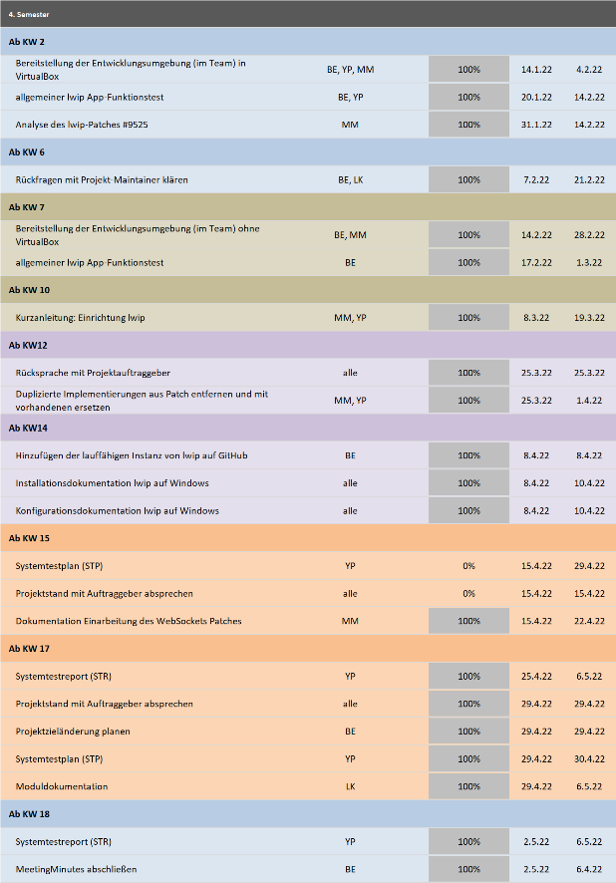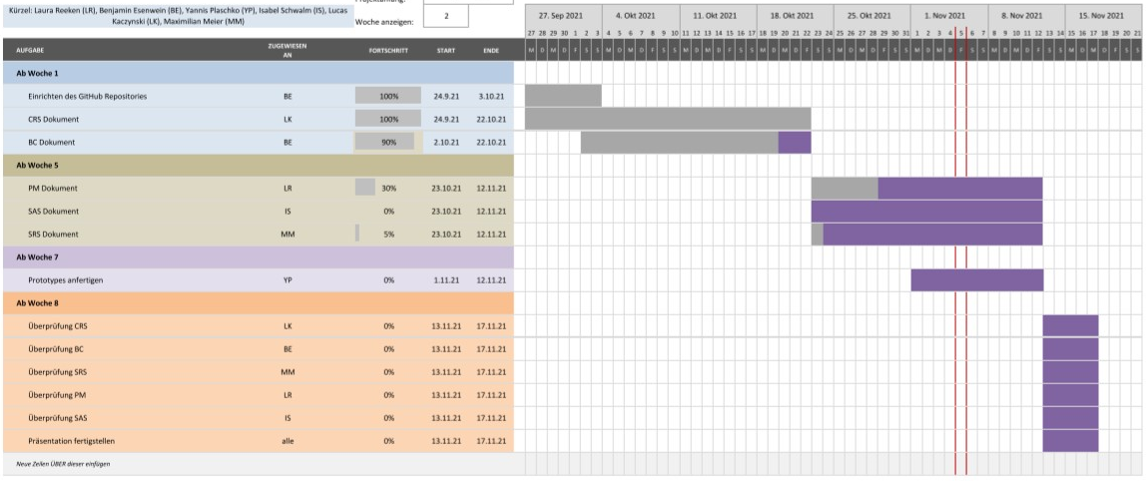

Detailed working time allocation of employees to task areas (specified in working hours):

|  |  |  |  |  |  |  |
| --- | --- | --- | --- | --- | --- | --- |
|  | Laura Reeken  (Project Manager) | Benjamin Esenwein  (Product Manager) | Yannis Plaschko  (Test Manager) | Maximilian Meier  (Head of Development) | Lucas Kaczynski  (Technical Editor) | Isabel Schwalm  (System Architect) |
| Documentation | 35 (18) | 30 | 30 (35) | 30 (35) | 40 | 25 (13) |
| Analysis | 20 (10) | 20 | 20 (26) | 20 (25) | 25 | 25 (13) |
| Design | 10 (5) | 15 | 5 | 10 | 5 | 20 (10) |
| Coding | 20 (10) | 25 | 25 (32) | 30 (35) | 25 | 30 (15) |
| Testing | 15 (8) | 20 (5) | 40 (5) | 20 (5) | 20 (5) | 20 (15) |
| GitHub organization | 20 (10) | 20 (15) | 5 | 20 (5) | 10 (5) | 10 (5) |
| Meetings | 20 (9) | 20 (36) | 20 (33) | 20 (36) | 20 (36) | 20 (9) |
| Customer exchange | 10 (5) | 5 (4) | 5 (4) | 5 (4) | 5 (4) | 5 (3) |
| Project management | 20 (10) | 20 | 5 | - | 5 | - |
| Presentation | 5 | 5 | 5 | 5 | 5 | 5 |
| Total (hours) | 175 (90) | 180 (175) | 160 (150) | 160 (160) | 160 (155) | 160 (88) |

Table 1: Resource plan

# Cost Calculation

Due to the current Corona pandemic, most of the work is done in the home office. The rent for an office is still payable, but the heating costs are minimal.

A server in Germany was rented for the project. This incurs monthly costs of 60 euros.

In order to be able to dynamically correct the workload if it is not possible to keep to the schedule, an extra person is included. Here, the lowest total cost of a project employee is chosen to keep the bid as low as possible.

|  |  |  |  |  |  |  |
| --- | --- | --- | --- | --- | --- | --- |
|  | Laura Reeken  (Project Manager) | Benjamin Esenwein  (Product Manager) | Yannis Plaschko  (Test Manager) | Maximilian Meier  (Head of Development) | Lucas Kaczynski  (Technical Editor) | Isabel Schwalm  (System Architect) |
| Total (hours) | **175 (90)** | **180 (175)** | **160 (150)** | **160 (160)** | **160 (155)** | **160 (88)** |
| Hourly wage | 90,0 € | 85,00 € | 84,50 € | 85,50 € | 80,00 € | 87,50 € |
| Estimated total costs per employee | 15.750 € (8.100 €) | 15.300 € (14.875 €) | 13.520 € (12.675 €) | 13.680 € (13.680 €) | 12.800 € (12.400 €) | 14.000 € (7.700 €) |
| TOTAL costs | **85.050 € + 12.800 € (69.430 + 7.700)** | | | | | |

Table 2: Project costs

|  |  |  |  |
| --- | --- | --- | --- |
|  | Price | Duration | Total costs |
| Office costs | 760 € | 6 months | 4.560 € |
| Internet | 50 € | 24 months | 1.200 € |
| Server | 60 € | 6 months | 360 € |
| Additional costs | 100 € | 6 months | 600 € |
| TOTAL |  |  | **6.710 €** |

Table 3: Fixed costs

# Financial Requirement

This results in the following offer for the client.

This project is not for profit. Therefore the profit is given as '0%'.

|  |  |  |
| --- | --- | --- |
| Costs | 97.850 € | (77.130 €) |
| Fixed Costs | 6.710 € | (6710 €) |
| Profit | 0 % | (0 %) |
| Offer | **104.560 €** | **(83.840 €)** |

Table 4: Final summation