SOFTWARE REQUIREMENT SPECIFICATION
FOR
CAR RENTAL SYSTEM
Under the Subject of
Software Engineering
(Semester – I)

Submitted by
Name of Student (Enrolment Number)

Mr. MILAN PATEL
(Faculty Guide)

Ms. Zalak Bhavsar
(FY1-Head of Department)

Academic Year
2024 – 25


L. J. Institute of Engineering & Technology, Ahmedabad (LJU)

L. J. INSTITUTE OF ENGINEERING AND TECHNOLOGY
FY2-Department 2024 – 25

CERTIFICATE
Date:
This is to certify that the Software Engineering Work entitled “Car Rental System”, carried out by the group of students mentioned below under my guidance is approved for the Degree of Bachelor of Engineering (Semester-I) of L. J. Institute of Engineering and Technology (LJU) during the academic year 2024-25.

- Patel Dev Pragneshbhai (24002170110139)
- Antala Tirth Arvindbhai ( 24002170110009)
- Mungalpara Yashbhai Pareshbhai(24002170110095)
- Jain Suhani Pankajkumar (24002170110062)
- Limbasiya Ayushkumar Champakbhai (24002170110083)

Guide

Mr. Milan Patel
FY1- Department, L.J.I.E.T.

Table of Contents
Sr. No. |  | Particulars | Page No.
1 |  | INTRODUCTION | 1
 | 1.1 | Purpose | 1
 | 1.2 | Scope | 1
 | 1.3 | Glossary | 1
 | 1.4 | Overview | 2
2 |  | OVERALL DESCRIPTION | 3
 | 2.1 | Problem Statement | 3
 | 2.2 | Existing System | 3
 | 2.3 | Proposed System | 3
 | 2.4 | Product Functions | 3
 | 2.5 | User Characteristics | 4
 |  | 2.5.1 User requirements | 4
 |  | 2.5.2 User Education Level | 4
 |  | 2.5.3 User’s Technical Expertise | 4
 | 2.6 | Constraints | 5
 | 2.7 | Assumption and Dependencies | 5
3 |  | REQUIREMENT SPECIFICATION | 6
 | 3.1 | Functional Requirements | 6
 |  | 3.1.1 Performance requirements | 6
 |  | 3.1.2 Design constraints | 6
 |  | 3.1.3 Hardware Requirements | 7
 |  | 3.1.4 Software Requirements | 7
 |  | 3.1.5 Other Requirement | 7
 | 3.2 | Non-Functional Requirements | 8
 |  | 3.2.1 Security | 8
 |  | 3.2.2 Reliability | 8
 |  | 3.2.3 Availability | 8
 |  | 3.2.4 Maintainability | 8
 |  | 3.2.5 Supportability | 8
4 |  | DIAGRAMS | 9
 | 4.1 | Use Case Diagram | 9
 | 4.2 | Data Flow Diagram | 10
 |  | 4.2.1 Level-0 DFD | 10
 |  | 4.2.2 Level-1 DFD | 11
 |  | 4.2.3 Level-2 DFD | 12
5 |  | CONCLUSION | 13
6 |  | SCOPE OF THE PROJECT | 14
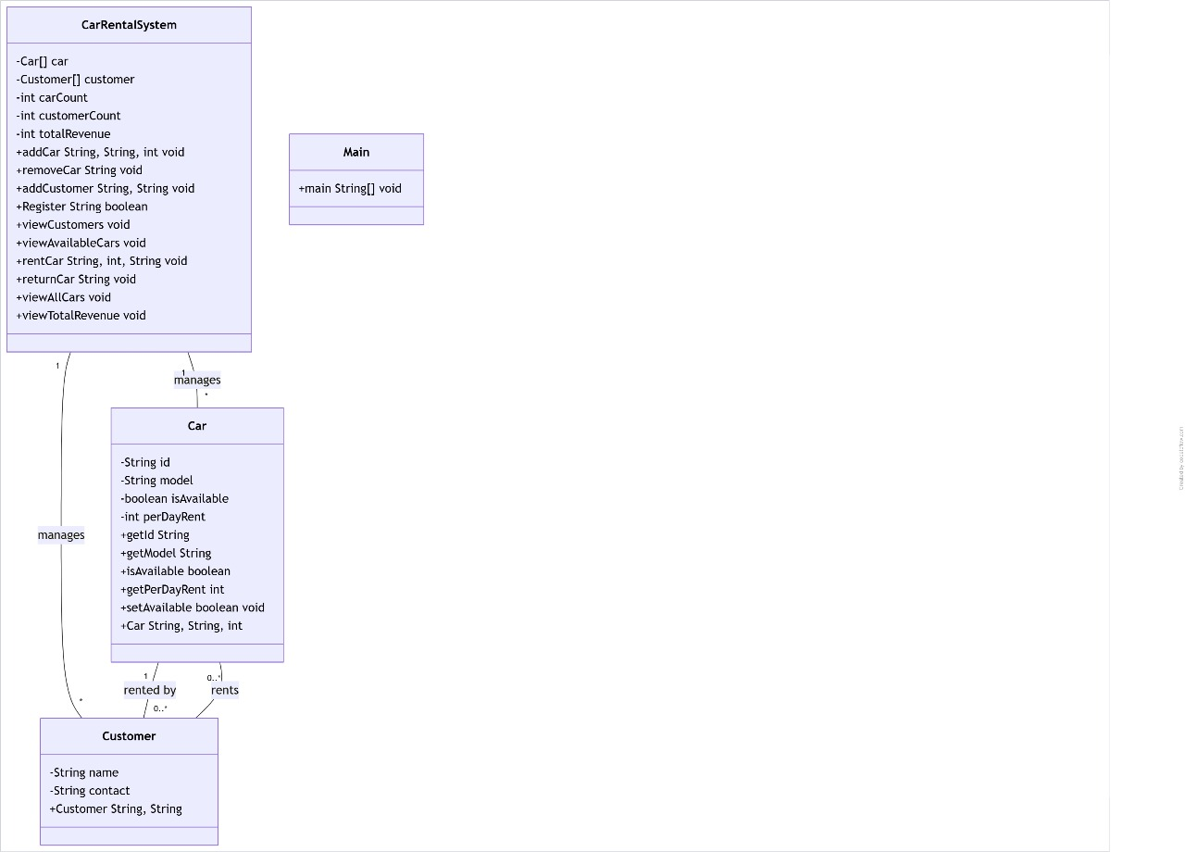
Class Diagram:
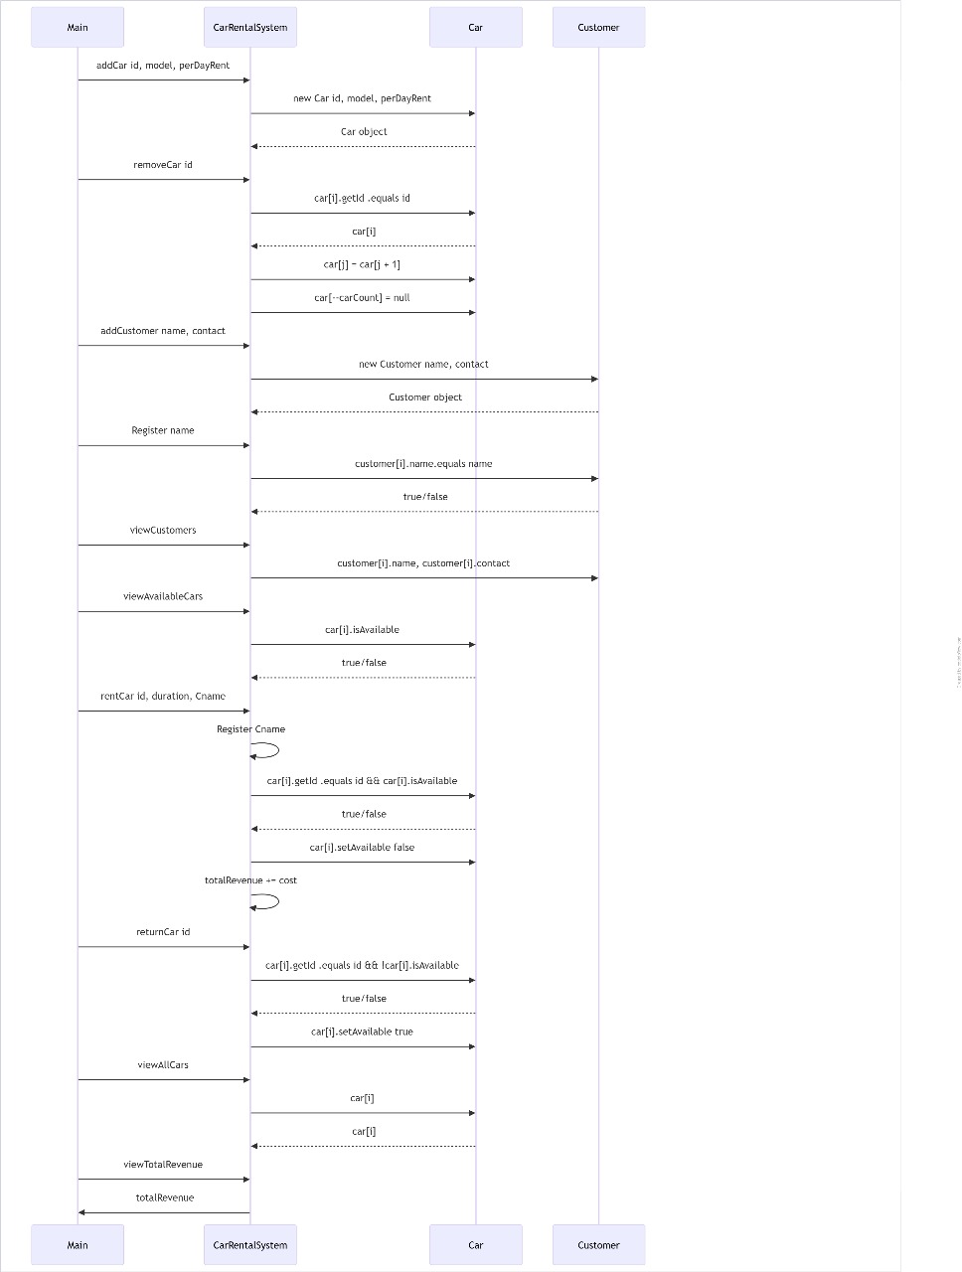
Sequence Diagram:

1. INTRODUCTION

1.1 Purpose
The purpose of this document is to define the requirements for the Car Rental System, which will facilitate renting cars online by automating booking, payment, and management processes.

1.2 Scope
The system will allow customers to browse available cars, book rentals, make payments, and return cars. The system will also provide features for administrators to manage cars, users, and bookings efficiently.

1.3 Glossary
- Admin: The person responsible for managing cars, users, and rental bookings.
- Customer: A user who books a car for rent.
- Payment Gateway: A service that allows secure online payments.

1.4 Overview
This document outlines the problem statement, system requirements, diagrams, and other essential aspects required for developing the Car Rental System.

2. OVERALL DESCRIPTION

2.1 Problem Statement
Traditional car rental processes involve manual paperwork and in-person bookings, leading to inefficiency and inconvenience. A digital solution is needed to streamline the process.

2.2 Existing System
The current system relies on physical records, manual scheduling, and limited availability for users to book cars. Payments and verifications are also handled manually.

2.3 Proposed System
The proposed system is an online platform that allows users to rent cars from anywhere, manage bookings efficiently, and make online payments securely.

2.4 Product Functions
- User Registration & Login
- Car Search & Availability Checking
- Booking & Rental Management
- Online Payment Processing
- Admin Panel for Car & User Management

2.5 User Characteristics

2.5.1 User Requirements
- Internet access
- Basic knowledge of online bookings

2.5.2 User Education Level
- General users: Basic understanding of online booking systems
- Admins: Familiar with database and system management

2.5.3 User’s Technical Expertise
- Customers: Basic familiarity with web applications
- Administrators: Moderate understanding of system functionalities

2.6 Constraints
- Internet dependency
- User authentication for security
- Limited to supported devices and browsers

2.7 Assumption and Dependencies
- Users have internet access
- The system is regularly maintained
- Payment gateway services are operational

3. REQUIREMENT SPECIFICATION

3.1 Functional Requirements

3.1.1 Performance Requirements
- The system should handle multiple bookings simultaneously.
- Response time should be within 2 seconds for key operations.

3.1.2 Design Constraints
- The system should be user-friendly.
- Responsive UI for various devices.

3.1.3 Hardware Requirements
- Server with sufficient storage & processing power.
- User devices (PC, laptop, mobile, tablet).

3.1.4 Software Requirements
- Operating System: Windows, Linux, MacOS
- Database: MySQL / PostgreSQL
- Backend: Java (Spring Boot)
- Frontend: HTML, CSS, JavaScript

3.1.5 Other Requirements
- Secure login authentication
- Data encryption for security

3.2 Non-Functional Requirements

3.2.1 Security
- Role-based access control
- Secure payment transactions

3.2.2 Reliability
- System should be available 24/7 with 99.9% uptime.

3.2.3 Availability
- Cloud-based hosting for better availability.

3.2.4 Maintainability
- Regular updates and security patches.

3.2.5 Supportability
- Multi-language support for wider user base.

4. DIAGRAMS

4.1 Use Case Diagram
A use case diagram illustrating user interactions with the system.

