🌱 What is Go (Golang)?
Go is a statically typed, compiled language developed at Google. It’s known for:
- Simple syntax
- Super-fast performance (like C)
- Built-in support for concurrency (via goroutines)
- Ideal for backend systems, APIs, cloud services, and DevOps tools

variables and data types.
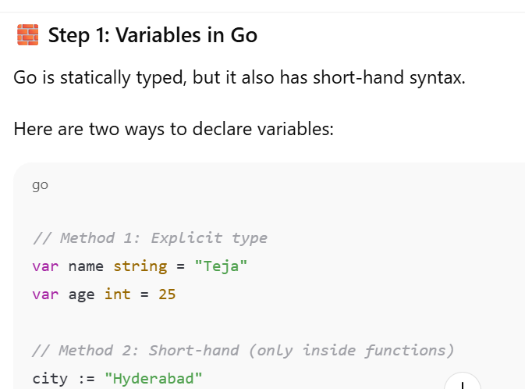

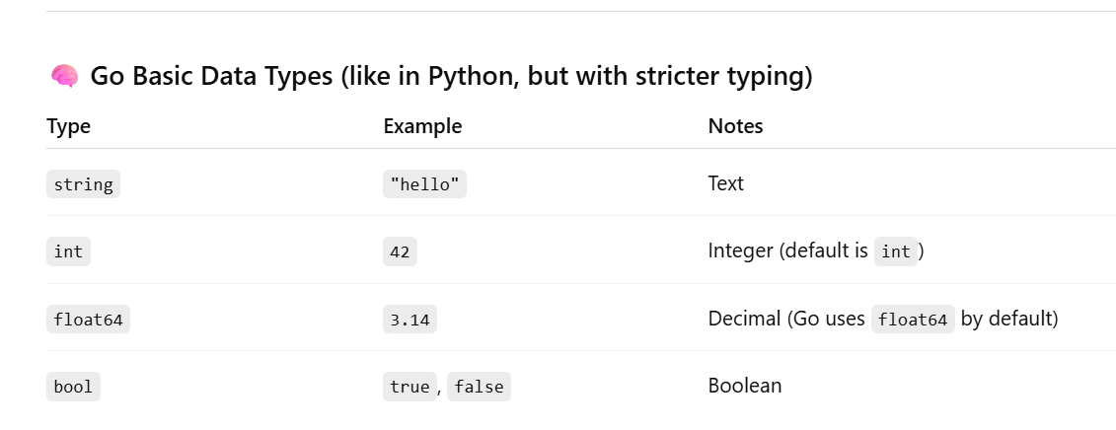

✅ Next: Input from User (like input() in Python)
Go handles input a little differently using the fmt.Scanln function.
Try this simple version:
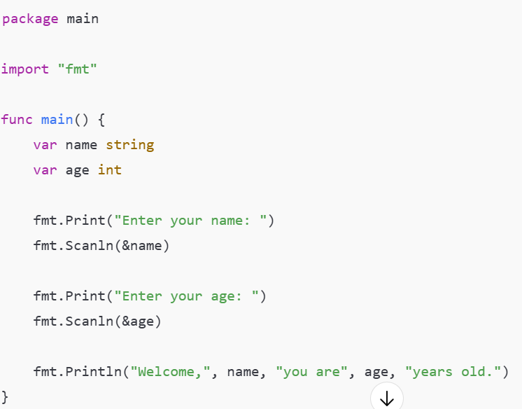

👀 A few things to notice:
- We use &name — the & means “address of” (Go uses this to store the input in a variable)
- Scanln reads input until Enter is pressed

Conditionals:
✅ Key differences from Python:
- No parentheses () around conditions (but you can use them if you want)
- Braces {} are required
- No colons :

Alright, last time we covered what Go is, how to install it, and wrote our first Hello, World! program.
Let’s move to Lecture 2: Variables and Data Types — this is where most Go programs begin to get interesting.

1. Variables in Go
A variable is a name for a piece of memory where we store data.
In Go, we can declare variables in a few ways:
Method 1: Using var
package main
import "fmt"

func main() {
var age int = 25
fmt.Println(age)
}
Here:
- var → tells Go you’re creating a variable
- age → variable name
- int → type (integer)
- 25 → value

Method 2: Type Inference
Go can guess the type from the value:
var name = "Alice"

Method 3: Short Declaration (:=)
This only works inside functions:
name := "Bob"

2. Basic Data Types
Go has several basic types:
- int → whole numbers (10, -5)
- float64 → decimal numbers (3.14, -0.5)
- string → text ("Hello")
- bool → true or false

💡 Quick Check for You:
How would you declare a variable in Go to store:
- Your age (integer)
- Your height in meters (float)
- Whether you like Go (boolean)
Can you try writing them in Go syntax?

Functions:

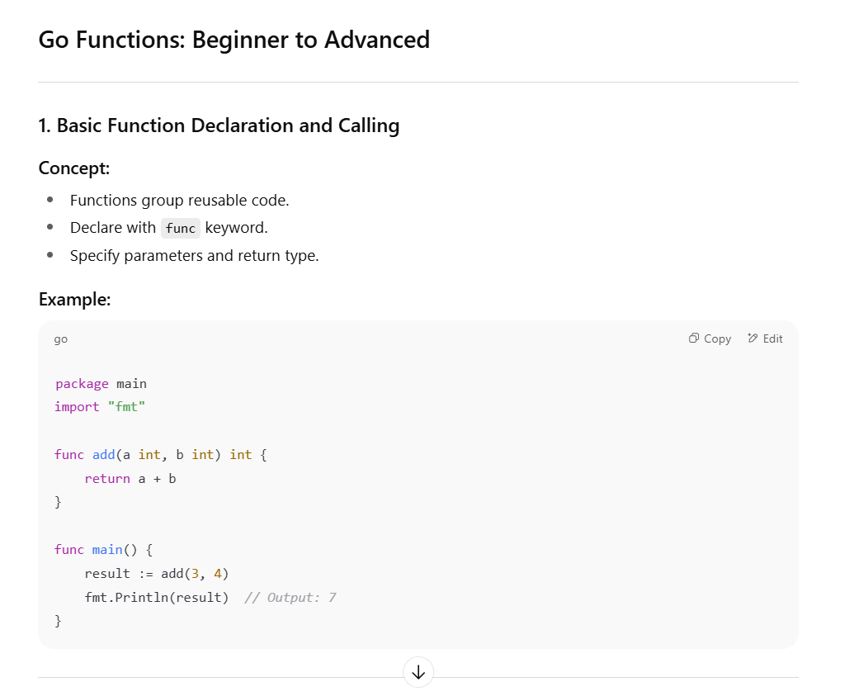

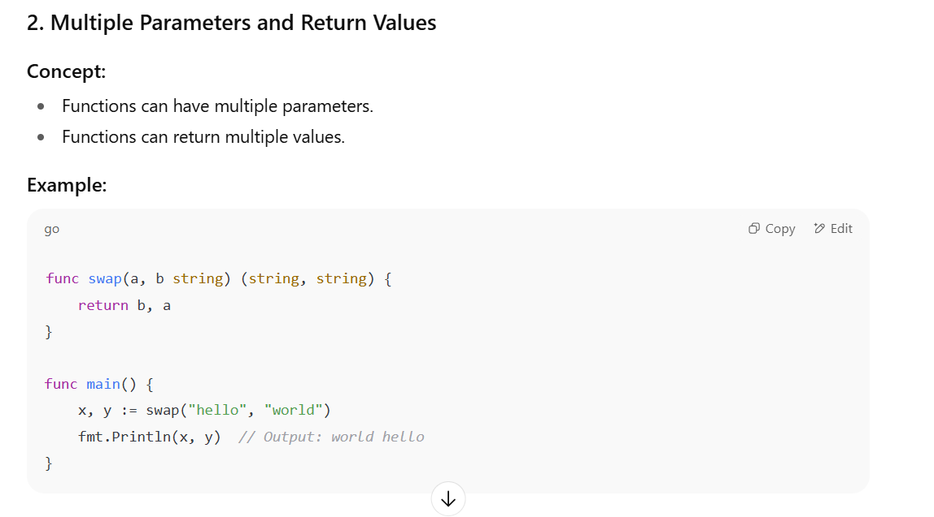

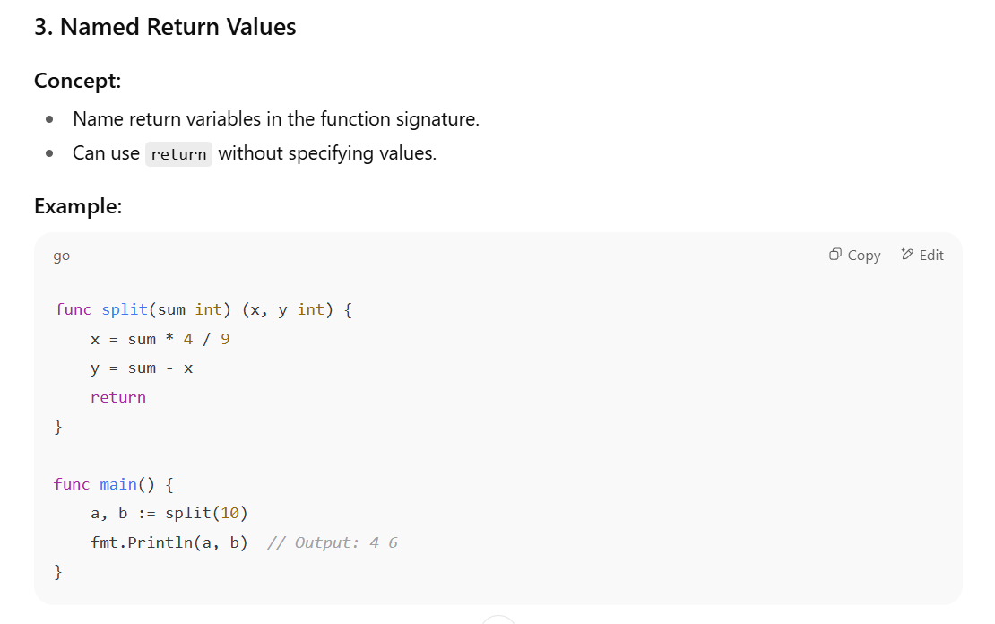

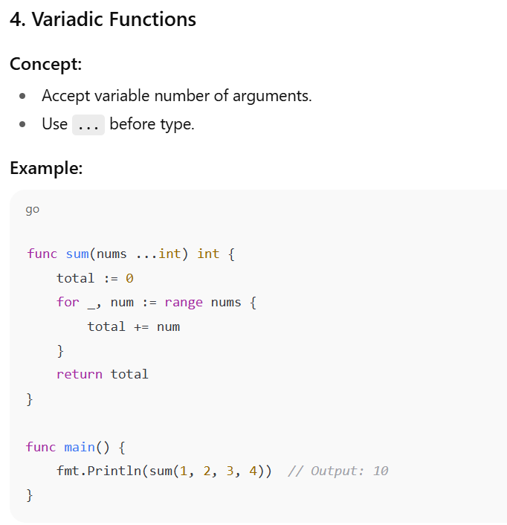

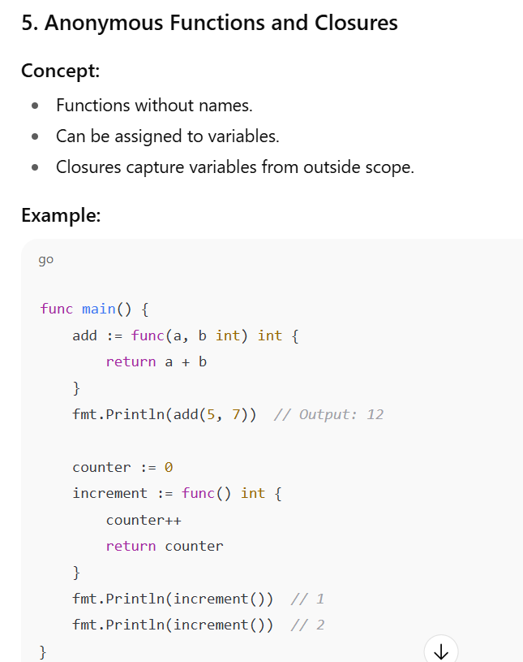

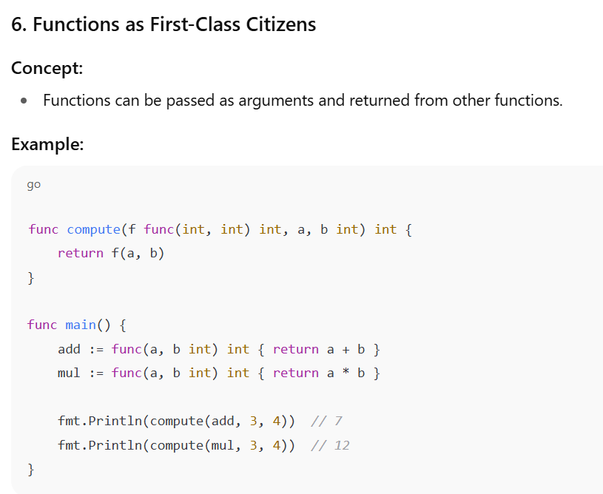

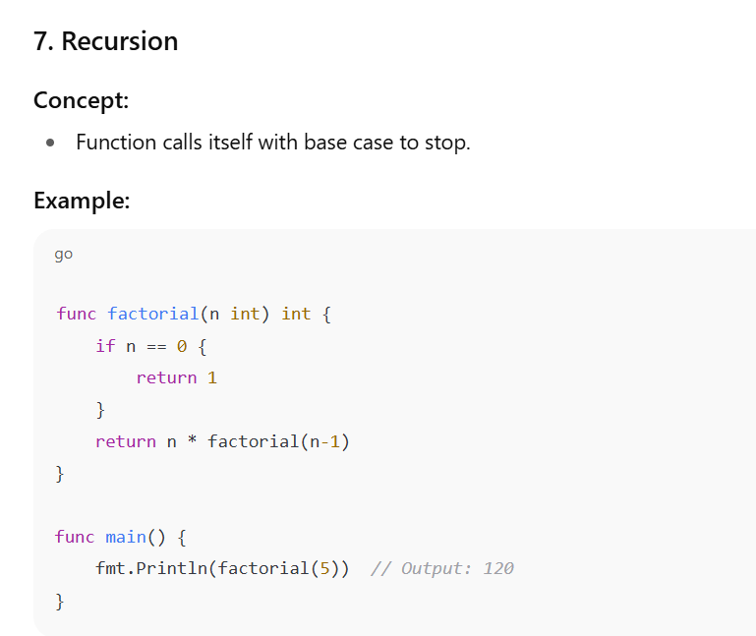

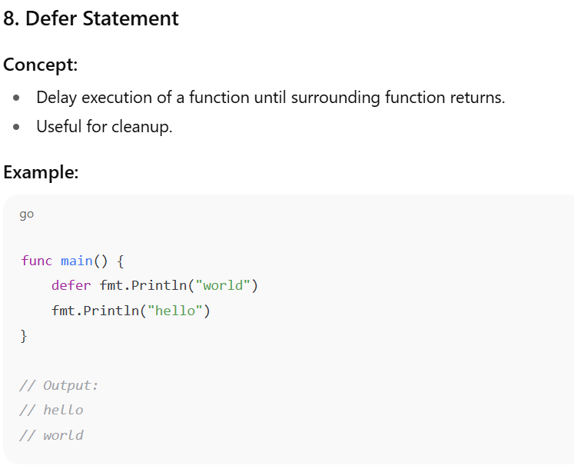

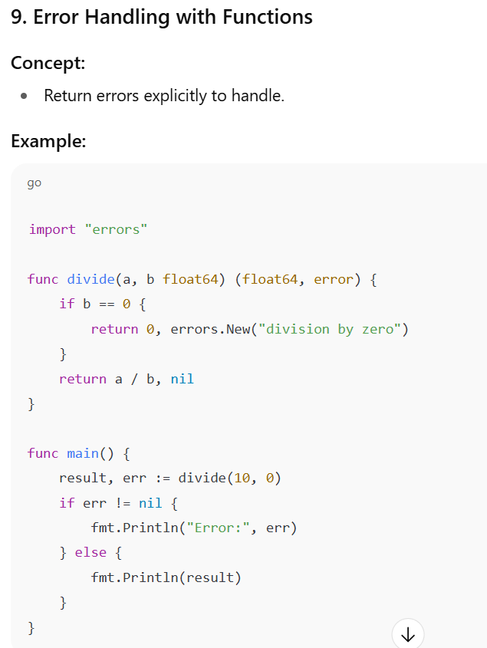

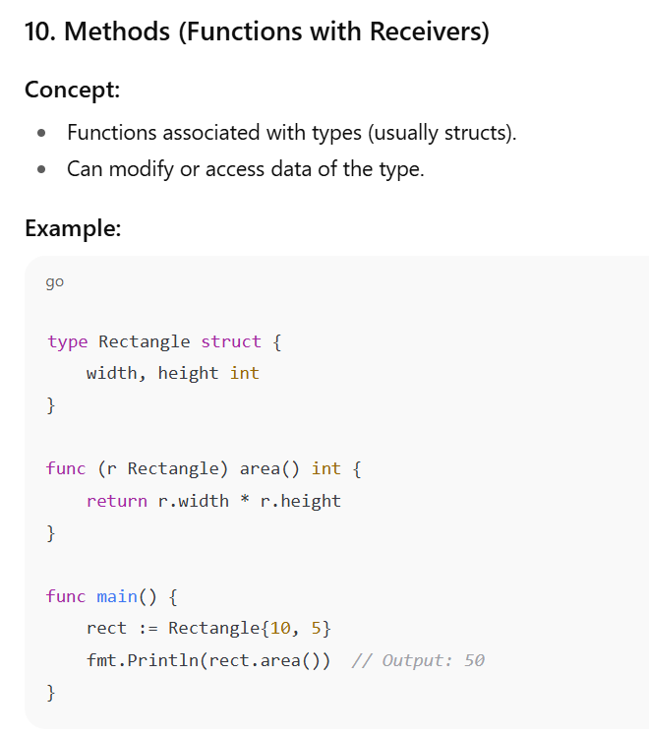

ARRAYS AND SLICES IN GO
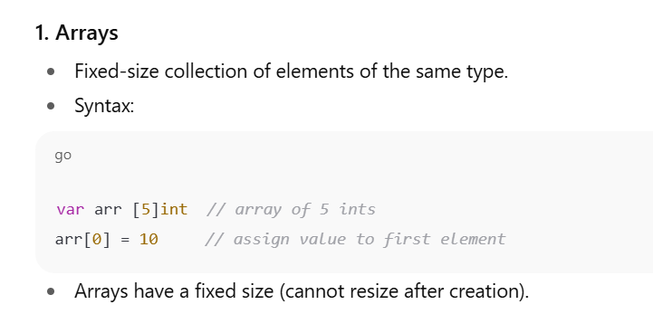

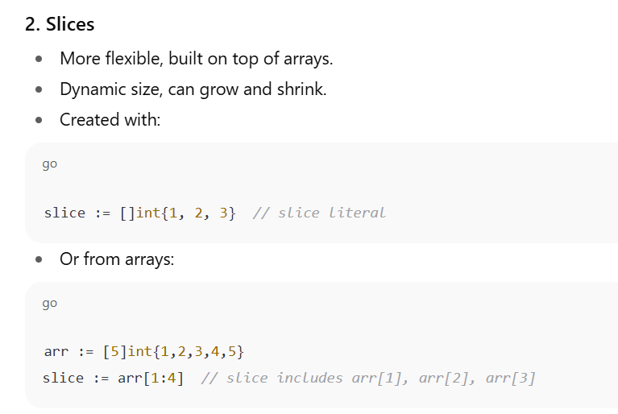

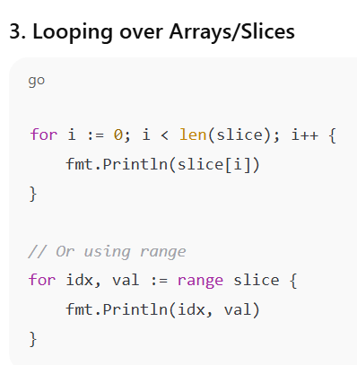

What is an Array?
- A collection of fixed-size elements of the same type.
- Size is part of the type — arrays have fixed length determined at compile time.
- Stored contiguously in memory.

Important Notes about Arrays
- Arrays cannot grow or shrink after declaration.
- Passing arrays to functions copies the entire array (not a reference).
- To avoid copying, use slices (covered next).

Slices in Go — Detailed Explanation

What is a Slice?
- A slice is a flexible, dynamically-sized view into an underlying array.
- Unlike arrays, slices can grow and shrink.
- Internally, a slice contains:
  - Pointer to the underlying array
  - Length (number of elements accessible)
  - Capacity (max size before resizing needed)
Slice Properties
- len(slice) returns length.
- cap(slice) returns capacity.
- You can append elements using append() (creates new underlying array if capacity exceeded).

Sure — this is one of those “Go quirks” that makes perfect sense once you see how slices actually work under the hood.

How slices work in Go
A slice in Go is not the actual array data — it’s just a small header structure containing:
- Pointer → points to the first element in an underlying array
- Length → how many elements are currently in the slice
- Capacity → how many elements can fit before needing a new array
Visually:
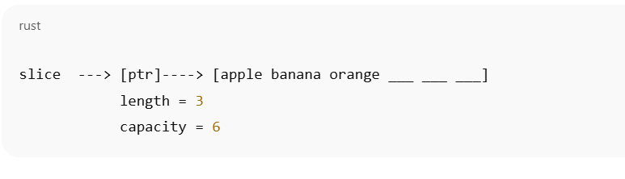
What happens with append
When you append:
- If the new length ≤ capacity, Go will just put the new element(s) into the existing array.
- If the new length > capacity, Go will:
  - Allocate a new array (usually double the size).
  - Copy the old elements into it.
  - Point the slice to this new array.
Here’s the catch:
If a new array is created, the slice variable now points to different memory than before.
If you didn’t return this updated slice, the caller still has the old slice pointing to the old array, so they won’t see your changes.
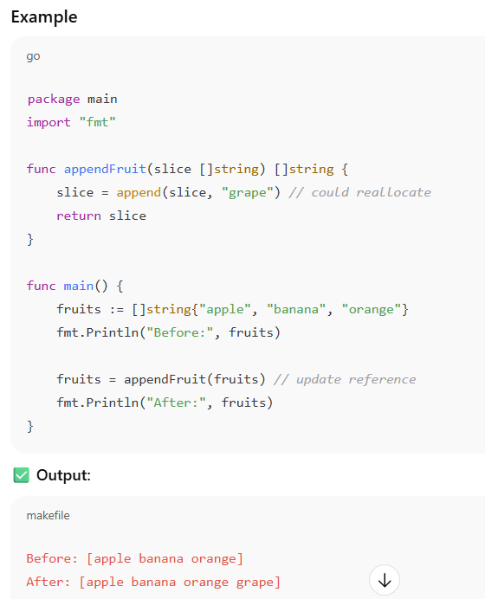

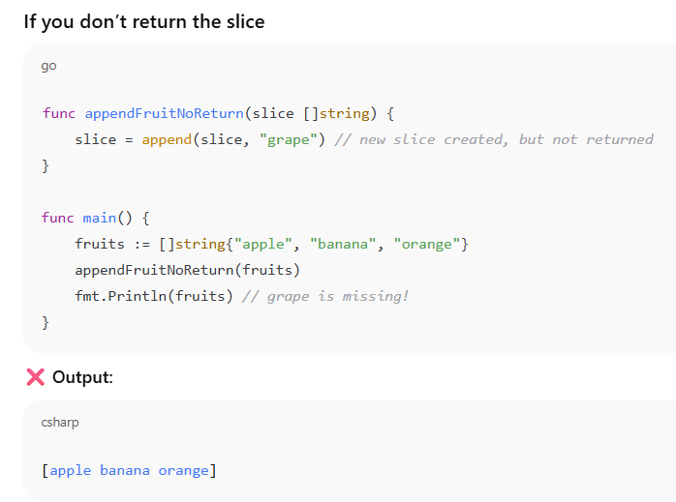

💡 Rule of thumb:
Whenever you append inside a function and want the caller to see the result, return the slice — unless you’re absolutely sure the append won’t cause a reallocation (which you usually can’t guarantee).

Rule
Whenever you might exceed capacity inside a function, append could make a new array and your original variable won’t see it unless you return the new slice (or pass a pointer to the slice header).

Got it ✅ — I’ll move you to the next logical Go topics that will strengthen you for Machine Learning work while still keeping it Go-focused.
Since you’ve already covered:
- Functions
- Arrays & slices (including pitfalls)
- Append, copy, multi-dimensional slices
The next topics should be:

1. Maps in Go
Maps are essential in ML-related Go work because you’ll often need to:
- Store label-to-index mappings
- Keep track of word frequencies
- Count occurrences in datasets
- Build dictionaries for features
Why maps are important for ML:
- Feature lookup (e.g., mapping words to vector positions in NLP)
- Label encoding
- Hash-based indexing

2. Structs and Methods
You’ll use structs to represent:
- Data records
- Model parameters
- Configurations for algorithms
Example:
type DataPoint struct {
Features []float64
Label string
}
Methods will let you attach logic directly to these types.

3. Pointers and Memory Management
- How to avoid unnecessary copies (important for large datasets in ML)
- When to pass by pointer vs by value

4. Interfaces
For ML:
- Different models (LinearRegression, DecisionTree) can share a common interface like Predict() and Train()

5. Goroutines & Channels (Concurrency)
- Parallel processing for dataset loading and preprocessing
- Speeding up training loops

6. File I/O and CSV Handling
- Reading datasets from CSVs
- Writing results
- Streaming large datasets without loading into memory fully

7. Go Modules & Package Management
- Organizing ML projects
- Using Go ML libraries like gorgonia, gonum, or gota

If you agree, we can go step-by-step starting with Maps since they’re the immediate building block after slices and will be heavily used in ML preprocessing.
Do you want me to start with Maps in Go?

MAPS:

Think of them as dictionaries in Python: a collection of key-value pairs with super-fast lookups.
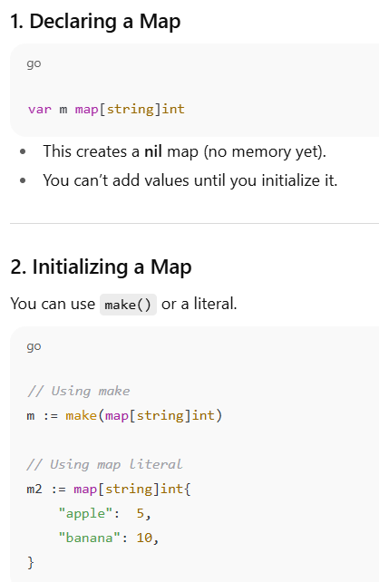

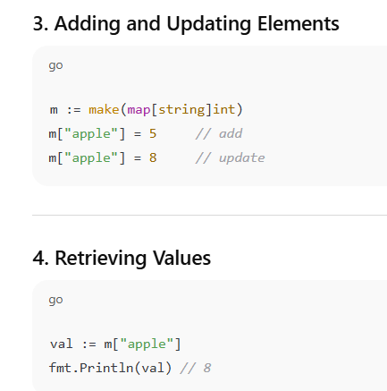

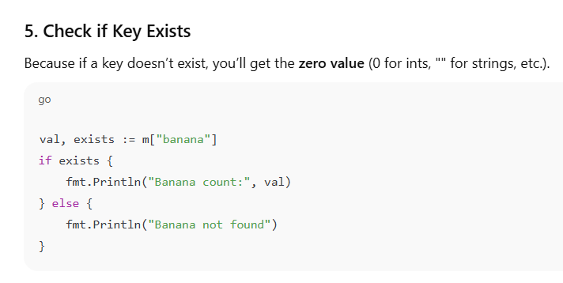

This is a Go language idiom used to retrieve a value from a map and check if the key exists simultaneously.
Explanation
- val: This variable will hold the value associated with the key "banana". If the key doesn't exist, val will be the zero value for the map's value type (which is 0 for an int).
- exists: This is a bool variable that will be true if the key "banana" is found in the map m, and false if it is not.
- m["banana"]: This is the standard way to access an element in the map m using the key "banana".
This comma-ok idiom is the preferred way to check for a key in a Go map. It's much safer than just val := m["banana"], because if the key doesn't exist, the latter would just return the zero value, and you wouldn't know whether the key was missing or if the stored value was actually 0.

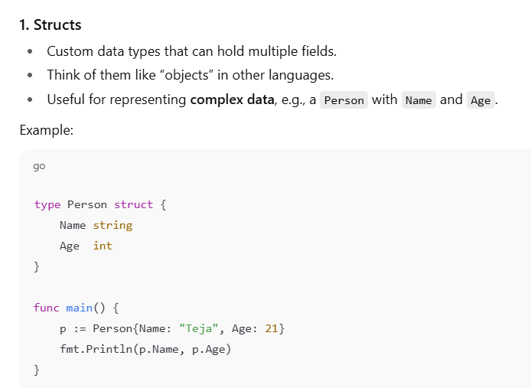

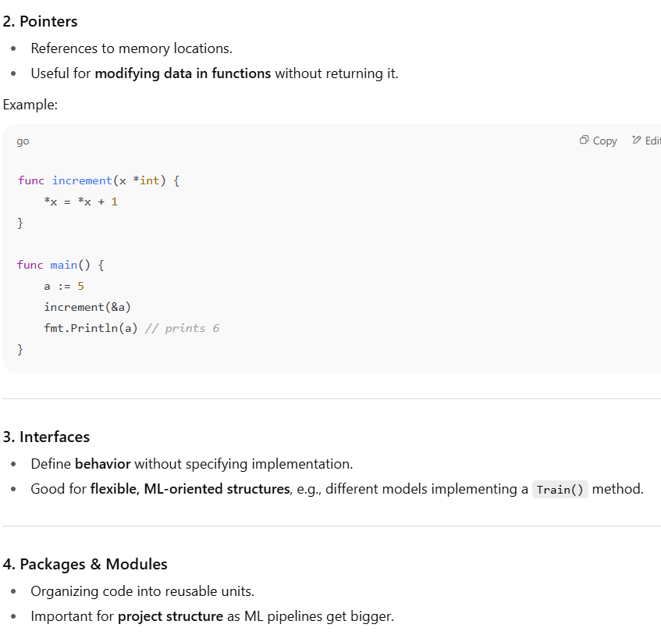

Structs:
1. What is a Struct?
A struct is a custom data type that lets you group different fields together under a single name.
Think of it as a record or a lightweight object.
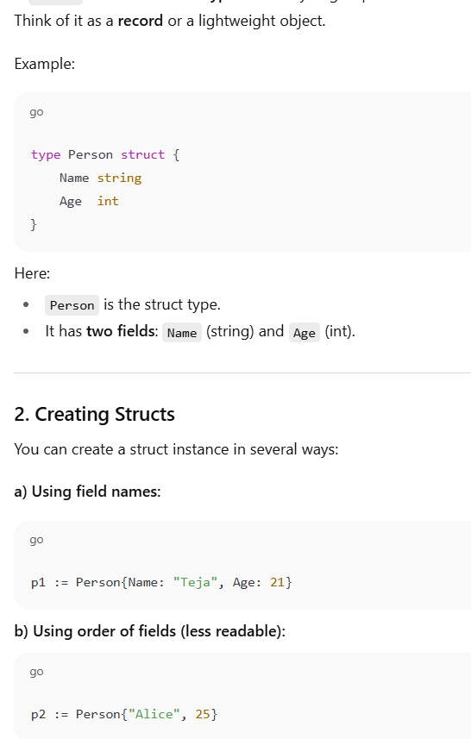

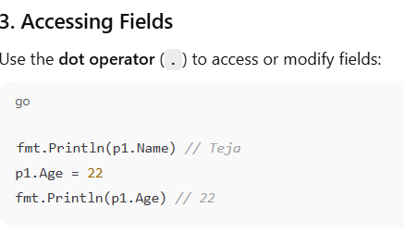

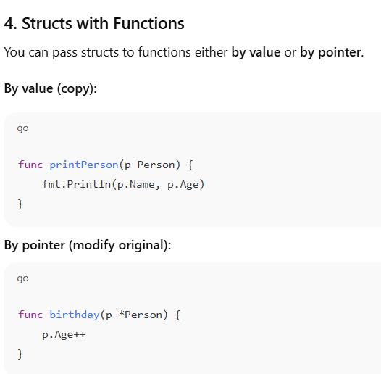

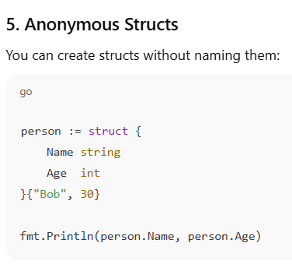

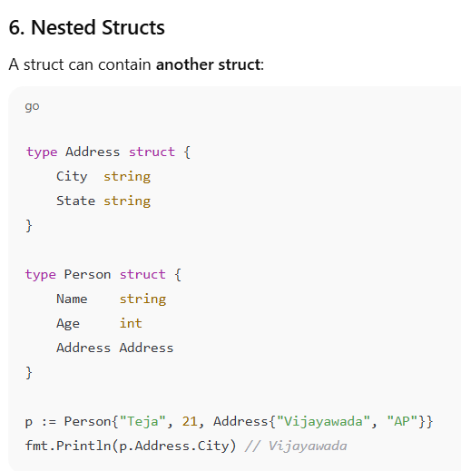

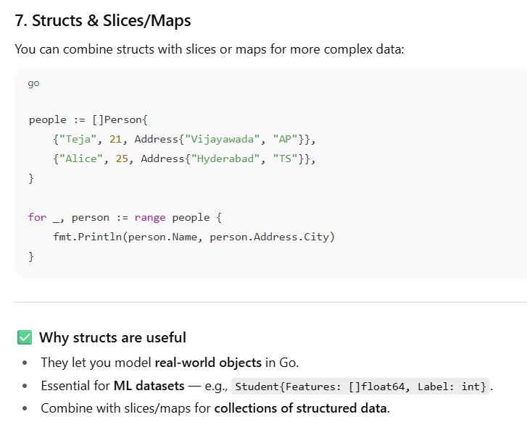

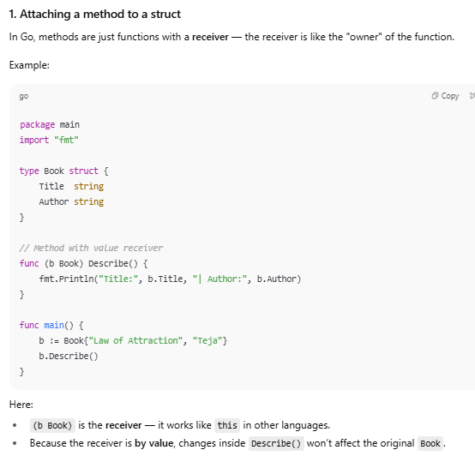

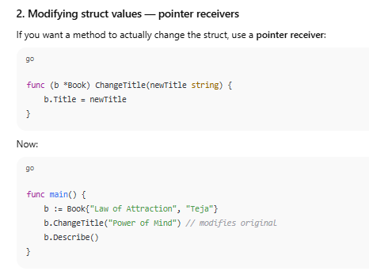

A method in Go is a function with a special receiver argument. The receiver is what ties the function to a specific type, allowing it to "belong" to that type. This is how Go achieves object-oriented programming concepts without classes.

Method Receivers
There are two types of receivers you can use when writing a method:
- Value Receiver: A method with a value receiver operates on a copy of the original value. Any changes made inside the method will not affect the original variable. This is a good choice for methods that only read or describe a value, as it's efficient for small data types.
- Pointer Receiver: A method with a pointer receiver operates on the original value itself. This means any modifications made by the method will persist after the method call. Use a pointer receiver when your method needs to modify the state of the receiver. This is also more efficient for large structs, as it avoids making a costly copy.

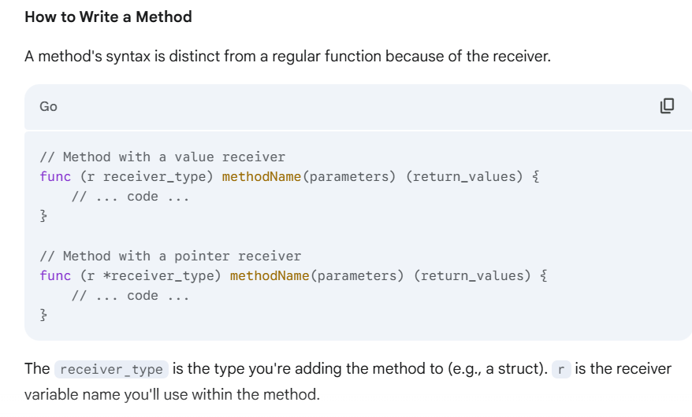

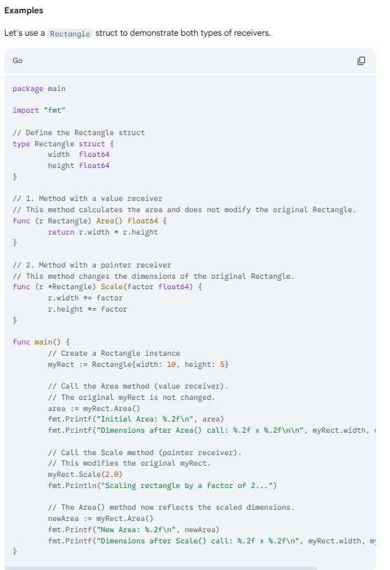

Key Takeaways
- Receiver is the key: The receiver is the syntax that makes a function a method.
- Value vs. Pointer: Choose a value receiver for read-only operations and a pointer receiver for methods that change the state of the struct.
- Syntactic Sugar: Go automatically handles the pointer/value conversion for you in method calls. You can call a method with a pointer receiver on a value type (myRect.Scale(2.0)) and vice versa. Go will implicitly take the address or dereference the pointer for you.

Writing multiple methods in Go is straightforward. You simply define each method with the same receiver type. Go doesn't restrict the number of methods a type can have; you can add as many as needed to define its behavior.

Example: A Circle Type
Let's create a Circle struct and add a few methods to it, all using a value receiver since these methods just read the data and don't change the circle's state.
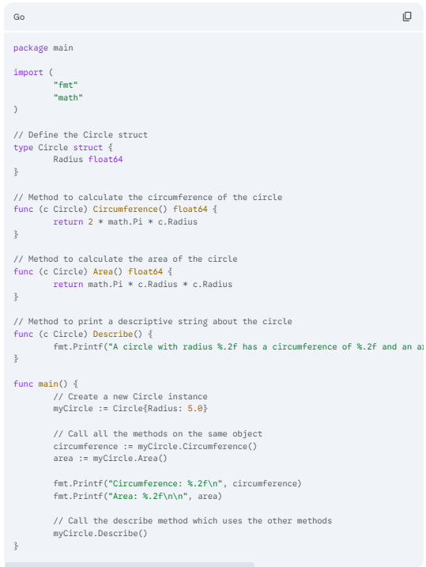

Key Takeaways
- Same Receiver Type: Notice that each method (Circumference, Area, Describe) is attached to the Circle type using the (c Circle) receiver.
- Independent Methods: Each method is a self-contained function. One method can even call another method of the same type, as seen in the Describe method.
- No Limit: You can continue adding methods to the Circle type to represent any behavior it needs, such as a Diameter() or Scale() method.
That’s great 🚀 — Go (Golang) is a solid language for backend, cloud, and systems programming.
I’ll give you a structured roadmap of Go topics you should learn, starting from basics to advanced, so you can track your progress:

🟢 Beginner (Foundations)
- Go Setup & Basics
  - Install Go, set up GOPATH, GOROOT, and environment variables
  - Your first Go program (package main, func main)
- Data Types & Variables
  - int, float, string, bool
  - Constants (const), variables (var, :=)
  - Type conversions
- Control Flow
  - if, else, switch, for (only loop in Go)
  - range keyword
- Functions
  - Basic functions
  - Multiple return values
  - Named return values
  - Variadic functions
- Arrays, Slices, and Maps
  - Fixed-size arrays
  - Dynamic slices (append, copy, subslices)
  - Maps (hash tables/dictionaries)

🟡 Intermediate (Core Concepts)
- Structs
  - Defining structs
  - Struct methods
  - Embedding (composition)

- Pointers
  - * (dereference), & (address-of)
  - Passing by reference vs by value
- Interfaces
  - Defining interfaces
  - Implementing interfaces implicitly
  - Empty interface (interface{})
  - Type assertions and type switches
- Error Handling
  - Multiple return values with error
  - Custom errors (errors.New, fmt.Errorf)
  - panic and recover
- Packages & Modules
  - import and organizing code
  - go mod init, go mod tidy
  - Using standard library

🔵 Advanced (Go’s Superpowers)
- Concurrency (Goroutines & Channels)
  - Goroutines (go keyword)
  - Channels (unbuffered & buffered)
  - select statement
  - Worker pools, fan-in/fan-out patterns
  - Context (context package) for cancellation & timeouts
- Synchronization
  - sync.Mutex, sync.WaitGroup
  - sync.Once, sync.Map
- File Handling & I/O
  - Reading/writing files
  - JSON, CSV, XML handling (encoding/json etc.)
- Testing
  - Writing tests (*_test.go)
  - testing package
  - Table-driven tests
  - Benchmarks
- Networking & Web
  - net/http (build simple HTTP server & client)
  - REST API with Go
  - Middleware basics

🔴 Expert (Professional Go Development)
- Advanced Concurrency
  - Pipelines
  - Actor model
  - Rate limiting
- Reflection & Generics (Go 1.18+)
  - Using reflection (reflect package)
  - Generics (type parameters)
- Profiling & Optimization
  - Memory management
  - Garbage collection
  - Profiling with pprof
- Popular Frameworks & Tools
  - Web: Gin, Echo, Fiber
  - CLI: Cobra
  - gRPC with Go
  - Docker & Kubernetes with Go
- Project Structure & Best Practices
  - Clean architecture in Go
  - Go module layout
  - Effective Go guidelines

👉 By the time you finish Intermediate, you’ll be very comfortable writing Go programs.
👉 By the time you finish Advanced, you’ll be ready to build production apps and even contribute to open-source projects.

Do you want me to give you a step-by-step learning path with practice problems (like we did with slices and functions) so you can follow one by one every day?

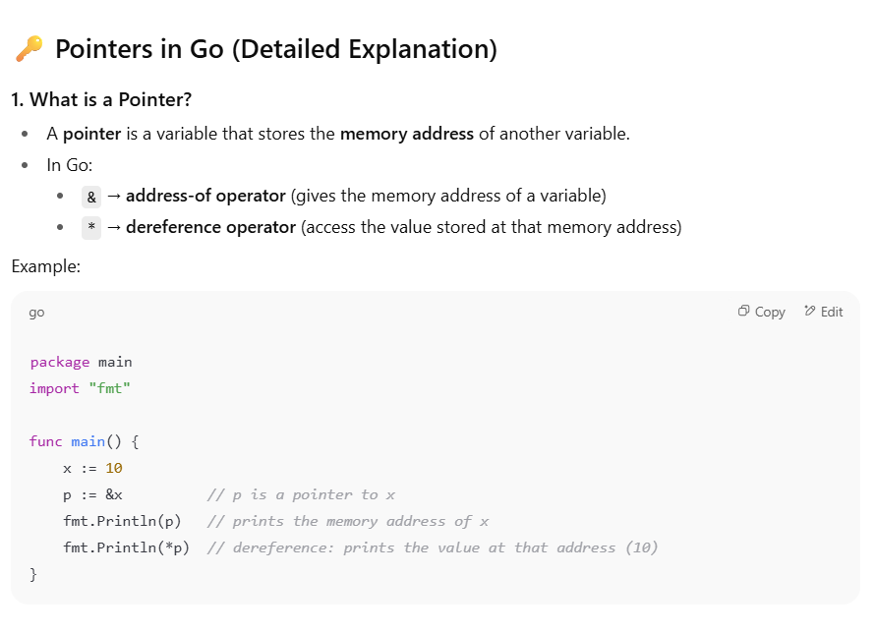

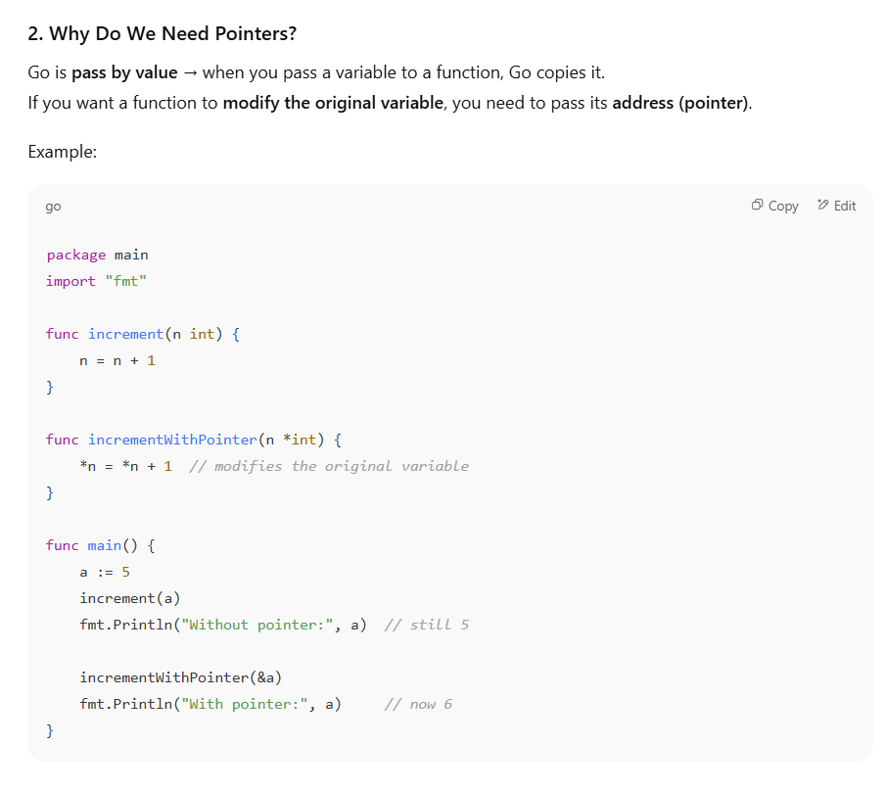

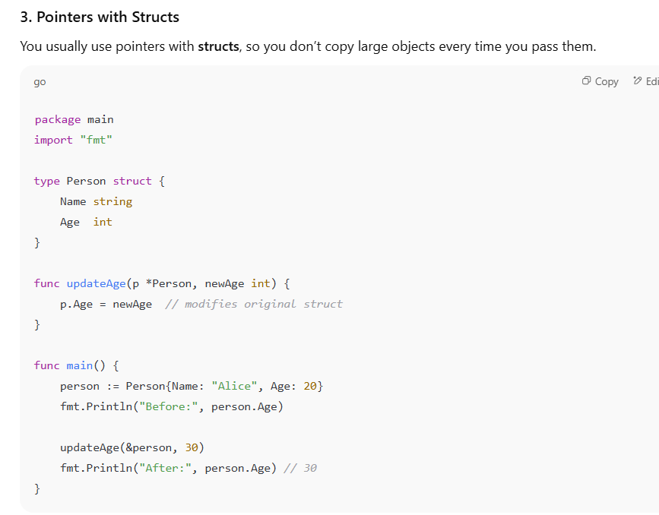

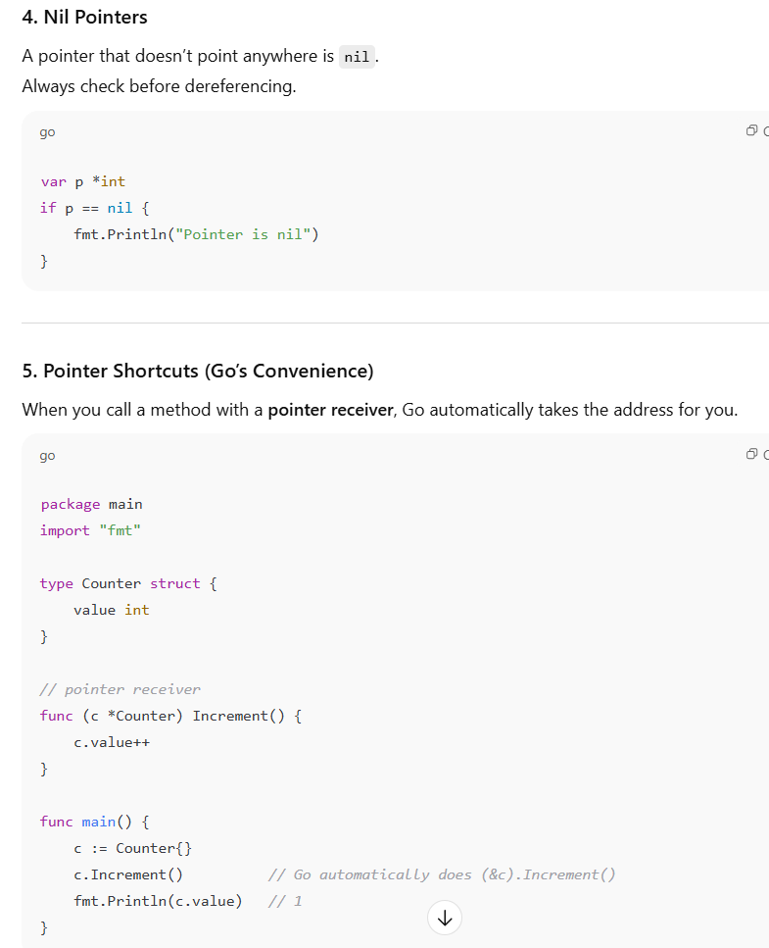
✅ Summary:
- & = get address
- * = get value at address
- Needed to modify variables in functions
- Commonly used with structs for efficiency

