- “go version” to check whether it is installed or not.
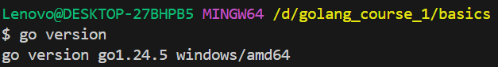

- To check the environments
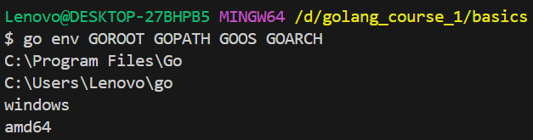

ERROR HANDLING:

