- Install chocolatey. It is a package manager for windows. It is like “apt” package manager for linux.
- Through that installed a Kubernetes
- 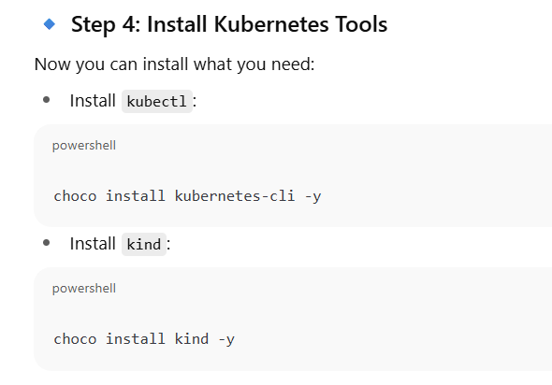

Running kubectl create deployment nginx-deploy --image=nginx creates a new Deployment resource in Kubernetes. This command is a quick way to get a basic application running.
What It Does
The command tells Kubernetes to do the following:
- kubectl: This is the command-line tool used to interact with a Kubernetes cluster.
- create deployment: This subcommand specifically tells Kubernetes to create a Deployment object. A Deployment is a high-level resource that manages a set of identical pods. It ensures a specified number of replicas of your application are running and handles updates and scaling.
- nginx-deploy: This is the name given to the new Deployment. You can choose any valid name. It's good practice to make the name descriptive.
- --image=nginx: This crucial flag specifies the container image that the pods managed by this Deployment will use. In this case, it pulls the official nginx image from Docker Hub (the default container registry) and uses it to create the containers within the pods.
When you run the command, Kubernetes creates the Deployment, which in turn creates a ReplicaSet. The ReplicaSet then ensures that the desired number of pods (by default, one) are running. Each pod contains a container running the NGINX web server.
What Happens Behind the Scenes
- Command Execution: You run the command on your terminal.
- API Server Call: kubectl sends a request to the Kubernetes API server.
- Deployment Creation: The API server creates the nginx-deploy Deployment object.
- ReplicaSet Creation: The Deployment controller sees the new Deployment and creates a new ReplicaSet.
- Pod Creation: The ReplicaSet controller sees that it needs to run one pod and sends a request to create a new pod with the nginx image.
- Scheduling: The scheduler finds a suitable worker node to run the new pod.
- Container Runtime: The Kubelet on the assigned node instructs the container runtime (e.g., Docker or containerd) to pull the nginx image and start a container.
- Application Running: The NGINX web server is now running inside the container, inside the pod, on a worker node in your cluster.

