DELA FUENTE, Marie Therese N. October 11, 2019

PROGCON Ms. Jen Arroyo

The programmer should be able to know and understand the steps involving the program development cycle in order to produce a continuous program free of errors. An important step in the process is planning the logic. An algorithm is used in planning the logic, it is defined as “the sequence of steps or rules you follow to solve a problem”. This is rather a concept of how the program should be than an actual computer program. The most common planning tools used are flowcharts, pseudocode, IPO charts and TOE charts.

Pseudocode is an “English-like representation of the logical steps it takes to solve a problem”. In simpler terms, it is a representation through words and phrases which enables flexibility in writing codes since it is written in the natural language and focuses on underline logic. Its simple structure allows adjustments and modifications as it does not tend to run over many pages and disregards the syntax. Unlike flowcharts, this does not provide visual representation and could cause confusion to nonprogrammers. An example would be a pseudocode representation of a number-doubling problem shown below:

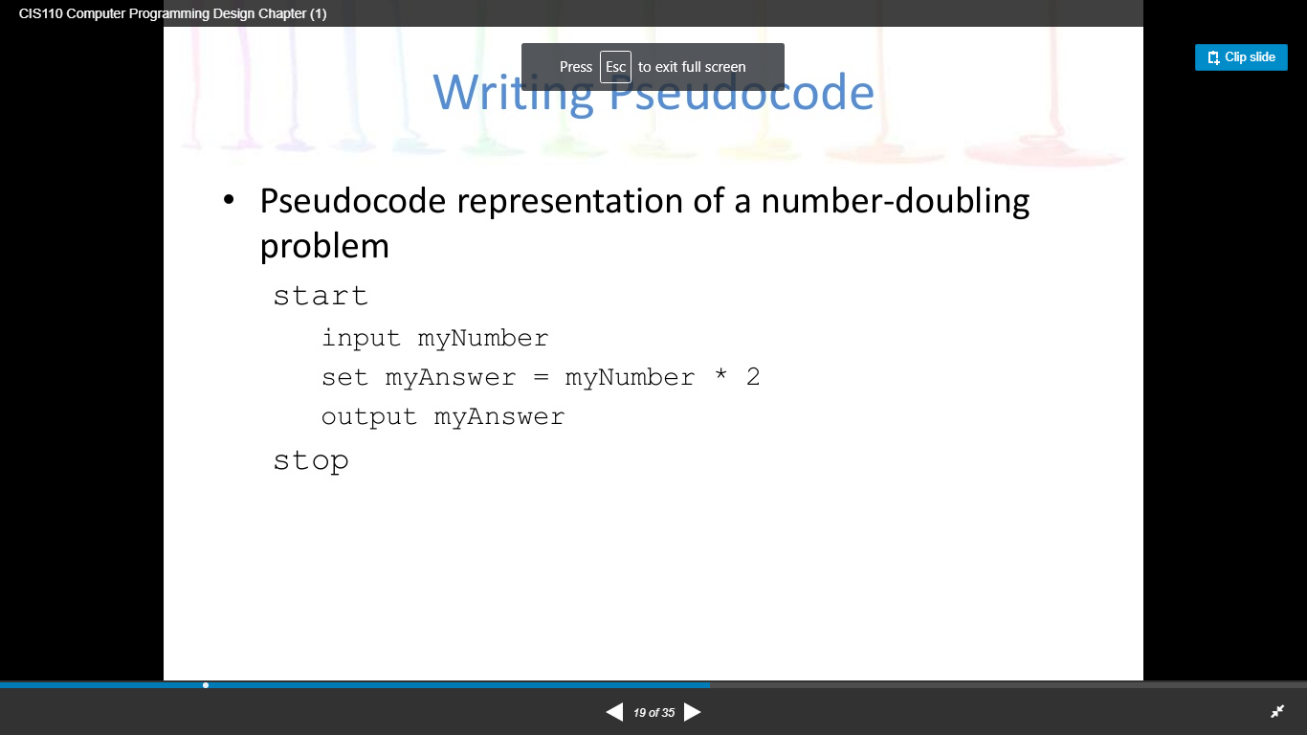

Retrieved from Programming Logic and Design, 8th edition

The start denotes the beginning as the stop denotes the end of the program. The input is the information to be processed, that is ‘myNumber’. The process is using the process of performing the input into an output that is ‘set myAnswer = myNumber\*2’. The output is the processed information that is ‘myAnswer’.

Flowchart is a “pictorial representation of the logical steps it takes to solve a problem”. In simpler terms, it is a representation through shapes and symbols which enables to view the map of the program that acts as a guide or blueprint. Since it does not use a specific programming languages concept, it is easier to write the program code and convert to a programming language code. Unlike pseudocodes, this is more complex and complicated as it is time-consuming to adjust and modify the shapes and symbols. These shapes and symbols execute a specific task as seen on the example below:

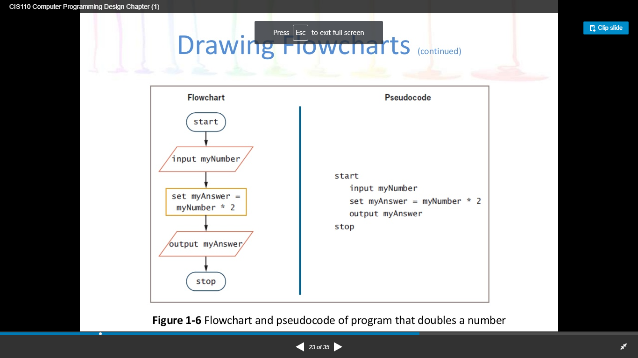

Retrieved from Programming Logic and Design, 8th edition

The terminal symbols indicate the start and the stop that is represented by an oblong, this is also called lozenges. Flowlines are the arrows that connect each step. The input symbols indicate the input operation that is represented by a parallelogram. The processing symbol indicates the processing statements that is represented by a rectangle. The output symbol indicates output statements that is represented by a parallelogram. Other symbols used are the decision symbol that is represented by a diamond shape, the usage of loops, and other codes.

The importance of a pseudocode and flowchart is that the beginners and nonprogrammers in programming and coding have an uncomplicated understanding of creating a program. The process will be simpler when they absorb the program development cycle. These codes could be applied in HTML, JavaScript for Web design, COBOL banking procedure, JAVA game action, and others as well.

Sources

Farrell, J. (2013). Programming Logic and Design, Comprehensive (8th ed.). Australia: Course Technology/Cengage Learning.

<https://www.techwalla.com/articles/what-are-the-advantages-limitations-of-pseudocode>

<https://www.buildprogrammer.com/advantages-and-disadvantages-of-pseudo-code/>

<http://computersciencementor.com/advantages-and-disadvantages-of-algorithm-and-flowchart/>