DELA FUENTE, Marie Therese N.

PROGCON Ms. Jen Arroyo

In doing the machine exercises, the Flowgorithm application was used in order to create flowcharts and run the program produced. This is a convenient and efficient method instead of creating manual flowcharts in a word document. Another advantage is that the programmer will be able to review the program, check for errors and other improvements that can be done in the program itself. The user must also be knowledgeable of the application being used whereas this could consume time and cause confusion. From the various exercises done, I was able to understand the know-hows of the applications and was able to run all my programs successfully.

In the first exercise, I was confused between the declare and assign symbols. Declare is when you specify the data whether it may be an Integer, String, Real or Boolean. Whereas, the assign symbol is similar to the process symbol. As I understood the difference, I placed the three major operations which is the input, process and output for adding the numbers. Thereafter finishing the program, I did a test run and it was well done. Also, I learned that it is possible to project your personality in your program. Every programmer has a different personality therefore programs are different from each other. I was able to spruce up my programs on the next exercises which I enjoyed and hopefully the user will as well. On the following exercise, it was a challenging process since there was a decision symbol involved. With this, I had difficulty in executing my program and run it through numerous tests. By assessing other programs, I concluded that I had to use the breakpoint symbol. This enabled the program to stop when needed be. On the last exercise, it was trouble-free since there were no computations involved. The purpose of the program was to determine whether it is an odd or even number.

**Flowgorithm Exercises**

**M1 Adding Two Numbers**

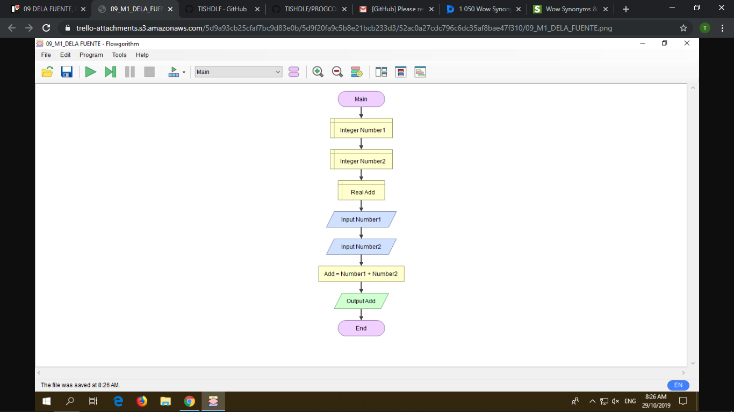

**M2 Area of a Circle using Radius and Diameter**

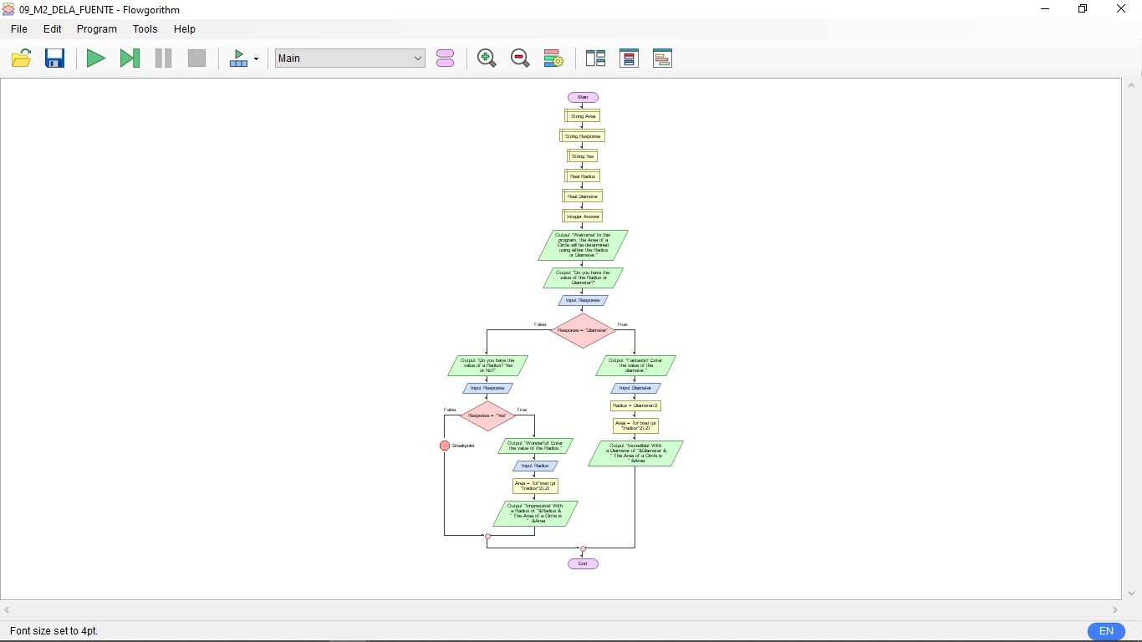

**M3 Even/Odd Number Program**

