LOGARITHMS

a^m =x

log (a^m) =log x

mloga =logx

m= logx/ loga

m = logx to base a

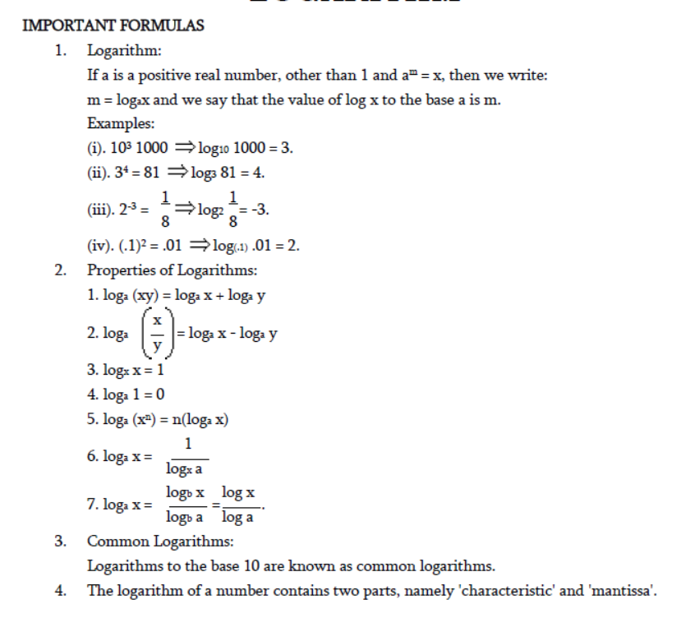

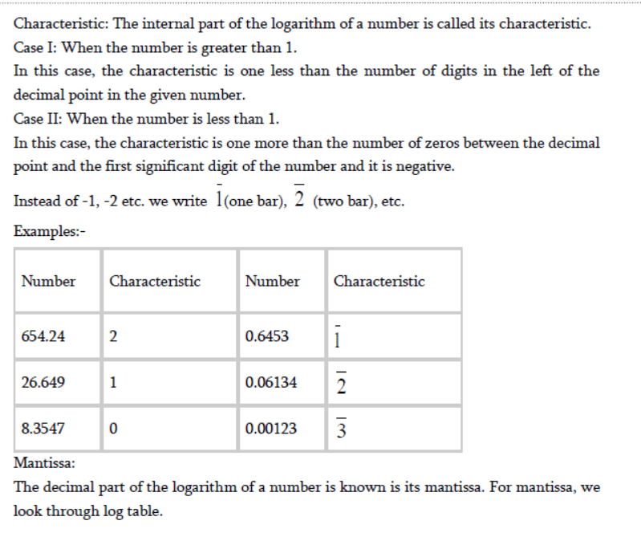

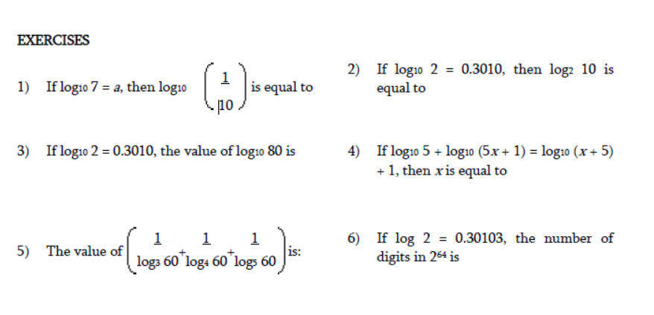

Log 80 =log(8\*10)

=log 8 + log 10

= log(2^3) + 1

= 3 log2 +1

= 3(0.3010)+1

=1.9030

If log 2 =0.3010, log3 =0.4771 then find log (1728)

Log (1728) = log (12 ^3)=3log (12)=3log (2^2\*3)

=6 log 2+ 3log3

=6(0.3010 ) + 3 (0.47710

=1.8060 +1.4313

=3.2373

If log2 =0.3010 and log3 =0.4771 then find log (125)

Log (125) =log (5^3) =3 log5 =3log (10/2) = 3log 10 – 3 log 2

=3-3(0.3010) =3-0.9030 =2.097

