SATHYABAMA INSTITUTE OF SCIENCE AND TECHNOLOGY
DEPARTMENT OF COMPUTER SCIENCE & ENGINEERING
QUESTION BANK
SCSA1701CYBER PHYSICAL SYSTEMS

UNIT – I

S. No | PART-A | CO | Blooms Level
1 | Define CPS and its components.  A cyber-physical system (CPS) or intelligent system is a computer system in which a mechanism is controlled or monitored by computer-based algorithms  Components: Computation, communication, Control | CO3 | L1
2 | Define IIoT.  Conceptual model where use new tech which enable device to communicate with each other over internet. | CO3 | L1
3 | Why Industry Fourth Revolution.  creates a world in which virtual and physical systems of manufacturing cooperate with each other in a flexible way at the global level | CO3 | L1
4 | List few Industry 4.0 technologies.  Big Data & Analytics. Autonomous Robots. Simulation/Digital Twins, IOT, Cloud Computing | CO3 | L3
5 | Sketch proposed CPS architecture.  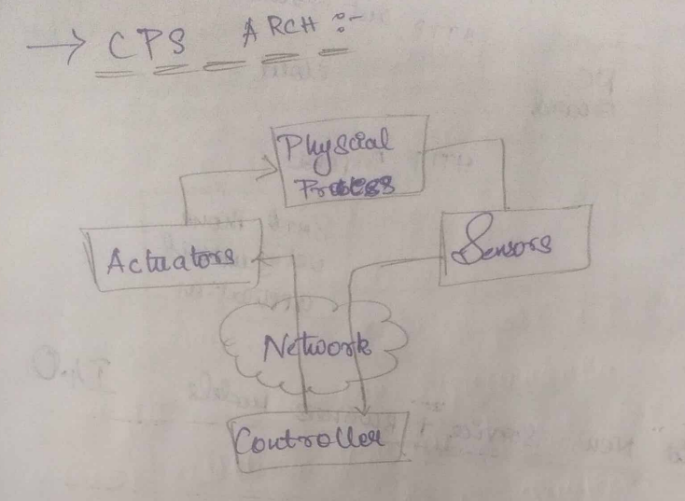 | CO3 | L3
6 | Classify IoT and IIoT | CO3 | L2
7 | What is AI.  Artificial intelligence is the simulation of human intelligence processes by machines, especially computer systems | CO3 | L1
8 | List few sensors used in Industrial Automation  Temperature Sensors.  Pressure sensors.  Level sensors.  Infrared sensors. | CO3 | L1
9 | What is Smart Transformation in Business?  adopting to digital technology that is slated to change the existing mechanisms of any department in the business. It is all about how it can affect the employees and the customers in a positive way | CO3 | L1
10 | Compare AR and VR  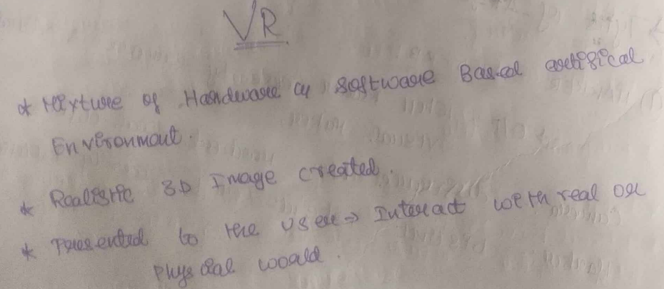  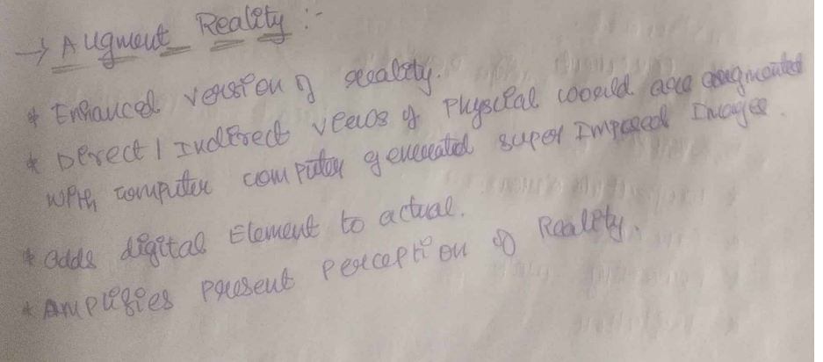 | CO3 | L1
11 | Define CPS and its components.  A cyber-physical system (CPS) or intelligent system is a computer system in which a mechanism is controlled or monitored by computer-based algorithms  Components: Computation, communication, Control | CO3 | L3

S.No | PART- B | CO | Blooms Level
1 | Describe Industrial Internet System. | CO3 | L2
2 | Discuss Industry 4.0. | CO3 | L2
3 | Explain basics of Industrial IoT. | CO3 | L5
4 | Write short notes on a) Collaborative Platform  b) Analytics for Smart Business Transformation | CO3 | L3
5 | Write briefly about basic principles of design and validation of CPS. | CO3 | L4
6. | Write briefly about Industrial sensing and actuations. | CO3 | L3

