SATHYABAMA INSTITUTE OF SCIENCE AND TECHNOLOGY
DEPARTMENT OF COMPUTER SCIENCE & ENGINEERING
QUESTION BANK
SCSA1701CYBER PHYSICAL SYSTEMS

UNIT – III

S.No | PART-A | CO | Blooms Level
1 | Define sensor. Classify different types of sensors  A sensor is a device that detects and responds to some type of input from the physical environment.  - Direct Sensor: A sensor that can convert a non-electrical stimulus into an electrical signal with intermediate stages. Eg: thermocouple (temperature to voltage).  - Indirect Sensor: A sensor that multiple conversion steps to transform the measured signal into an electrical signal. Eg: fiber-optic displacement sensor (light current to photons to current). | CO3 | L1
2 | Define Actuators? Mention the different types of Actuation systems  An actuator is a machine component that is used for moving and controlling a system or mechanism.  Hydraulic Actuators  · Pneumatic Actuators  · Electrical Actuators | CO3 | L1
3 | State distributed system  Distributed system a system in which components are distributed across multiple locations and computer-network. | CO3 | L1
4 | Point out any four applications of WSN.  easier to deploy  maintain and offer better flexibility of devices  don't need the physical network infrastructure to be modified  cost effective | CO3 | L3
5 | Sketch the sensor node with its components  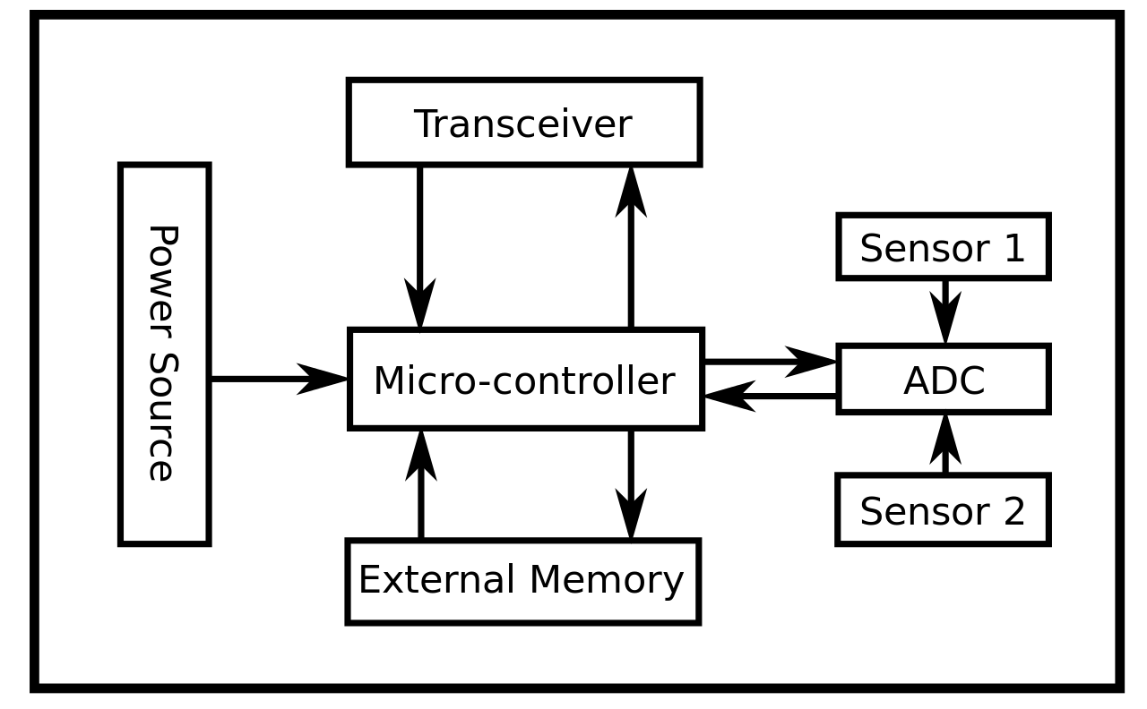 | CO3 | L3
6 | Classify multiple access protocols  random access protocols, controlled access protocols and channelization protocols  https://www.tutorialspoint.com/multiple-access-protocols-in-computer-networks#:~:text=Multiple%20access%20protocols%20can%20be,access%20protocols%20and%20channelization%20protocols. | CO3 | L2
7 | What are real-time communication protocols?  WebSocket  XMPP  WebRTC  The Bayeux Protocol  Server-Sent Events  Wave Federation Protocol  IRC | CO3 | L1
8 | What are middleware architecture types examples?  Game Engines  Device Middleware  Integration Middleware | CO3 | L1
9 | What do you mean by micro sensors?  These are a sensors which perform the necessary actions given but, the size and development is small in size and faster in development | CO3 | L1
10 | What is meant by signal processing?  Signal processing is an electrical engineering subfield that focuses on analysing, modifying, and synthesizing signals such as sound, images, and scientific measurements. | CO3 | L1
11 | Compare real time and distributed systems.  https://www.atikaschool.org/kcse-computer-studies-questions-and-answers-836310/distinguish-between-real-time-operating-system-and-distributed-operating-system#:~:text=Distinction%20between%20real%2Dtime%20and,not%20share%20memory%20or%20clock. | CO3 | L4

S.No | PART- B | CO | Blooms Level
1 | Describe with neat diagram the architecture of wireless sensor networks | CO3 | L2
2 | Discuss in detail about various real time communication protocols. | CO3 | L2
3 | Explain the middleware architecture for distributed real-time and secure services. | CO3 | L5
4 | Write short notes on a) collaborative signal processing b) Data Gathering | CO3 | L3
5 | Analyze the various applications of sensors and actuators. | CO3 | L4
6. | Write briefly about Time dependent systems and clock synchronization. | CO3 | L3

