Register Number

SATHYABAMA UNIVERSITY
(Established under section 3 of UGC Act,1956)

Course & Program : B.E/B.TECH - CSE/EEE/IT Max. Marks :80
Title of the Paper: Resource Management Techniques
Course. Code : SMEX1017(2014) Time : 3 Hours
Date :09/09/2017 Session :FN
______________________________________________________________________________________________________________________

(NOTE: Assume relevant data, if found missing)

PART – A (10 x 2 = 20)
Answer All the Questions

1. What is the role of operations research in decision making?

2. Write down any two applications of operations research in production management?

3. Define: Optimal solution in Transportation problem.

4. Write down mathematical model of the assignment problem.

5. Define: Idle time on a machine.

6. What are the major limitations of the PERT?

7. What are the various assumptions of EOQ formula?

8. Define: Simulation.

9. Define: Principles of dominance.

10. Define: Payoff matrix.
PART – B (5 x 12 = 60)
Answer All the Questions

11. Use Graphical method to solve the following LP problem,
Maximize 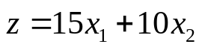
Subject to the constraints 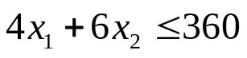
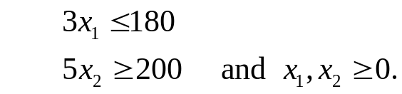
(or)
12. Use Penalty (Big – M) method to solve the following LP problem
Minimize 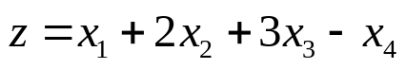
Subject to the constraints 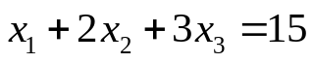
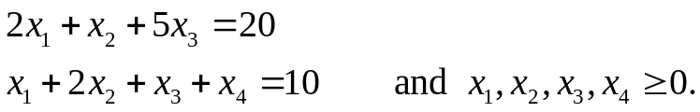

13. A company has factories at F1, F1, F3 that supply products to ware houses at W1, W2, W3. The weekly capacities of the factories are 200, 160, 90 units respectively. The weekly ware houses requirements are 180,120,150 units respectively. The unit shipping costs in rupees are as follows:
Factory | Warehouse
Factory |  | W1 | W2 | W3 | Supply
Factory | F1 | 16 | 20 | 12 | 200
Factory | F2 | 14 | 8 | 18 | 160
Factory | F3 | 26 | 24 | 16 | 90
Factory | Demand | 180 | 120 | 150 | 450400
Determine the optimal distribution for this company in order to minimize its total shipping cost.
(or)
14. A company has four machines that are to be used for three jobs. Each job can be assigned to one and only one machine. The cost of each job machine is given in the following table.
Jobs | Machines
Jobs |  | W | X | Y | Z
Jobs | A | 18 | 24 | 28 | 32
Jobs | B | 8 | 13 | 17 | 18
Jobs | C | 10 | 15 | 19 | 22
What are the job assignment pairs that shall minimize the total costs?
15. There are seven jobs each of which has to go through the machines A and B in the order AB. Processing times in hours are as follows:
Job | 1 | 2 | 3 | 4 | 5 | 6 | 7
Machine A | 3 | 12 | 15 | 6 | 10 | 11 | 9
Machine B | 8 | 10 | 10 | 6 | 12 | 1 | 3
Determine a sequence of these jobs that will minimize the total elapsed time T. Also find T and idle time for machines A and B.
(or)
16. A small project is composed of 7 activities whose time estimates are given below
 | Estimated Duration (in Time)
Activity (i-j) | Optimistic | Most likely | Pessimistic
1 – 2 | 1 | 1 | 7
1 – 3 | 1 | 4 | 7
1 – 4 | 2 | 2 | 8
2 – 5 | 1 | 1 | 1
3 – 5 | 2 | 5 | 14
4 – 6 | 2 | 5 | 8
5 – 6 | 3 | 6 | 15
(a) Draw the network diagram.
(b) Find the expected duration and variance for each activity what is the expected project length?

17. The production department of a company requires 3,600 kg of raw material for manufacturing a particular item per year. It has been estimated that the cost of placing an order is Rs.36 and the cost of carrying inventory is 25 percent of the investment in the inventories. The price is Rs.10 per Kg. Determine an ordering policy for raw material.
(or)
18. A dentist schedules all his patients for 30 minutes appointments some of the patients take 30 minutes some less, depending on the type of dental work
Category of service | Time required (minutes ) | Probability of category
Filling | 45 | 0.40
Crown | 60 | 0.15
Cleaning | 15 | 0.15
Extraction | 45 | 0.10
Checkup | 15 | 0.20
Simulate the dentist’s clinic for four hours and determine the average waiting time for the patients as well as the idleness of the doctor. Assume that all patients show up at the clinic at exactly their scheduled arrival time starting at 8.00 am. Use the following random numbers for handling the above problem 40, 82, 11, 34, 25, 66, 17, 79.

19. Consider a single server queuing system with Poisson input and exponential service times. Suppose the mean arrival rate is 3 calling units per hour the excepted service time is 0.25 hr and the maximum permissible calling units in the system is two. Derive the steady – state probability distribution of the number of calling units in the system and then calculate the expected number in the system.

20. A computer contains 10,000 resistors when any resistor fails it is replaced. The cost of a replacing a resistor individually is Rs1 only. If all the resistors are replaced at the same time the cost per resistor would be reduced to 35 paise. The percentage of surviving resistors say S(t) at the end of month t and the probability of failure P(t) during the month t as follows:
t | 1 | 1 | 2 | 3 | 4 | 5 | 6
S(t) | 100 | 97 | 90 | 70 | 30 | 15 | 0
P(t) | - | 0.03 | 0.07 | 0.20 | 0.40 | 0.15 | 0.15
What is the optimal replacement plan?

