PROJECT REGISTRATION AND MAINTENANCE
Submitted in partial fulfillment of the requirements for the award of
Bachelor of Engineering degree in Computer Science and Engineering

By

HARIHARAN B P (Reg No – 39110373)
JAGADEESH N (Reg No – 39110393)
MOHNISH DEVARAJ (Reg No - 39110636)



DEPARTMENT OF COMPUTER SCIENCE AND ENGINEERING

SCHOOL OF COMPUTING

SATHYABAMA

INSTITUTE OF SCIENCE AND TECHNOLOGY

(DEEMED TO BE UNIVERSITY)
Accredited with Grade “A” by NAAC | 12B Status by UGC | Approved by AICTE
JEPPIAAR NAGAR, RAJIV GANDHISALAI,
CHENNAI - 600119

APRIL - 2023


DEPARTMENT OF COMPUTER SCIENCE AND ENGINEERING

BONAFIDE CERTIFICATE

This is to certify that this Project Report is the bonafide work of Hariharan B P (Reg No-39110373), Jagadeesh N (Reg No-39110393) and Mohnish Devaraj (Reg No-3911001) who carried out the Project Phase-2 entitled “PROJECT REGISTRATION AND MAINTENANCE” under my supervision from Jan 2023 to April 2023.

Internal Guide
Dr. Albert J. Mayan M.E., Ph.D

Head of the Department
Dr. L. LAKSHMANAN, M.E., Ph.D.

Submitted for Viva voce Examination held on

Internal Examiner External Examiner

DECLARATION

I, Hariharan B P (Reg No- 39110373), hereby declare that the Project Phase-2 Report entitled “PROJECT REGISTRATION AND MAINTENANCE” done by me under the guidance of Dr. Albert J Mayan, M.E., Ph.D is submitted in partial fulfillment of the requirements for the award of Bachelor of Engineering degree in Computer Science and Engineering.

DATE: 19-04-2023

PLACE: Chennai SIGNATURE OF THE CANDIDATE
ACKNOWLEDGEMENT

I am pleased to acknowledge my sincere thanks to Board of Management of SATHYABAMA for their kind encouragement in doing this project and for completing it successfully. I am grateful to them.
I convey my thanks to Dr. T.Sasikala M.E., Ph. D, Dean, School of Computing, Dr. L. Lakshmanan M.E., Ph.D., Head of the Department of Computer Science and Engineering for providing me necessary support and details at the right time during the progressive reviews.
I would like to express my sincere and deep sense of gratitude to my Project Guide Dr. Albert J. Mayan M.E., Ph.D., for his valuable guidance, suggestions and constant encouragement paved way for the successful completion of my phase-2 project work.
I wish to express my thanks toall Teaching and Non-teaching staff members of the Department of Computer Science and Engineering who were helpful in many ways for the completion of the project.

ASTARCT

This application is a web-based portal that allows the students to register themselves and select their guide for the final year project. This is an in-house project given by the department of CSE. The student can register their team using their name, email, password, and project details such as project title, project domain and project description. The students can choose their guide based on the availability of the guide, and the details of their team will be emailed to the student(s) containing the project details via SMTP protocol. Once the team is registered. The students can login again to change the project title, but cannot change guide once selected. Then, students should prepare their documentation and ppt, and upload in the portal. The guides can view the documentation and ppt, and verify it. The team documents which are not approved will be given time to change, and reupload again. This registration will be for the final year students. There is another module being added which is for pre-final year students, in which they need to select the options for PT1 and PT2. Similarly, pre-final year students should also be able to upload the documents of the project, and reupload the documents if the project documents are not approved. This portal can be used for any university purpose which can save time for collecting the data of the students doing the projects. The details are stored in the backend and can be retrieved any time. The details can be retrieved by excel format.

TABLE OF CONTENTS
Chapter No | TITLE |  | Page No.
 | ABSTRACT |  | v
 | LIST OF FIGURES |  | viii
 | LIST OF TABLES
 | LIST OF ABBREVIATIONS
1 | INTRODUCTION |  | 1
2 | LITERATURE SURVEY  2.1 Inferences from Literature Survey |  | 14
 | 2.2 Open problems in Existing System |  | 15
3 | REQUIREMENTS ANALYSIS
 | 3.1 | Feasibility Studies/Risk Analysis of the Project | 17
 | 3.2 | Software Requirements Specification Document | 18
4 | DESCRIPTION OF PROPOSED SYSTEM |  | 31
 | 4.1 | Selected Methodology or process model | 32
 | 4.2 | Architecture / Overall Design of Proposed System | 36
 | 4.3 | Description of Software for Implementation and Testing plan of the Proposed Model/System | 38
 | 4.4 | Project Management Plan | 40
 | 4.5 | Financial report on estimated costing | 40
5 | IMPLEMENTATION DETAILS |  | 42
 | 5.1 | Development | 42
 | 5.2 | Deployment Setup | 42
 | 5.3 | Testing | 43
6 | RESULTS AND DISCUSSION |  | 45
7 | CONCLUSION |  | 47
 | 7.1 | Conclusion | 47
 | 7.2 | Future work | 48
 | 7.3 | Research Issues and Implementation Issues | 49
 | REFERENCES |  | 50
 | APPENDIX |  | 51
 | - SOURCE CODE |  | 51
 | - SCREENSHOTS |  | 57
 | - RESEARCH PAPER |  | 59

.

LIST OF FIGURES
FIGURE NO | FIGURE NAME | Page No.
3.1 | HTML LOGO | 15
3.2 | CSS LOGO | 16
3.3 | BOOTSTRAP LOGO | 17
3.4 | JAVASCRIPT LOGO | 17
3.5 | DJANGO LOGO | 18
3.6 | POSTGRESQL LOGO | 18
3.7 | HEROKU LOGO | 19
3.8 | RAILWAY LOGO | 20
3.9 | CLOUDFLARE LOGO | 21
3.10 | VS CODE LOGO | 21
3.11 | FIGMA LOGO | 22
3.12 | STAR UML LOGO | 23
3.13 | AWS LOGO | 23
3.14 | DATABASE STRUCTURE OF THE PROJECT | 26
4.1 | IDEATION MAP FOR THE PROJECT MANAGEMENT AND MAINTENANCE | 29
4.2 | SYSTEM ARCHITECTURE FOR PROJECT MANAGEMENT AND MAINTENANCE | 32
4.3 | OVERALL DESIGN OF PROPOSED SYSTEM | 33
4.4 | PROCESS DIAGRAM | 33
4.5 | LOGIN AND REGISTRATION USE-CASE | 33

LIST OF TABLES
TABLE NO | TABLE NAME | Page No.
4.1 | Estimation of the Project Cost Funded | 41

LIST OF ABBREVIATIONS
ABBREVIATION | EXPANSION
VSC | Visual Studio Code
AWS | Amazon Web Services

CHAPTER 1

INTRODUCTION

In recent years, department used to collect the details of the student’s project details manually, to make it automatic, this portal is used. The Student Project and Guide Registration System is a web-based portal. It can be used by educational institutes or colleges to maintain the projects of students easily. This Portal allows online submission of student Project details and selection of the guide. Achieving this objective is difficult using a manual system as the information is scattered, can be redundant and collecting relevant information may be very time consuming. This Portal will store the details of the students such as student details, Project details, guide selected, guide details. And using this portal, the details can be retrieved easily. In the backend, the data can be retrieved in the form of excel, containing the details of the students and the projects. Students need to create an account before registering. For creating an account, they need to verify their email id. To verify their email id, an token link is generated, and the same is sent to the respective email. After verifying, they need to login, and select the size of the team, one or two. If two is selected, they need to enter the second team member email id, and verify the email id, via OTP. Then it will be redirected to the form in which, it contains the project details and team member details. If the team size is one, then it will only contain the form for single member team. If two, then it will have details for two-member form. The form consists of project title, project domain and project description, for student, the form contains Name, email, Registration Number, Mobile Number. After submitting, it will be redirected to the guide page. In this guide page, it consists of professors available to do the project under them. The page consists of the Serial Number, Supervisors details such as Name, position and email id, Specialization of the professor, Guide vacancy, and a select button which will select the guide. After selecting the guide, the web page will be re directed to the confirmation page, which will showcase the all the details, which were filled. After submitting the confirmation page, the details are stored in the backend and can be retrieved any time.

For phase-2 we have added a dashboard for both the guides and the teams. They both will have separate dashboard. For guide the dashboard will contain the teams registered under him/her and when they visit the team profile, they can choose whether to approve the team’s profile or not, to approve the documents they have upload or not and the guide can also give comments to any teams and will be displayed to the team when they log-in to their portal.

For teams, they cannot add any comment as well as not change the approval status given by the guide that privilege lies only with the guide and/or super admin user. Both team and the guide has the privilege to edit the project and student details (except number of team members) of their particular team and the same can be changed or removed by the guide if found to be inaccurate.

CHAPTER 2

LITERATURE SURVEY
This problem statement has been extensively studied over the past 5 years by researchers and students in a bid to create a solution, and all their solutions vary from analyzing various patterns.

The work of Shahnawaz., 2019, August [1] The system to record activities of the project in graphic detail on GIS map with geo-coded images and to create a digital representation of the entire project rollout. This digital representation becomes a valuable resource for operation and maintenance on completion of the project rolls out, the progress can be seen on an intuitive GIS based dashboard.

This paper describes an innovative web-based Project Management System that adds to the set of established tools of project management. The system is designed to handle several very large projects. It is based on robust open-source systems and frameworks. In addition to the basic features such as Network Diagram, Critical Path Method (CPM), Program Evaluation and Review Technique (PERT), Work Breakdown Structure (WBS), Gantt Chart etc., the system integrates with Geographical Information System (GIS.)

The work Zhang Yan, Guo Wei, Liu, Dongdong, Niu Lie, Yan, Mengran., 2020 [2] The system includes project application and review module, project opening management module, project completion management module and project research results display module and project declaration, opening report, progress report and conclusion report and network review.

The work of ExoSys Team, 2018, October [3] Project selection is the process of evaluating and choosing projects that both align with an organization’s objectives and maximize its performance. Prioritization refers to ranking or scoring projects, based on certain criteria, to determine the order of execution. However, the terms “prioritization” and “selection” are often used interchangeably, as the two processes are intertwined. Selection and prioritization are important elements of project portfolio management (PPM), an approach that connects the execution of projects with high-level business strategy. As per the 2017 PMI report, 37% of project failures are attributed to a lack of clearly defined objectives and discipline when implementing strategy. This demonstrates how crucial the PPM function is. PPM implementation can be time consuming, which is why establishing a project management office (PMO) that works on selection and prioritization can be extremely beneficial.
PMP-Project Management Platform is an online forum for the students and guides to get under one umbrella and keep track of the project and its progress. This web app will connect Students and explore their senior’s project for reference.
This web app is exclusively for Sathyabama University to make the project submission and grading process easier. A unified digital platform to upload, access and download the project files. The guides can track the project status of the student through this web app. Keyword based search will be provided. This System provides a solution using Postgres, Express JS, React and Strapi i.e., PERN Stack.

2.1 INFERENCES FROM LITREATURE SURVEY

We inferred that the issues faced such as duplication in users, unlimited guide repetitions, multiple logins and editing of details unwantedly. So, the system was made by understanding these issues and implemented certain strategies and limitations in the backend to avoid these duplication and login issues in the future.

The other main issue was the user interface and the compatibility on devices, which is also been solved and implemented using better UI/UX and media queries. This project is mainly considered for the PC platform since it was software based but it was planned and implemented in a web-based portal in which it can be accessed from anywhere and anytime using any kind of devices which can access web.

We also particularly planned well and spent a few weeks in total development for the testing phase to avoid major bugs both in the UI and the backend process. This portal also went though few cyber-attacks such a DDOS in order to determine the level of security and strength.

Majority of project management software's are paid and very costly and it is tough to coordinate with the developers immediately in case if a problem arises. so to avoid it this project is developed by the inhouse students and is all deployed and maintained under the guidance of the institution so this makes things easier to work in a flow and the cost of development is also very less compared to the software cost.

2.2 OPEN PROBLEMS IN EXISTING SYSTEM
- Too many duplications in users: Duplications were created, which led to many confusions and mess in the data.

- Selection of Guide was unlimited: According to the given requirement there were certain restrictions for the guide. The limitation was lost for the guide.

- Collection of data of the students and projects: Collecting the data from every single student is difficult.

- Lack of transparency: Process is hidden and it becomes difficult for the students to follow the process.

- Lack of updates and information: Information cannot be shared to every single student personally, which makes the students miss the information.

- Cross platform: By this it can be used in any platform such as mobile, PC, tabs, etc.

- Limited Operations and functions: All operations can’t be done manually, by using this it makes them easy to add operations.

- Most Common performance issues.

- DNS and Network Issue: A DNS failure occurs when users are unable to connect to an IP address via a domain name

- Slow Servers and loading time: At any given level, a web server can only support requests from a certain number of people. Once that number is surpassed, the page will load slower. The more visitors, the slower the website

- Poorly written code: A bad code is when a programmer or coder do program to get things done faster without thinking much about future changes and ignoring the possibility of other developers touching the code. Hard to read and understand: The first characteristic of bad code is that nobody else understands it fast.

- Load Balancing: Load balancing is the process of distributing network traffic across multiple servers. This ensures no single server bears too much demand. By spreading the work evenly, load balancing improves application responsiveness. It also increases availability of applications and websites for users.

- User Traffic: User traffic is transported via the Packet Data Protocol (PDP) Contexts in GPRS and Packet Data Network (PDN) Connections in EPC. Different forms of traffic at a UE side need to connect to the PDNs corresponding to different APNs through multiple PDP Contexts or PDN Connections.

- Optimized bandwidth Usage: The Bandwidth Optimization report summarizes the overall inbound and outbound bandwidth improvements on your network. You can create reports according to the time period, port, and traffic direction of your choice. For details about the report format, see Overview.

CHAPTER 3
REQUIREMENT ANALYSIS
3.1 Feasibility Studies/Risk Analysis of the Project
Feasibility Study in Software Engineering is a study to evaluate feasibility of proposed project or system. Feasibility study is one of stage among important four stages of Software Project Management Process. As name suggests feasibility study is the feasibility analysis or it is a measure of the software product in terms of how much beneficial product development will be for the organization in a practical point of view. Feasibility study is carried out based on many purposes to analyze whether software product will be right in terms of development, implantation, contribution of project to the organization etc.

3.1.1 Aim of feasibility study:
- the overall objective of the organization is covered and contributed by the system or not.
- the implementation of the system be done using current technology or not.
- can the system be integrated with the other system which are already exist

3.1.2 Need of Feasibility Study:
Feasibility study is so important stage of Software Project Management Process as after completion of feasibility study it gives a conclusion of whether to go ahead with proposed project as it is practically feasible or to stop proposed project here as it is not right/feasible to develop or to think/analyze about proposed project again.

Along with this Feasibility study helps in identifying risk factors involved in developing and deploying system and planning for risk analysis also narrows the business alternatives and enhance success rate analyzing different parameters associated with proposed project development.

3.2 SOFTWARE REQUIREMENTS SPECIFICATION DOCUMENT

Front-end:

HTML 5,

CSS 3,

Bootstrap,

Java Script

Back-end:

Django (Python)

Database:

Postgres

Hosting:

Heroku (Earlier)

Railway

Domain:

GoDaddy

SSL:

Cloudflare

Cloud:

AWS S3 (Usage based)

3.2. HARDWARE REQUIREMENTS SPECIFICATION DOCUMENT:
- Any Type of Processor (Preferably, Intel core i5 or i7 processor with a frequency of 3GHz or more)
- 3 GB or above Ram
- Hard Disk 50GB
- Internet Connection

HTML:



Fig 3.1 HTML LOGO

The HyperText Markup Language or HTML is the standard markup language for documents designed to be displayed in a web browser. It can be assisted by technologies such as Cascading Style Sheets (CSS) and scripting languages such as JavaScript. Web browsers receive HTML documents from a web server or from local storage and render the documents into multimedia web pages. HTML describes the structure of a web page semantically and originally included cues for the appearance of the document. HTML elements are the building blocks of HTML pages. With HTML constructs, images and other objects such as interactive forms may be embedded into the rendered page. HTML provides a means to create structured documents by denoting structural semantics for text such as headings, paragraphs, lists, links, quotes and other items. HTML elements are delineated by tags, written using angle brackets. Tags such as <img /> and <input /> directly introduce content into the page. Other tags such as <p> surround and provide information about document text and may include other tags as sub-elements. Browsers do not display the HTML tags but use them to interpret the content of the page. HTML can embed programs written in a scripting language such as JavaScript, which affects the behavior and content of web pages. Inclusion of CSS defines the look and layout of content. The World Wide Web Consortium (W3C), former maintainer of the HTML and current maintainer of the CSS standards, has encouraged the use of CSS over explicit presentational HTML since 1997.[2] A form of HTML, known as HTML5, is used to display video and audio, primarily using the <canvas> element, in collaboration with javascript.

CSS:



Fig 3.2 CSS LOGO

Cascading Style Sheets (CSS) is a style sheet language used for describing the presentation of a document written in a markup language such as HTML or XML (including XML dialects such as SVG, MathML or XHTML).[1] CSS is a cornerstone technology of the World Wide Web, alongside HTML and JavaScript. CSS is designed to enable the separation of content and presentation, including layout, colors, and fonts.[3]

This separation can improve content accessibility; provide more flexibility and control in the specification of presentation characteristics; enable multiple web pages to share formatting by specifying the relevant CSS in a separate .css file, which reduces complexity and repetition in the structural content; and enable the .css file to be cached to improve the page load speed between the pages that share the file and its formatting.

Separation of formatting and content also makes it feasible to present the same markup page in different styles for different rendering methods, such as on-screen, in print, by voice (via speech-based browser or screen reader), and on Braille-based tactile devices. CSS also has rules for alternate formatting if the content is accessed on a mobile device

Bootstrap:



Fig 3.3 BOOTSTRAP LOGO

Bootstrap is a free and open-source CSS framework directed at responsive, mobile-first front-end web development. It contains HTML, CSS and (optionally) JavaScript-based design templates for typography, forms, buttons, navigation, and other interface components. As of July 2022, Bootstrap is the eighth most starred project on GitHub, with over 158,000 stars

JavaScript:



Fig 3.4 JAVASCRIPT LOGO

JavaScript, often abbreviated as JS, is a programming language that is one of the core technologies of the World Wide Web, alongside HTML and CSS. As of 2022, 98% of websites use JavaScript on the client side for webpage behaviour, often incorporating third-party libraries. All major web browsers have a dedicated JavaScript engine to execute the code on users' devices. JavaScript is a high-level, often just-in-time compiled language that conforms to the ECMAScript standard.[10] It has dynamic typing, prototype-based object-orientation, and first-class functions. It is multi-paradigm, supporting event-driven, functional, and imperative programming styles. It has application programming interfaces (APIs) for working with text, dates, regular expressions, standard data structures, and the Document Object Model (DOM).

Django (Python):



Fig 3.5 DJANGO LOGO

Django is a high-level Python web framework that encourages rapid development and clean, pragmatic design. Built by experienced developers, it takes care of much of the hassle of web development, so you can focus on writing your app without needing to reinvent the wheel. It’s free and open source. The code lives in the django.core.mail module. With Django, you can take web applications from concept to launch in a matter of hours. Django takes care of much of the hassle of web development, so you can focus on writing your app without needing to reinvent the wheel. It’s free and open source.

PostgreSQL:



Fig 3.6 POSTGRESQL LOGO

PostgreSQL is a powerful, open-source object-relational database system that uses and extends the SQL language combined with many features that safely store and scale the most complicated data workloads.

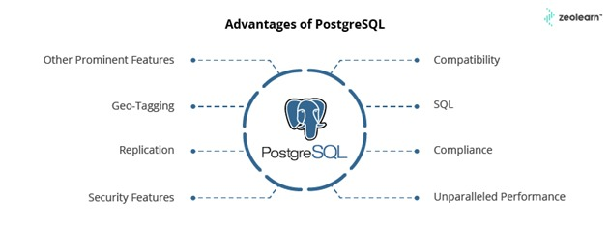

Fig 3.1: Advantages of PostgreSQL

The origins of PostgreSQL date back to 1986 as part of the POSTGRES project at the University of California at Berkeley and has more than 35 years of active development on the core platform. PostgreSQL has earned a strong reputation for its proven architecture, reliability, data integrity, robust feature set, extensibility, and the dedication of the open-source community behind the software to consistently deliver performant and innovative solutions. PostgreSQL runs on all major operating systems, has been ACID-compliant since 2001, and has powerful add-ons such as the popular PostGIS geospatial database extender. It is no surprise that PostgreSQL has become the open-source relational database of choice for many people and organisations. PostgreSQL has been proven to be highly scalable both in the sheer quantity of data it can manage and in the number of concurrent users it can accommodate. There are active PostgreSQL clusters in production environments that manage many terabytes of data, and specialized systems that manage petabytes.

Heroku:



Fig 3.7 HEROKU LOGO

Heroku is a cloud platform as a service (PaaS) supporting several programming languages. One of the first cloud platforms, Heroku has been in development since June 2007, when it supported only the Ruby programming language, but now supports Java, Node.js, Scala, Clojure, Python, PHP, and Go.[3] For this reason, Heroku is said to be a polyglot platform as it has features for a developer to build, run, and scale applications in a similar manner across most languages. Heroku was acquired by Salesforce in 2010 for $212 million. Heroku was initially developed by James Lindenbaum, Adam Wiggins, and Orion Henry for supporting projects that were compatible with the Ruby programming platform known as Rack. The prototype development took around six months. Later on, Heroku faced setbacks because of lack of proper market customers as many app developers used their own tools and environment.[citation needed] In January 2009, a new platform was launched which was built almost from scratch after a three-month effort. In October 2009, Byron Sebastian joined Heroku as CEO. On December 8, 2010, Salesforce.com acquired Heroku as a wholly owned subsidiary of Salesforce.com. On July 12, 2011, Yukihiro "Matz" Matsumoto, the chief designer of the Ruby programming language, joined the company as Chief Architect, Ruby. That same month, Heroku added support for Node.js and Clojure. On September 15, 2011, Heroku and Facebook introduced Heroku for Facebook.[10] At present Heroku supports Redis databases in addition to its standard PostgreSQL.

Railway:



Fig 3.8 RAILWAY LOGO

Railway is a deployment platform where you can provision infrastructure, develop with that infrastructure locally, and then deploy to the cloud. Railway is suited for a variety of use-cases. This page will walk-through what the platform is perfect for today and our recommendations for apps of all sizes. Railway is a deployment platform that helps developers deliver their software through the entire application life-cycle through git native tooling, composable infrastructure, and built in instrumentation. We design and develop our product features to serve what we consider to be the three primary stages of software development:

Development

Deployment

Diagnosis

Railway believes that most developer-oriented products attempt to target one or more stages within the software development cycle. Railway provides solutions for developers for all of these stages, whereas some vendors focus on specific stages.

Railway is a company staffed with people who know that developers would prefer to use tools that they are familiar with. We believe software should be take what you need, and leave what you don't. As a result, we are comfortable recommending additional vendors if we feel their needs might be acutely met by them. Our goal is for your unique need to be served, so you can focus on delivering for your customers.

Cloudflare:



Fig 3.9 CLOUDFLARE LOGO

Cloudflare, Inc. is an American content delivery network and DDoS mitigation company, founded in 2010. It primarily acts as a reverse proxy between a website's visitor and the Cloudflare customer's hosting provider. Its headquarters are in San Francisco, California. According to The Hill, it is used by more than 20 percent of the entire Internet for its web security services.

Visual Studio Code:



Fig 3.10 VS CODE LOGO

Visual Studio Code, also commonly referred to as VS Code,[9] is a source-code editor made by Microsoft with the Electron Framework, for Windows, Linux and macOS. Features include support for debugging, syntax highlighting, intelligent code completion, snippets, code refactoring, and embedded Git. Users can change the theme, keyboard shortcuts, preferences, and install extensions that add additional functionality. Visual Studio Code is a source-code editor that can be used with a variety of programming languages, including Java, JavaScript, Go, Node.js, Python, C++, C, Rust and Fortran. It is based on the Electron framework, which is used to develop web applications that run on the Blink layout engine. Visual Studio Code employs the same editor component (codenamed "Monaco") used in Azure DevOps (formerly called Visual Studio Online and Visual Studio Team Services).

Figma – UI/UX Designing Tool:



Fig 3.11 FIGMA LOGO

Figma is a vector graphics editor and prototyping tool which is primarily web-based graphics editing and user interface designing. You can use it to do all kinds of graphic design work from wireframing websites, designing mobile app interfaces, prototyping designs, crafting social media posts, and everything in between. It focuses on User Interface and User Experience with an emphasis on real-time collaboration. Figma is different from other graphics editing tools. Mainly because it works directly on your browser. This means you get to access your projects and start designing from any computer or platform without having to buy multiple licenses or install software.

Git and GitHub:

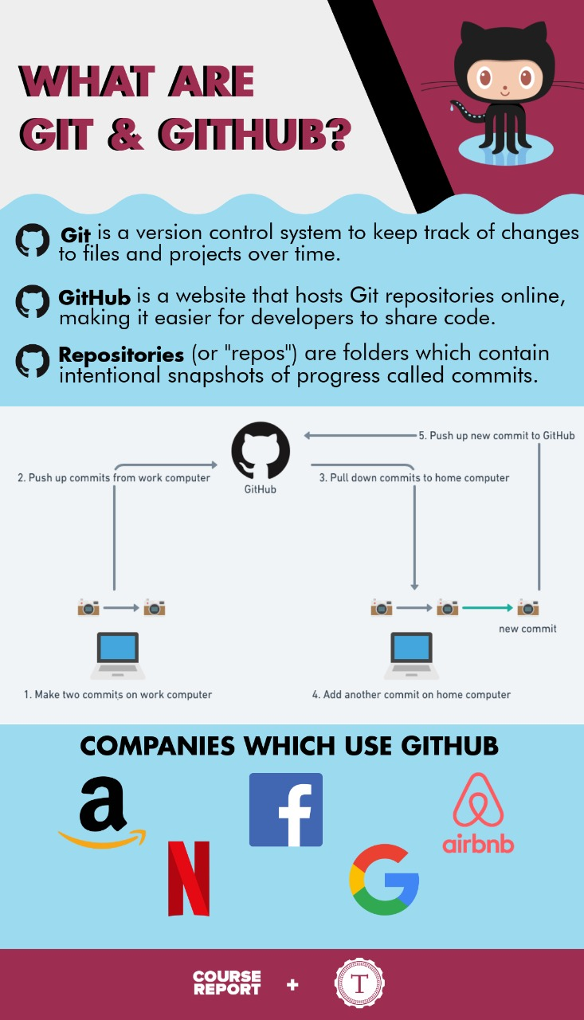

Git is an open-source, version control tool created in 2005 by developers working on the Linux operating system; GitHub is a company founded in 2008 that makes tools which integrate with git. You do not need GitHub to use git, but you cannot use GitHub without using git.

Star UML:

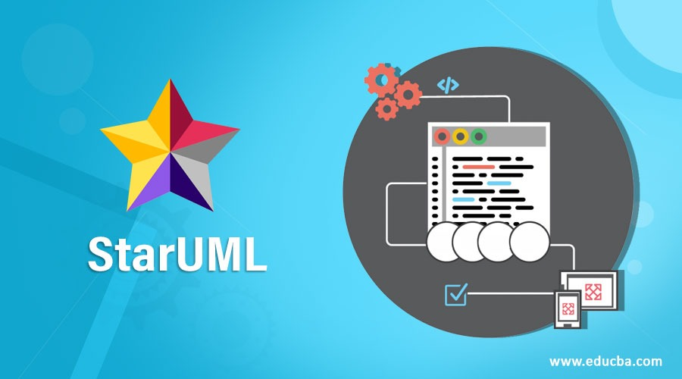

Fig 3.12 STAR UML LOGO

StarUML is a software engineering tool for system modeling using the Unified Modeling Language, as well as Systems Modeling Language, and classical modeling notations. It is published by MKLabs and is available on Windows, Linux and MacOS. StarUML is the successor of an object-oriented modelling software called Plastic. Plastic 1.0 was published in 1997 to support the OMT notation. The version 1.1 published in 1998 dropped the OMT to support in favor of UML. The last version under this brand was called Agora Plastic 2005 and was published by the Korean company Plastic Software Inc, Seoul. It was an internationalized product, compliant with UML 1.4,and claiming to support the Object Management Group's MDA approach.

AWS S3 BUCKET (Free Tier):



Fig 3.13 AWS LOGO

Amazon S3 (Simple Storage Service) provides object storage, which is built for storing and recovering any amount of information or data from anywhere over the internet. It provides this storage through a web services interface. While designed for developers for easier web-scale computing, it provides 99.999999999 percent durability and 99.99 percent availability of objects. It can also store computer files up to 5 terabytes in size.

Some of the benefits of AWS S3 are:

Durability: S3 provides 99.999999999 percent durability.

Low cost: S3 lets you store data in a range of “storage classes.” These classes are based on the frequency and immediacy you require in accessing files.

Scalability: S3 charges you only for what resources you actually use, and there are no hidden fees or overage charges. You can scale your storage resources to easily meet your organization’s ever-changing demands.

Availability: S3 offers 99.99 percent availability of objects

Security: S3 offers an impressive range of access management tools and encryption features that provide top-notch security.

Flexibility: S3 is ideal for a wide range of uses like data storage, data backup, software delivery, data archiving, disaster recovery, website hosting, mobile applications, IoT devices, and much more.

Simple data transfer: You don’t have to be an IT genius to execute data transfers on S3. The service revolves around simplicity and ease of use.

These are compelling reasons to sign up for S3. Now, let’s move on and have a look at some of the major components of the AWS S3 storage service.

Modules:

Django MVT:

The MVT (Model View Template) is a software design pattern. It is a collection of three important components Model View and Template. The Model helps to handle database. It is a data access layer which handles the data. The Template is a presentation layer which handles User Interface part completely. The View is used to execute the business logic and interact with a model to carry data and renders a template. Although Django follows MVC pattern but maintains its own conventions. So, control is handled by the framework itself. There is no separate controller and complete application is based on Model View and Template. That’s why it is called MVT application.

Django ORM:

Django lets us interact with its database models, i.e., add, delete, modify and query objects, using a database-abstraction API called ORM (Object Relational Mapper). This article discusses all the useful operations we can perform using Django ORM.

Django Import/Export:

The “django-import-export” is a Django application and library for importing and exporting data with included admin integration.

Features:

Support multiple formats (Excel, CSV, JSON) and everything else that tablib supports)

Admin integration for importing

Preview import changes

Admin integration for exporting

Export data respecting admin filters

Sending mail:

Although Python provides a mail sending interface via the smtplib module, Django provides a couple of light wrappers over it. These wrappers are provided to make sending email extra quick, to help test email sending during development, and to provide support for platforms that can’t use SMTP. The code lives in the django.core.mail module.

Psycopg:

Psycopg is the most popular PostgreSQL database adapter for the Python programming language. Its main features are the complete implementation of the Python DB API 2.0 specification and the thread safety (several threads can share the same connection). It was designed for heavily multi-threaded applications that create and destroy lots of cursors and make a large number of concurrent INSERTs or UPDATEs. Psycopg 2 is mostly implemented in C as a libpq wrapper, resulting in being both efficient and secure. It features client-side and server-side cursors, asynchronous communication and notifications, COPY support. Many Python types are supported out-of-the-box and adapted to matching PostgreSQL data types; adaptation can be extended and customized thanks to a flexible objects adaptation system. Psycopg 2 is both Unicode and Python 3 friendly.

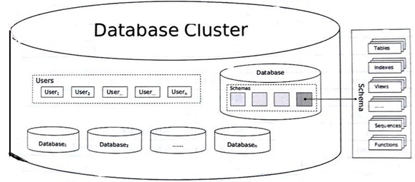

Fig 3.14 DATABASE STRUCTURE OF THE PROJECT

CHAPTER 4

DESCRIPTION OF PROPOSED SYSTEM

In recent years, department used to collect the details of the student’s project details manually, to make it automatic, this portal is used. The Student Project and Guide Registration System is a web-based portal. It can be used by educational institutes or colleges to maintain the projects of students easily. This Portal allows online submission of student Project details and selection of the guide. Achieving this objective is difficult using a manual system as the information is scattered, can be redundant and collecting relevant information may be very time consuming. This Portal will store the details of the students such as student details, Project details, guide selected, guide details. And using this portal, the details can be retrieved easily. In the backend, the data can be retrieved in the form of excel, containing the details of the students and the projects. Students need to create an account before registering. For creating an account, they need to verify their email id. To verify their email id, an OTP is generated, and the OTP is sent to the respective email id. After verifying, they need to login, and select the size of the team, one or two. If two is selected, they need to enter the second team member email id, and verify the email id, same as the first team member verification. Then it will be redirected to the form in which, it contains the project details and team member details. If the team size is one, then it will only contain the form for single member team. If two, then it will have details for two-member form. The form consists of project title, project domain and project description, for student, the form contains Name, email, Registration Number, Mobile Number. After submitting, it will be redirected to the guide page. In this guide page, it consists of professors available to do the project under them. The page consists of the Serial Number, Supervisors details such as Name, position and email id, Specialization of the professor, Guide vacancy, and a select button which will select the guide. After selecting the guide, the web page will be re directed to the confirmation page, which will showcase the all the details, which were filled. After submitting the confirmation page, the details are stored in the backend and can be retrieved any time.
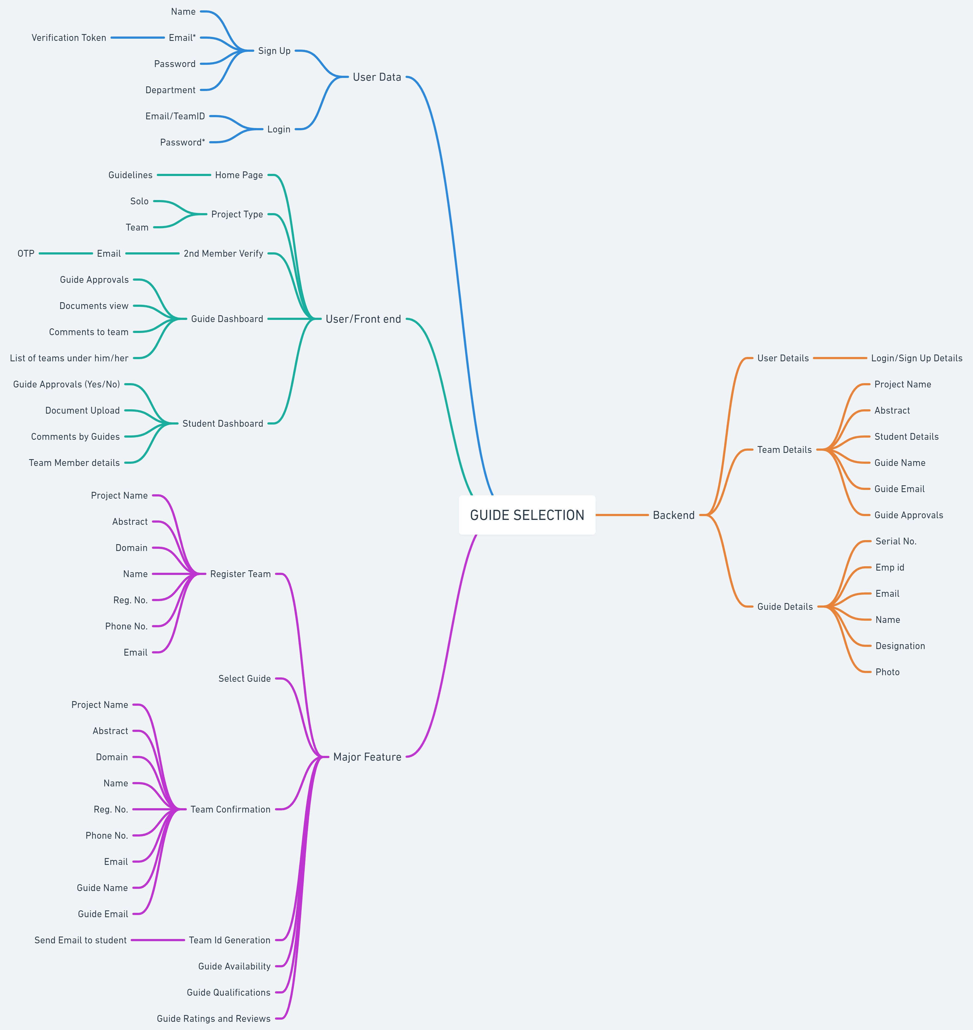

Fig 4.1: Ideation Map for the Project Management and Maintenance

4.1 SELECTED METHODOLOGY OR PROCESS MODEL

Software Development Life Cycle is the application of standard business practices to building software applications. It is typically divided into six to eight steps: Planning, Requirements, Design, Build, Document, Test, Deploy, Maintain. Some project managers will combine, split, or omit steps, depending on the project’s scope. These are the core components recommended for all software development projects. SDLC is a way to measure and improve the development process. It allows a fine-grain analysis of each step of the process. This, in turn, helps companies maximize efficiency at each stage. As computing power increases, it places a higher demand on software and developers. Companies must reduce costs, deliver software faster, and meet or exceed their customers’ needs. SDLC helps achieve these goals by identifying inefficiencies and higher costs and fixing them to run smoothly.

1. Planning
In the Planning phase, project leaders evaluate the terms of the project. This includes calculating labour and material costs, creating a timetable with target goals, and creating the project’s teams and leadership structure. Planning can also include feedback from stakeholders. Stakeholders are anyone who stands to benefit from the application. Try to get feedback from potential customers, developers, subject matter experts, and sales reps. Planning should clearly define the scope and purpose of the application. It plots the course and provisions the team to effectively create the software. It also sets boundaries to help keep the project from expanding or shifting from its original purpose.

2. Define Requirements
Defining requirements is considered part of planning to determine what the application is supposed to do and its requirements. For example, a social media application would require the ability to connect with a friend. An inventory program might require a search feature. Requirements also include defining the resources needed to build the project. For example, a team might develop software to control a custom manufacturing machine. The machine is a requirement in the process.

3. Design and Prototyping
The Design phase models the way a software application will work. Some aspects of the design include:

Architecture – Specifies programming language, industry practices, overall design, and use of any templates or boilerplate
User Interface – Defines the ways customers interact with the software, and how the software responds to input
Platforms – Defines the platforms on which the software will run, such as Apple, Android, Windows version, Linux, or even gaming consoles
Programming – Not just the programming language, but including methods of solving problems and performing tasks in the application
Communications – Defines the methods that the application can communicate with other assets, such as a central server or other instances of the application
Security – Defines the measures taken to secure the application, and may include SSL traffic encryption, password protection, and secure storage of user credentials

Prototyping can be a part of the Design phase. A prototype is like one of the early versions of software in the Iterative software development model. It demonstrates a basic idea of how the application looks and works. This “hands-on” design can be shown to stakeholders. Use feedback o improve the application. It’s less expensive to change the Prototype phase than to rewrite code to make a change in the Development phase.

4. Software Development
This is the actual writing of the program. A small project might be written by a single developer, while a large project might be broken up and worked by several teams. Use an Access Control or Source Code Management application in this phase. These systems help developers track changes to the code. They also help ensure compatibility between different team projects and to make sure target goals are being met. The coding process includes many other tasks. Many developers need to brush up on skills or work as a team. Finding and fixing errors and glitches is critical. Tasks often hold up the development process, such as waiting for test results or compiling code so an application can run. SDLC can anticipate these delays so that developers can be tasked with other duties. Software developers appreciate instructions and explanations. Documentation can be a formal process, including wiring a user guide for the application. It can also be informal, like comments in the source code that explain why a developer used a certain procedure. Even companies that strive to create software that’s easy and intuitive benefit from the documentation.

5. Testing
It’s critical to test an application before making it available to users. Much of the testing can be automated, like security testing. Other testing can only be done in a specific environment – consider creating a simulated production environment for complex deployments. Testing should ensure that each function works correctly. Different parts of the application should also be tested to work seamlessly together—performance test, to reduce any hangs or lags in processing. The testing phase helps reduce the number of bugs and glitches that users encounter. This leads to a higher user satisfaction and a better usage rate.

6. Deployment
In the deployment phase, the application is made available to users. Many companies prefer to automate the deployment phase. This can be as simple as a payment portal and download link on the company website. It could also be downloading an application on a smartphone.

Deployment can also be complex. Upgrading a company-wide database to a newly-developed application is one example. Because there are several other systems used by the database, integrating the upgrade can take more time and effort.

7. Operations and Maintenance
At this point, the development cycle is almost finished. The application is done and being used in the field. The Operation and Maintenance phase is still important, though. In this phase, users discover bugs that weren’t found during testing. These errors need to be resolved, which can spawn new development cycles. In addition to bug fixes, models like Iterative development plan additional features in future releases. For each new release, a new Development Cycle can be launched.

For phase-2 we have added a dashboard for both the guides and the teams. They both will have separate dashboard. For guide the dashboard will contain the teams registered under him/her and when they visit the team profile, they can choose whether to approve the team’s profile or not, to approve the documents they have upload or not and the guide can also give comments to any teams and will be displayed to the team when they log-in to their portal.

For teams, they cannot add any comment as well as not change the approval status given by the guide that privilege lies only with the guide and/or super admin user. Both team and the guide have the privilege to edit the project and student details (except number of team members) of their particular team and the same can be changed or removed by the guide if found to be inaccurate.

We also have added the announcements and news page which is separate for guides and students. So, that if any information needs to shared can be shared their and visited there. This also makes sure that manual announcements of the project phases are reduced and communication gap can be reduced drastically.

4.2 ARCHITECTURE / OVERALL DESIGN OF PROPOSED SYSTEM

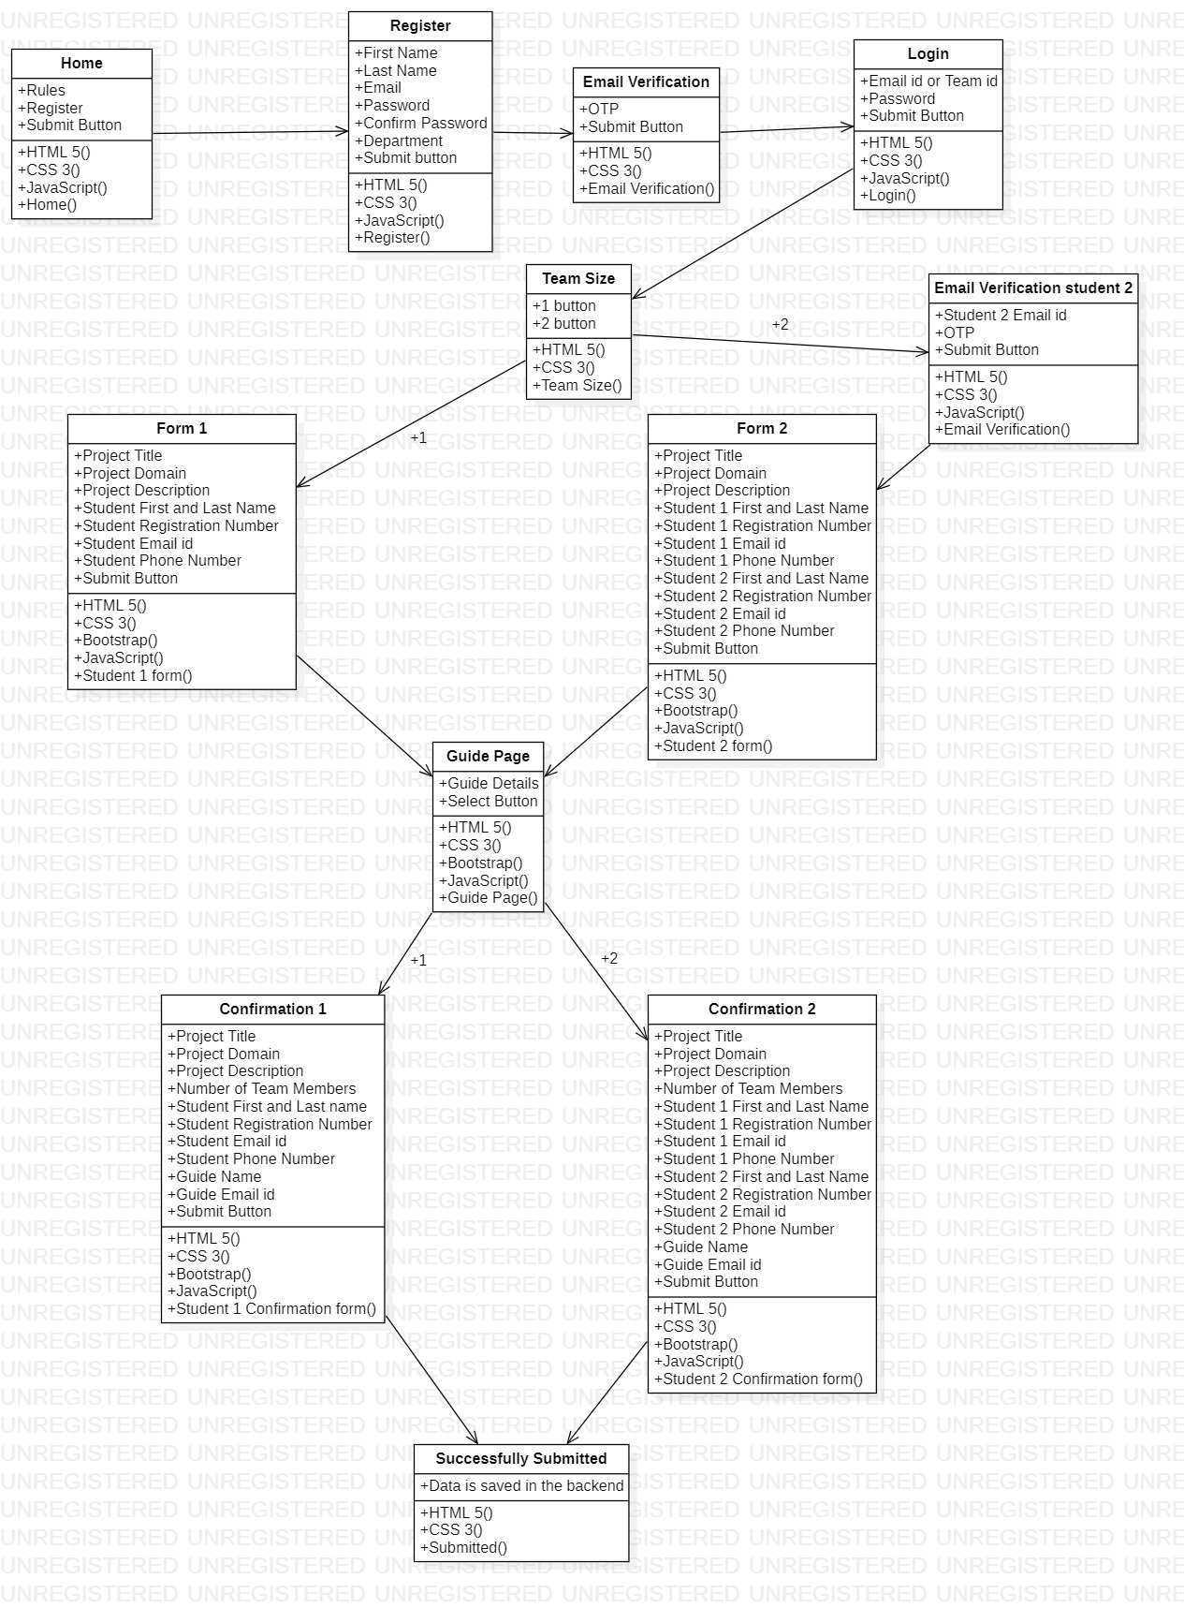
Fig 4.2: OVERALL DESIGN OF PROPOSED SYSTEM

The architecture of the whole project is given in above figure (Fig 4.3) the architecture diagram mentions the whole process involved between a user and the server to add, update his/her team and also tells the process the guide has to take while approving his/her teams.

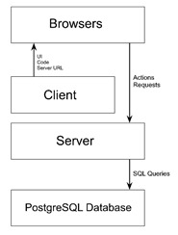

Fig 4.2: SYSTEM ARCHITECTURE FOR PROJECT MANAGEMENT AND MAINTENANCE

The block diagram of the working system has been shown in the above figure. The Portal stores the students’ details and the project which they are going to do in the final year. The portal collects the data such as Project Title, Project Domain, Project Description, Student details such as Name, Registration Number, Email id, Phone Number. This data is being collected from all the students, and it can be retrieved in multiple formats such as csv(comma-separated values), xls(Microsoft Excel Spreadsheet), xlsx(Microsoft Excel Open XML), tsv(tab-separated values), ods(Open Document Spreadsheet), json(JavaScript Object Notation), yaml(Yet Another Markup Language) and html(Hyper Text Markup Language).
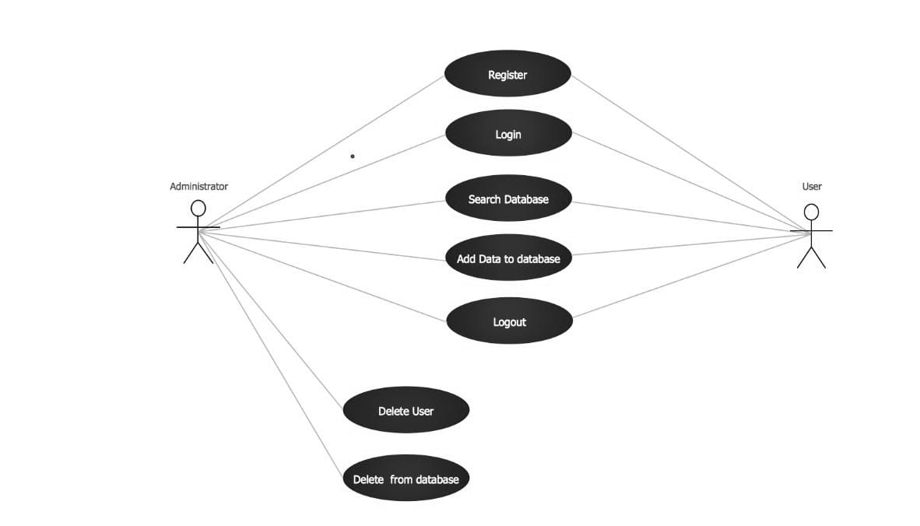
Fig 4.4: PROCESS DIAGRAM

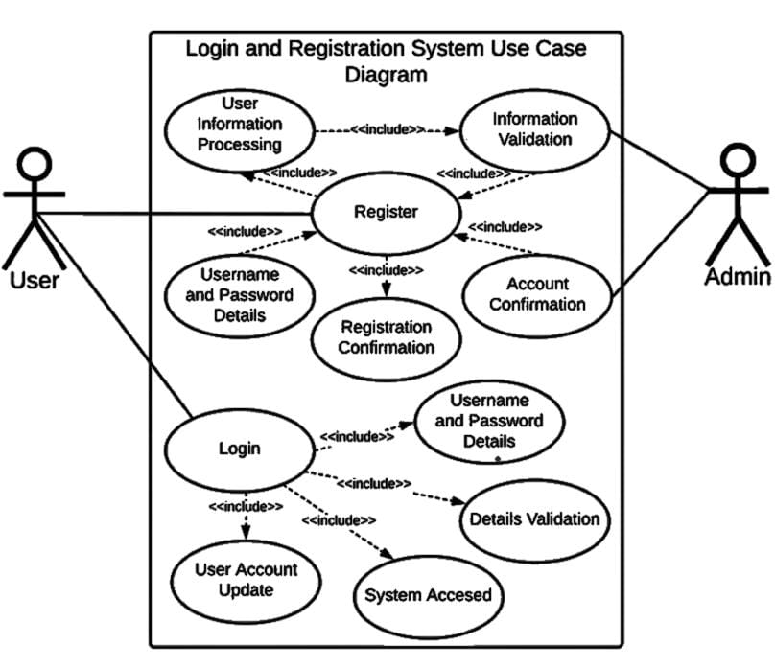

Fig 4.5 LOGIN AND REGISTRATION USE-CASE

4.3 DESCRIPTION OF SOFTWARE FOR IMPLEMENTATION AND TESTING PLAN OF THE PROPOSED MODEL/SYSTEM
Software implementation is important because it allows us to access the latest technology. By replacing old applications with new software, it helps in increasing their productivity and produce higher quality work.
A software implementation plan helps the institution find and deploy the right software for your needs. Adopting new software is both time-consuming and can be costly in terms of finances and human resources. Without a plan in place before the process starts, it's likely your software adoption will fail.
Software testing is the act of examining the artifacts and the behaviour of the software under test by validation and verification. Software testing can also provide an objective, independent view of the software to allow the business to appreciate and understand the risks of software implementation. Test techniques include, but not necessarily limited to:
- analysing the product requirements for completeness and correctness in various contexts like industry perspective, business perspective, feasibility and viability of implementation, usability, performance, security, infrastructure considerations, etc.
- reviewing the product architecture and the overall design of the product
- working with product developers on improvement in coding techniques, design patterns, tests that can be written as part of code based on various techniques like boundary conditions, etc.
- executing a program or application with the intent of examining behaviour.
- reviewing the deployment infrastructure and associated scripts and automation
- take part in production activities by using monitoring and observability techniques

Software testing can provide objective, independent information about the quality of software and risk of its failure to users or sponsors.

- Acceptance testing: Verifying whether the whole system works as intended.
- Integration testing: Ensuring that software components or functions operate together.
- Functional testing: Checking functions by emulating scenarios, based on functional requirements.
- Black-box testing is a common way to verify functions.
- Performance testing: Testing how the software performs under different workloads. Load testing.
- Regression testing: Checking whether new features break or degrade functionality. It can be used to verify menus, functions, and commands at the surface level, when there is no time for a full regression test.
- Stress testing: Testing how much strain the system can take before it fails.
- Usability testing: Validating how well a customer can use a system or web application to complete a task.

Testing for this system was extensively performed for a few weeks from the development plan inside the university campus with the help of our juniors. The testing phase was broken into 3 phases.
phases:
1.Network Traffic and Load handling test
2. Pen Test, security, and strength test
3.site speed, UI, and functionalities test.

All these tests were performed and bugs were fixed on regular basis to make sure the site runs smoothly without errors. The site has also gone through cyber-attacks like DDOS to check the strength and security of the site.

Testing can be used to correct:
- Architectural flaws
- Poor design decisions
- Invalid or incorrect functionality
- Security vulnerabilities
- Scalability issues

4.4 PROJECT MANAGEMENT PLAN

The project registration and guide selection are a module for the final year and it is deployed in Heroku. The project registration and guide selection are a module for the final year and it is deployed in Heroku. This module helps in maintaining the projects done by the final and pre-final year students with ease. This makes the job much easier for both the department and students. We are planning to implement a cloud storage to collect all the project documents, ppt and course/internship certifications. This project is used by the department to collect the student details, project details, guide details and to check and review the ppt and documentation. The staffs can also give the comments, suggestions and remarks on the project and the students can review it and can work in it.

4.5 FINANCIAL REPORT ON ESTIMATED COSTING

As our project is built inhouse using the students as developers. The cost spent for this project will be less compared to buying a system outside. We have carefully planned and analyzed the amount of money required to spend in order to complete the project, setup and make it run successfully. Spendings required for:
1. To buying a domain for our site from Go daddy for hosting and masking it with a decent domain name.
2. We have also requested for a special system with good configuration to host it free of cost (or) spend some money to re-host the site with better server configuration on either Heroku or Railway.
3. We have also requested for a cloud network with descent amount of storage to store all the documents, ppt, and certifications collected from the students for the reviews.
4. The SSL certificate we are using in the site is of free of cost and if required we would request for a better paid SSL key in order for our site to work securely on https.

Table 4.1 Estimation of the Project Cost Funded

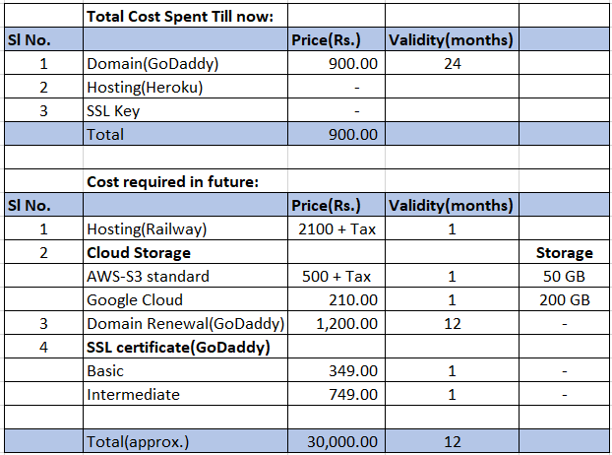

CHAPTER 5

IMPLEMENTATION DETAILS

DEVELOPMENT SETUP

Like anyother projects we also have some development and deployment setup to be made.

Development setup:

Create a virtual environment to install all the required liberaries using this command:-

python -m venv <name_of_environment>

where,

<name_of_the_environment> is the name you want to give to the environment

To install the liberaries while developing:-

pip install <name_of_the_liberary>

where, <name_of_liberary> is the name of the liberary you want to install

If cloning the project from github and setting up development setup

git clone https://github.com/PrideCell/guide-backend.git

pip install -r requirements.txt

To start the local server:

python manage.py runserver (run it in root directory)

DEPLOYMENT SETUP

The following are the major security checks we need to do before making it deployment ready:

Make DEBUG = False in settings.py

Create a Procfile with the following contents

web: python manage.py migrate && python manage.py collectstatic --noinput && gunicorn <name_of_the_project>.wsgi --timeout 0

where, the –timeout parameter is to make sure that “Connection Time Out doesn’t occur”.

Push all your changes to github’s master branch and create an account in railway and also create a django project in the account dashboard

Create a database (postgresql in our case) and copy the details of the postgresql root user.

Change the database URL in your settings.py file to point to railway’s postgresql databse.

Push the changes to github repositories master branch

Connect your Django project created in railway to the github repository to make sure every pushes to master get deployed automatically to railway.

Once the logs says deployed, the site is ready to be used globally!

5.3 TESTING
It’s critical to test an application before making it available to users. Much of the testing can be automated, like security testing. Other testing can only be done in a specific environment – consider creating a simulated production environment for complex deployments. Testing should ensure that each function works correctly. Different parts of the application should also be tested to work seamlessly together—performance test, to reduce any hangs or lags in processing.
Software testing can provide objective, independent information about the quality of software and risk of its failure to users or sponsors.

- Acceptance testing: Verifying whether the whole system works as intended.
- Integration testing: Ensuring that software components or functions operate together.
- Functional testing: Checking functions by emulating scenarios, based on functional requirements.
- Black-box testing is a common way to verify functions.
- Performance testing: Testing how the software performs under different workloads. Load testing.
- Regression testing: Checking whether new features break or degrade functionality. It can be used to verify menus, functions, and commands at the surface level, when there is no time for a full regression test.
CHAPTER 6
RESULTS AND DISCUSSION

The implementation of effective project management and maintenance practices in web development projects yielded several positive results. These results include:
- Improved project organization: Through the use of project management techniques such as defining clear objectives, creating realistic timelines, and assigning roles and responsibilities, the projects were better organized and coordinated. This led to a smoother workflow, minimized delays, and improved overall project efficiency.
- Enhanced communication and collaboration: Effective project management facilitated improved communication and collaboration among team members and Department. Regular progress updates, meetings, and documentation helped ensure everyone was on the same page and aligned towards project goals. This led to better teamwork, reduced misunderstandings, and enhanced overall project coordination.
- Timely project delivery: Proper project management practices, such as setting realistic timelines, managing risks, and monitoring progress, helped ensure that the web development projects were completed on time. This resulted in timely delivery of the projects, meeting the deadlines and requirements set by the department.
- Higher quality outcomes: Effective project management allowed for better quality control measures, such as testing, reviewing, and refining project deliverables. This helped identify and address issues and errors early in the project lifecycle, resulting in higher quality outcomes that met the intended requirements and user needs.

The results of implementing project management and maintenance practices in web development projects are significant and can greatly impact the success of the projects. The improved project organization, communication, and collaboration resulted in more efficient project execution, reduced delays, and minimized risks. This allowed the projects to be delivered on time and met the desired quality standards.

Effective project management also enabled better resource allocation, including human resources, time, and budget, which contributed to the successful completion of the projects. Additionally, proper maintenance practices ensured that the web applications remained functional, secure, and up-to-date, enhancing their long-term sustainability.

However, challenges may arise in implementing project management and maintenance practices, such as resistance to change, lack of resources or expertise, and external constraints. It may require effort and commitment from the project team to adopt and implement these practices effectively.

In conclusion, the implementation of effective project management and maintenance practices in web development projects has resulted in improved project organization, communication, timely delivery, and higher quality outcomes. These practices are crucial for successful web development projects and should be considered as essential components of any web development endeavor.

CHAPTER 7

CONCLUSION

7.1 CONCLUSION

In conclusion, project management and maintenance are critical components of web development projects that significantly impact their success. Proper project management ensures efficient project execution, timely delivery, and improved collaboration among team members. Maintenance, on the other hand, ensures the continued performance, security, functionality, retriving of data of the students of the web application even after the project completion.

The implementation of effective project management practices, such as defining clear objectives, creating realistic timelines, managing risks, and fostering communication and collaboration, has shown to result in improved project outcomes, including better organization, timely delivery, and higher quality outcomes.

Additionally, maintenance practices, such as regular monitoring, testing, bug fixing, and updates, are essential for the long-term sustainability and success of web applications. By consistently maintaining and improving the web application, it remains functional, secure, and aligned with evolving user requirements.

However, challenges may arise in implementing project management and maintenance practices, and addressing them may require effort, commitment, and resources. But the benefits of effective project management and maintenance practices outweigh the challenges, as they contribute to successful web development projects that meet student and guide needs, adhere to project goals, and ensure long-term sustainability.

In conclusion, incorporating sound project management and maintenance practices in web development projects is crucial for achieving successful outcomes, and web developers should prioritize these practices in their projects to maximize their chances of success.

7.2 FUTURE WORK

Future work for project management and maintenance in web development can involve several areas of improvement and innovation, including:

Implementation of predictive analytics: Predictive analytics involves using data and statistical algorithms to forecast future outcomes. Future work can involve implementing predictive analytics in project management and maintenance processes to better predict project risks, estimate resource needs, and optimize project schedules. This can result in more accurate project planning and resource allocation, leading to improved project outcomes.

Embracing emerging technologies: Web development is constantly evolving, and future work can involve exploring and adopting emerging technologies that can enhance project management and maintenance processes. For example, artificial intelligence (AI) and machine learning (ML) can be leveraged for automated testing, error detection, and performance optimization. Blockchain can be used for secure and transparent project management, and Internet of Things (IoT) can enable real-time monitoring and management of web applications.

Enhancing cybersecurity measures: With the increasing prevalence of cybersecurity threats, future work in project management and maintenance can involve strengthening cybersecurity measures. This can include implementing robust security protocols, regular security audits, and training team members on cybersecurity best practices. Proactive security measures can help protect web applications from potential security breaches and ensure their long-term sustainability.

Continuous improvement and feedback loops: Future work can also focus on establishing continuous improvement and feedback loops in project management and maintenance processes. Regular retrospectives, post-project evaluations, and feedback from stakeholders can provide insights and opportunities for further improvement in project management and maintenance practices. This can help identify areas of improvement and implement corrective actions to optimize project outcomes.

In conclusion, future work in project management and maintenance for web development can involve adopting, implementing predictive analytics, embracing emerging technologies, enhancing cybersecurity measures, and establishing continuous improvement and feedback loops. By staying updated with evolving industry trends and incorporating innovative practices, project management and maintenance in web development can be further improved to ensure successful project outcomes in the future.

7.3 RESEARCH ISSUES AND IMPLEMENTATION ISSUES:

While developing and getting the requirements ready we were not able to find any suitable software which provided similar functionality. This made us to decide and do everything as trial-and-error method.

So, we decided to make a basic prototype for the requirements laid down and were able to come up with a solution which was at-par in solving the problem which existed in the earlier system.

While implementing the main prototype we faced issues in sending the generated unique token through email as the Gmail service doesn’t allow automated mails to be sent which marks it as bot activity. We also faced issues with user spamming the verification emails and then we disabled the re-send by adding a time limit before requesting another email.

REFERENCES
- Shahnawaz Alam, 2019, August.
https://ieeexplore.ieee.org/document/8843768
- EcoSys Team., 2018, October.
https://www.ecosys.net/blog/project-selection-prioritization-guide/#:~:text=What%20Is%20Project%20Selection%3F,determine%20the%20order%20of%20execution
- Simililearn, 2022, August.
https://www.simplilearn.com/project-management-apps-article
- W3Schools, for dropdowns
https://www.w3schools.com/howto/howto_js_cascading_dropdown.asp
- 7 Steps for Software Implementation Success, by Santex Group
https://santexgroup.com/blog/7-steps-for-software-implementation-success/
- Django Security Vulnerabilities fix:
https://stackoverflow.com/questions/52405589/how-to-check-django-security-vulnerabilities-and-how-to-fix-them
- Django Documentation for logout upon closing the browser window:
https://docs.djangoproject.com/en/2.0/topics/http/sessions/#browser-length-sessions-vs-persistent-sessions

APPENDIX

SOURCE CODE

def project_details_1(request):
guides = Guide.objects.order_by('serial_no')
curr_user = request.user
if Team.objects.filter(teamID=curr_user.username).exists():
is_team = Team.objects.filter(teamID=curr_user.username).get()
guide_inst = Guide.objects.filter(serial_no=is_team.guide)
guide_inst.vacancy += 1
guide_inst.save()
is_team.delete()
is_user = User.objects.filter(username=is_team.teamID)
is_user.delete()
messages.info(
request, 'Your team is removed please to the process again!!')
return render(request, 'Register/register.html')
if request.method == 'POST':
project_name = request.POST['project_name']
project_domain = request.POST['project_domain']
project_description = request.POST['project_description']
reg_no_1 = request.POST['reg_no_1']
if len(reg_no_1) > 8:
messages.error(request, 'Register Number be 8 digits long.')
return redirect('project-details-1')
student_1_no = request.POST['student_1_no']
if len(student_1_no) > 10:
messages.error(request, 'Number must of 10 digits.')
return redirect('project-details-1')

student_1_name = curr_user.first_name + ' ' + curr_user.last_name
student_1_email = curr_user.email
user = User.objects.get(username=curr_user.username)
print("TYPE OF user.id: ", type(user.id))
if Temp_Team.objects.filter(student_1_email=curr_user.email).exists():
obj = Temp_Team.objects.filter(
student_1_email=curr_user.email).get()
obj.delete()
if Temp_Team.objects.filter(reg_no_1=reg_no_1).exists():
messages.error(
request, 'The Register Number already exists in another team.')
return redirect('project-details-1')
temp_team = Temp_Team.objects.create(
project_name=project_name,
project_domain=project_domain,
project_description=project_description,
no_of_members='1', reg_no_1=reg_no_1,
student_1_name=student_1_name,
student_1_email=student_1_email,
student_1_no=student_1_no
)
print('temp_team: ', temp_team.project_name)
temp_team.save()
context = {
'user': curr_user,
'guides': guides,
}
return render(request, 'GuideList/guide.html', context)
else:
context = {
'user': curr_user
}
return render(request, '1_project_form/1_project_form.html', context)
def project_details_2(request):
curr_user = request.user
guides = Guide.objects.order_by('serial_no')
student_2_email = Otp_Two.objects.filter(temp_email=curr_user.email).get()
if Team.objects.filter(teamID=curr_user.username).exists():
is_team = Team.objects.filter(teamID=curr_user.username).get()
is_team.delete()
is_user = User.objects.filter(username=is_team.teamID)
is_user.delete()
messages.info(
request, 'Your team is removed please to the process again!!')
return render(request, 'Login/login.html')
if request.method == 'POST':
project_name = request.POST['project_name']
project_domain = request.POST['project_domain']
project_description = request.POST['project_description']
reg_no_1 = request.POST['reg_no_1']
student_1_no = request.POST['student_1_no']
if len(reg_no_1) > 8:
messages.error(request, 'Register Number be 8 digits long.')
return redirect('project-details-1')
student_1_no = request.POST['student_1_no']
if len(student_1_no) > 10:
messages.error(request, 'Number must of 10 digits.')
return redirect('project-details-2')
student_1_name = curr_user.first_name + ' ' + curr_user.last_name
student_1_email = curr_user.email
first_name_2 = request.POST['first_name_2']
last_name_2 = request.POST['last_name_2']
reg_no_2 = request.POST['reg_no_2']
student_2_no = request.POST['student_2_no']
if len(reg_no_2) > 8:
messages.error(request, 'Register Number be 8 digits long.')
return redirect('project-details-2')
student_2_no = request.POST['student_2_no']
if len(student_2_no) > 10:
messages.error(request, 'Number must of 10 digits.')
return redirect('project-details-2')
student_2_name = first_name_2 + ' ' + last_name_2
user = User.objects.get(username=curr_user.username)
print("TYPE OF user.id: ", type(user.id))
if Team.objects.filter(reg_no_1=reg_no_1).exists():
messages.error(
request, '1st Register Number already exists in another team.')
return redirect('project-details-2')
elif Team.objects.filter(reg_no_2=reg_no_2).exists():
messages.error(
request, '2nd Register Number already exists in another team.')
return redirect('project-details-2')
if Team.objects.filter(student_1_no=student_1_no).exists():
messages.error(
request, '1st Phone Number already exists in another team.')
return redirect('project-details-2')
elif Team.objects.filter(student_2_no=student_2_no).exists():
messages.error(
request, '2nd Phone Number already exists in another team.')
return redirect('project-details-2')
if Temp_Team.objects.filter(student_1_email=curr_user.email).exists():
if Temp_Team.objects.filter(student_1_email=user.email).exists():
obj = Temp_Team.objects.filter( student_1_email=curr_user.email).get()
obj.delete()
temp_team = Temp_Team.objects.create(project_name=project_name, project_domain=project_domain, project_description=project_description, no_of_members='2', reg_no_1=reg_no_1, student_1_name=student_1_name, student_1_email=student_1_email, student_1_no=student_1_no, reg_no_2=reg_no_2, student_2_name=student_2_name, student_2_email=student_2_email.user_email, student_2_no=student_2_no)
temp_team.save()
context = {
'guides': guides,
}
return render(request, 'GuideList/guide.html', context)
else:
print('INSIDE GET REQUEST ELSE')
context = {
'email': student_2_email,
'user': curr_user,
}
return render(request, '2_project_form/2_project_form.html', context)

SCREENSHOTS

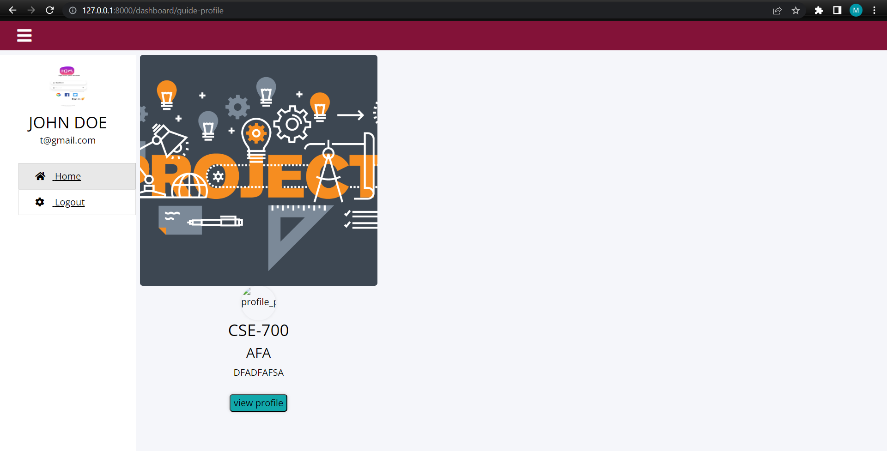

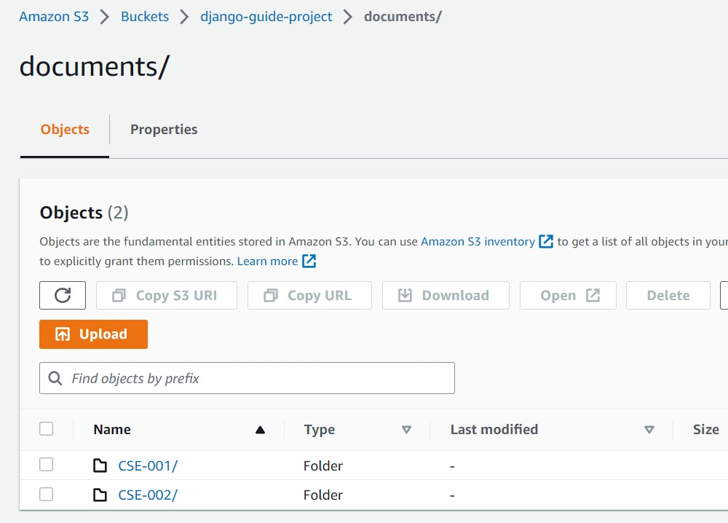

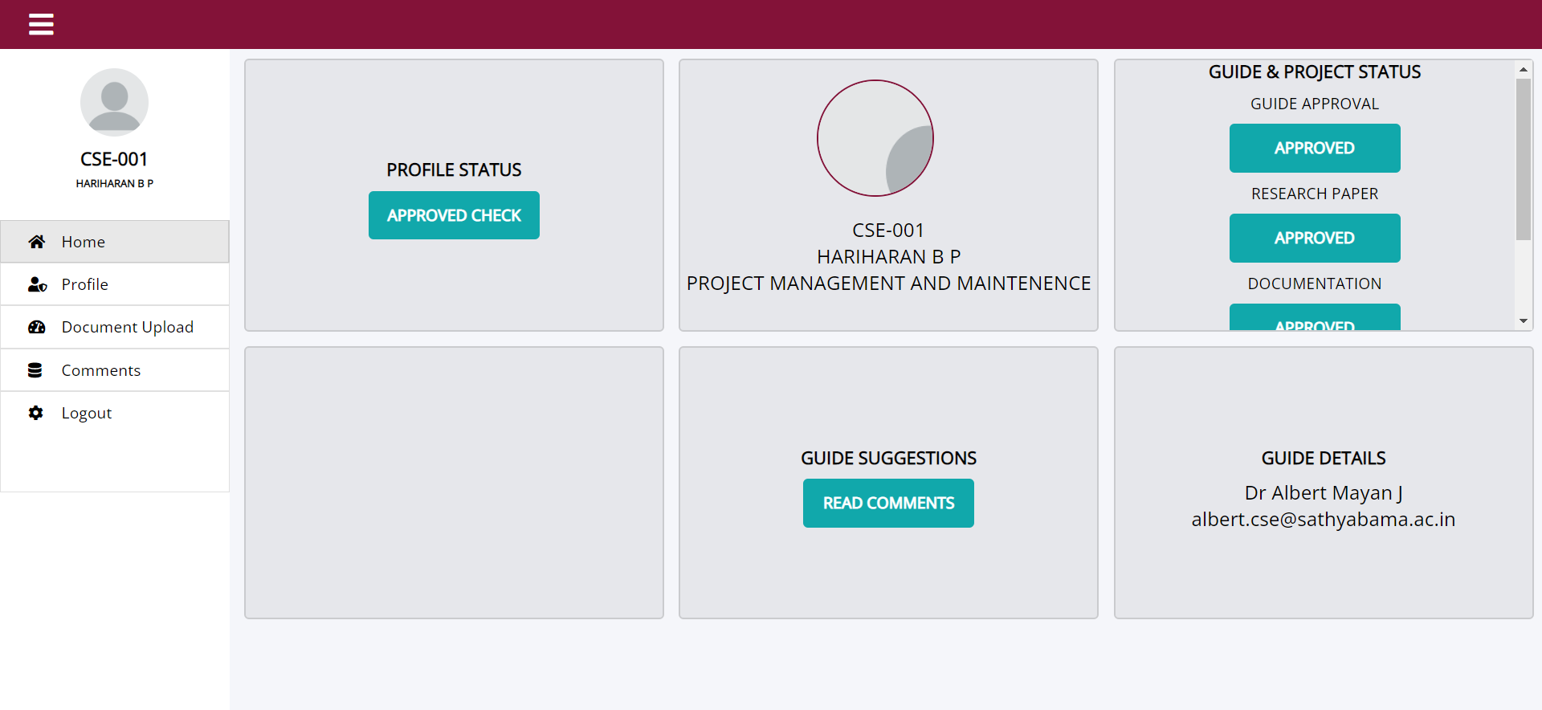

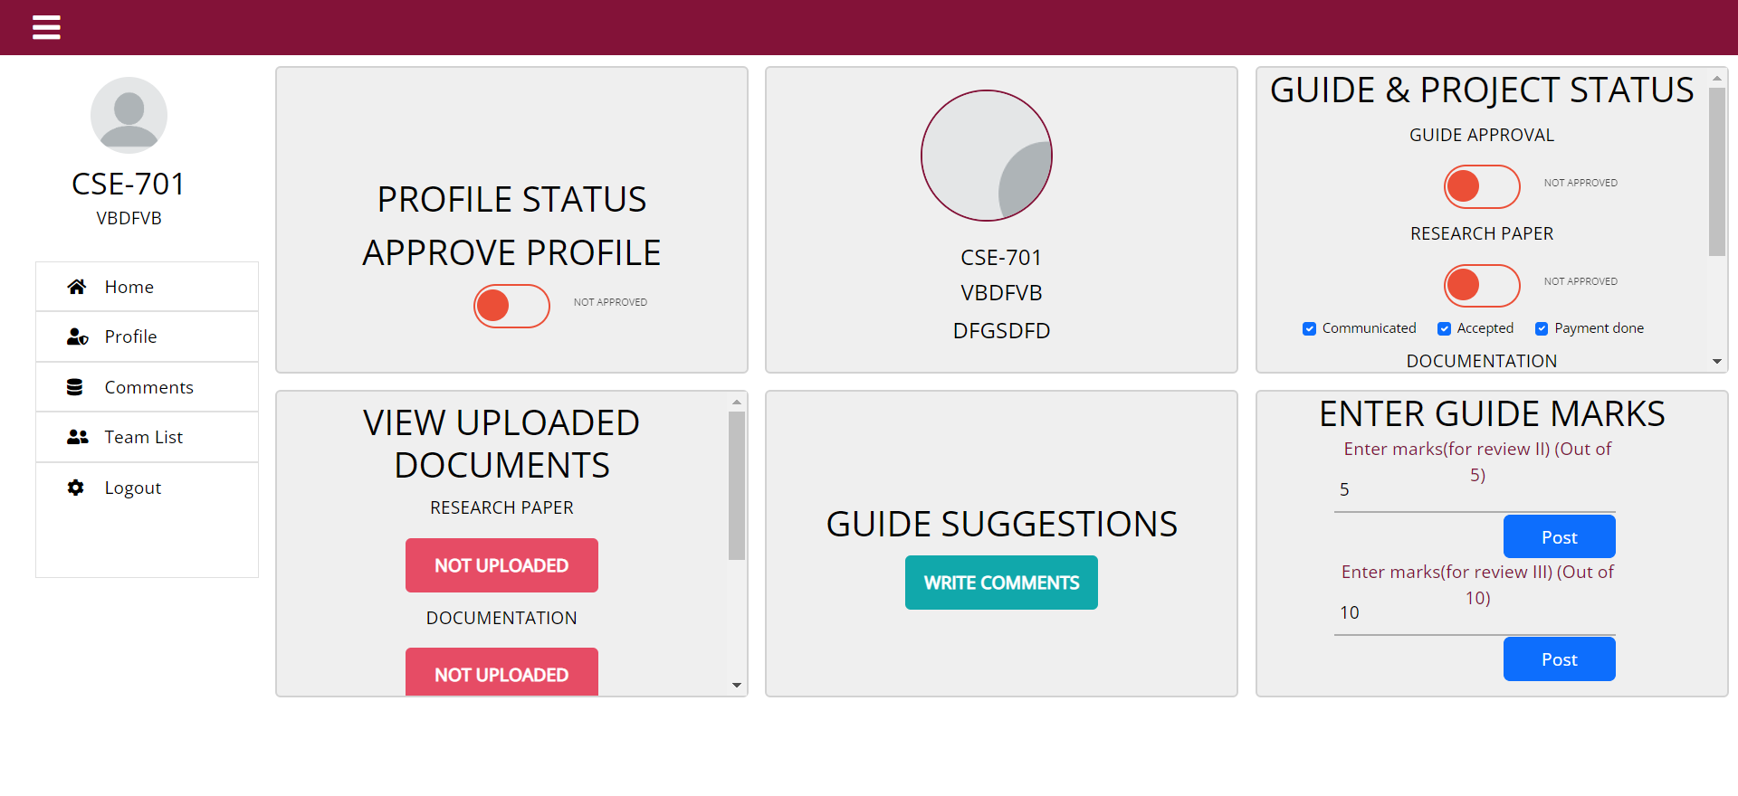

RESEARCH PAPER

