**ReadMe**

Research is based on calculating f1 score for fake news detection on performing cross dataset experiment.

Cross-Dataset is a term used when we perform training on a single dataset and test on other datasets.

SVM, LSTM, BERT, ALBERT are the models used to work on the dataset and see the difference in f1 score.

These folder contain a presentation and 3 folders: - Dataset, Code, Result.

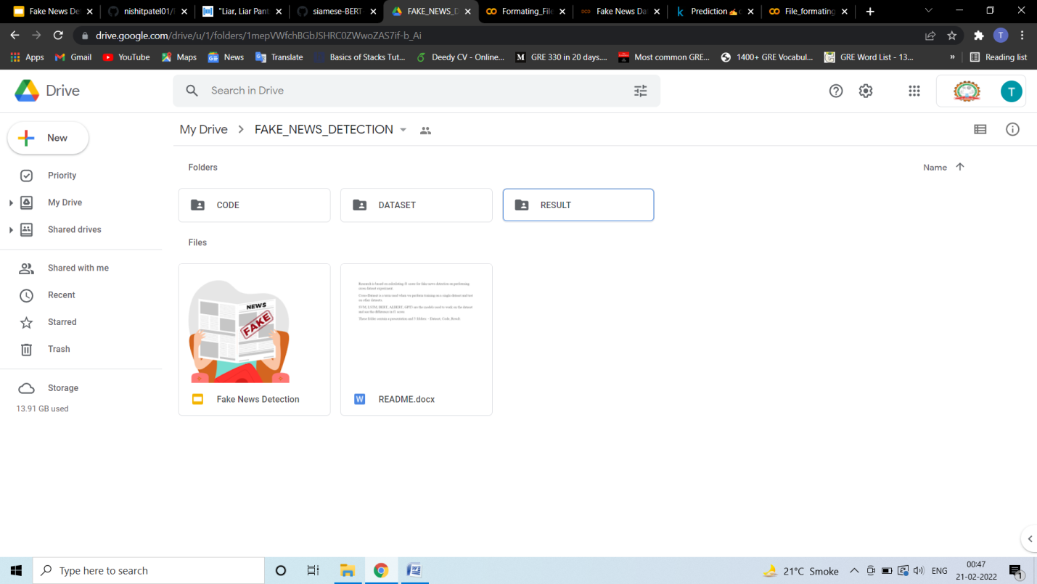

Presentation is brief of dataset, the code performed on dataset and result.

Dataset folder consist of data and readme which describes the source of dataset , formatting tweets or text and final csv file we are using for the code

Code folder consist of the code of formatting files, Models code (SVM, LSTM, BERT, ALBERT, GTP-3) and readme describing everything about code

Result folder consist of csv file of result of different Models.