
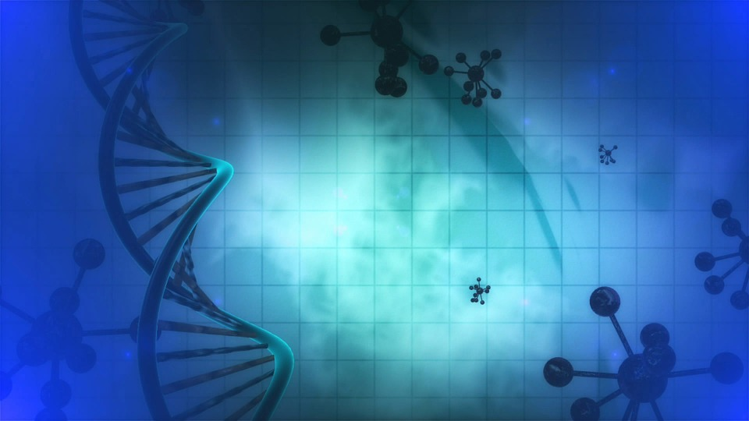
Tracker –
Project 8: DNA Status: 0=Not Started; 1=Started;
2=Learning; 3=Proficient; 4=Can Teach)
(Resources: A=Article read; V=Video watched)

Instructors: M = Minutes for this item; T = Total minutes

M / T | Goals / Choices Notes Status Resources Date
 | Goal 1: Learn about basic genetics and DNA research.
 | A. Get an introduction to genetics for family history.
 | B: Learn the basics of DNA research for family history.
 | Goal 2: Learn about DNA testing.
 | A: Learn the basics of DNA testing.
 | B: Learn about autosomal (recent ancestry) DNA testing.
 | C: Learn about mitochondrial (maternal line) DNA testing.
 | B: Learn about Y-DNA (paternal line) DNA testing.
 | Goal 3: Select and take a DNA test.
 | A: Learn the basics of choosing a DNA test.
 | B: Learn about DNA tests available through Ancestry.
 | C: Learn about 23andMe and DNA tests.
 | D: Learn about FamilyTreeDNA (FTDNA) and DNA tests.
 | Goal 4: Learn about DNA matching for your test results.
 | A. Learn the basics of DNA matching.
 | B. Learn about DNA matching with Ancestry.
 | C. Learn about using the GEDMatch database.
 | D. Get help with your DNA matching questions on Facebook.
 | Goal 5: Learn about your ethnicity and how to find family relationships.
 | A. Learn about ethnicity and matching.
 | B. Learn about DNA circles and finding cousins.
 | C: Find other possible family relationships through your DNA testing
 | D. Learn how to solve family history challenges with DNA results.
 | Goal 6: Learn about DNA research tools.
 | A: Learn about DNA research tools you can use for family history.
 | B: Get help with your DNA tool questions on Facebook.
 | Goal 7: Learn about adoption and DNA.
 | A: Get an introduction to DNA research for adoptees.
 | B: Learn more about adoption and DNA research.
 | C: Get help with your adoption and DNA questions on Facebook.
 | Goal 8: Get additional help with your DNA research questions.
 | A: Use Facebook pages and blog sites to get help.
 | B: Use message boards and forums to get help.

