
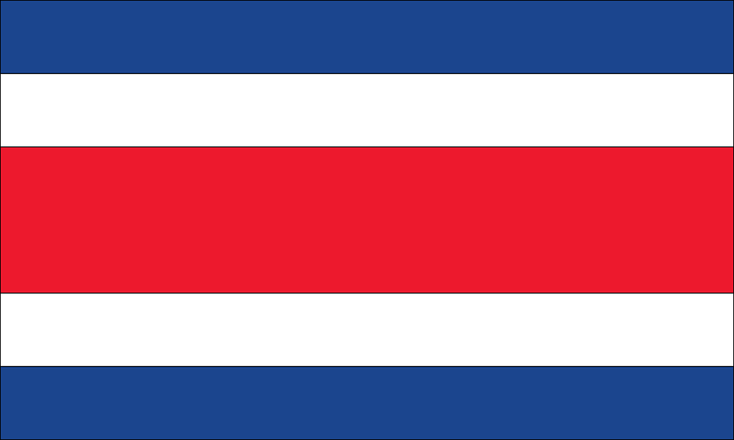
Tracker –
Project 4: Costa Rica Status: 1=Not Started; 2=Started;
3=Learning; 4=Proficient; 5=Can Teach)
(Resources: A=Article read; V=Video watched)

Goals / Choices Notes Status Resources Date
Goal 1: Learn about Costa Rican research.
A: Learn about Costa Rican genealogy.
Goal 2: Learn about Costa Rica civil registration.
A: Learn about Costa Rica civil registration.
Goal 3: Learn about Costa Rica archives and libraries.
A: Learn about Costa Rican archives and libraries.
Goal 4: Learn about Costa Rica maps.
A: Explore Costa Rica map resources.
Goal 5: Learn about Costa Rica newspapers.
A: Learn about Costa Rica newspapers.
Goal 6: Explore additional websites for Costa Rican research.
A: Explore additional websites.
Goal 7: Search records from Costa Rica.
A: Use the QUIKLinks in the left side.
B: Explore additional record collections.
Goal 8: Get help with your Costa Rica research.
A: Use Facebook pages to get answers to your questions.
B: Join a mailing list or message board for Costa Rica research.

