
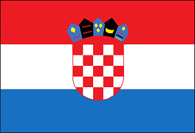
Tracker –
Project 4: Croatia Status: 1=Not Started; 2=Started;
3=Learning; 4=Proficient; 5=Can Teach)
(Resources: A=Article read; V=Video watched)

Goals / Choices Notes Status Resources Date
Goal 1: Learn about Croatian research.
A: Learn about Croatian genealogy.
B: Learn about Croatian language and genealogy terms.
Goal 2: Explore Croatia census records and civil registration.
A: Learn about Croatia census records.
B: Learn about Croatia civil registration.
Goal 3: Explore Croatia archives and libraries.
A: Learn about Croatian archives and libraries.
Goal 4: Learn about Croatia church records.
A: Learn about Croatia church records.
Goal 5: Learn about Croatia maps.
A: Explore Croatia map resources.
Goal 6: Learn about Croatia newspapers.
A: Learn about Croatia newspapers.
Goal 7: Explore additional websites for Croatian research.
A: Explore additional websites.
Goal 8: Search records from Croatia.
A: Use the QUIKLinks in the left side.
B: Explore additional record collections.
Goal 9: Get help with your Croatia research.
A: Use Facebook pages to get answers to your questions.
B: Join a mailing list or message board for Croatia research.
C: Learn about Croatia genealogy societies.

