
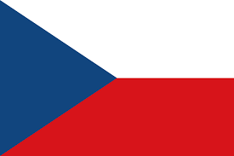
Tracker –
Project 4: Czech Republic Status: N=Not Started; S=Started;
L=Learning; P=Proficient; T=Can Teach)
(Resources: A=Article read; V=Video watched)

Goals / Choices Notes Status Resources Date
Goal 1: Expand your research in the Czech Republic.
A: Learn the basics of online Czech Republic research.
Goal 2: Learn about Czech Republic archives and libraries.
A: Learn about Czech Republic archives and libraries.
B: Explore Czech Republic archives and libraries.
Goal 3: Learn about the Czech Republic census.
A: Learn about using Czech Republic census records.
Goal 4: Learn about Czech Republic land and property.
A: Learn about Czech Republic land and property.
Goal 5: Learn about Czech Republic obituaries and cemeteries.
A: Learn about Czech Republic obituaries.
B: Explore Czech Republic gravestones.
Goal 6: Learn about Czech Republic church records.
A: Learn about Czech Republic church records in the FS Wiki article.
Goal 7: Learn about Czech Republic maps.
A: Learn about Czech Republic maps.
B: Explore Czech Republic maps.
Goal 8: Learn about Czech Republic newspapers.
A: Explore Czech Republic newspapers.
Goal 9: Explore additional Czech Republic websites.
A: Explore additional websites.
Goal 10: Search records from the Czech Republic.
A: Use the search links in the left side.
B: Explore additional record collections.
Goal 11: Get help with your Czech Republic research.
A: Use Facebook pages to get answers to your questions.
B: Join a mailing list or message board.
C: Learn about Czech Republic genealogy societies.

