
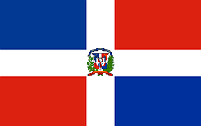
Tracker –
Project 4: Dominican Republic Status: 1=Not Started; 2=Started;
3=Learning; 4=Proficient; 5=Can Teach)
(Resources: A=Article read; V=Video watched)

Goals / Choices Notes Status Resources Date
Goal 1: Learn about Dominican Republic research.
A: Learn about Dominican genealogy.
Goal 2: Explore Dominican Republic civil registration.
B: Learn about Dominican Republic civil registration.
Goal 3: Learn about Dominican Republic maps.
A: Explore Dominican Republic map resources.
Goal 4: Learn about Dominican Republic newspapers.
A: Learn about Dominican Republic newspapers.
Goal 5: Explore additional websites for Dominican research.
A: Explore additional websites.
Goal 6: Search records from Dominican Republic.
A: Use the QUIKLinks in the left side.
B: Explore additional record collections.
Goal 7: Get help with your Dominican Republic research.
A: Use Facebook pages to get answers to your questions.

