
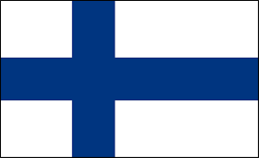
Tracker –
Project 4: Finland Status: N=Not Started; S=Started;
L=Learning; P=Proficient; T=Can Teach)
(Resources: A=Article read; V=Video watched)

Goals / Choices Notes Status Resources Date
Goal 1: Learn about research in Finland.
A: Get started with Finnish research.
B: Explore databases in the Genealogical Society of Finland site.
Goal 2: Explore Finland archives and libraries.
A: Learn about Finland archives and libraries.
Goal 3: Explore Finland census records.
A: Learn about Finland census records.
Goal 4: Learn about Finland church and cemetery records.
A: Learn about Finland church records.
B: Explore Finnish gravestones and cemetery records.
Goal 5: Learn about Finland emigration and immigration.
A: Learn about Finland emigration and immigration.
B: Explore Finland emigration and immigration.
Goal 6: Learn about Finland maps.
A: Learn about Finland maps.
B: Explore Finland maps.
Goal 7: Explore newspaper resources for Finland.
A: Use Finland newspapers in your research.
B: Explore Finnish newspapers for research.
Goal 8: Explore additional websites forFinnish research.
A: Explore additional websites.
Goal 9: Search records from Finland.
A: Use the search links in the left side.
B: Explore additional record collections.
Goal 10: Get help with your Finland research.
A: Use Facebook pages to get answers to your questions.
B: Join a mailing list or message board.
C: Learn about Finland genealogy societies.

