
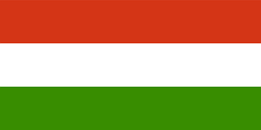
Tracker –
Project 4: Hungary Status: 1=Not Started; 2=Started;
3=Learning; 4=Proficient; 5=Can Teach)
(Resources: A=Article read; V=Video watched)

Goals / Choices Notes Status Resources Date
Goal 1: Learn about Hungarian research.
A: Learn about Hungarian genealogy.
B: Learn about Hungarian names and genealogy terms.
Goal 2: Explore Hungary vital records and civil registration.
A: Learn about Hungary vital records.
B: Learn about Hungary civil registration.
Goal 3: Learn about Hungary census records.
A: Learn about Hungarian census records.
Goal 4: Explore Hungary archives and libraries.
A: Learn about Hungary archives and libraries.
Goal 5: Learn about Hungary church records.
A: Learn about Hungary church records.
Goal 6: Learn about Hungary emigration and immigration.
A: Learn about Hungarian emigration.
Goal 7: Learn about Hungary maps.
A: Learn about Hungary maps and gazetteers.
B: Explore Hungary map resources.
Goal 8: Learn about Hungary newspapers.
A: Learn about Hungary newspapers.
Goal 9: Explore additional websites for Hungarian research.
A: Explore additional websites.
Goal 10: Search records from Hungary.
A: Use the QUIKLinks in the left side.
B: Explore additional record collections.
Goal 11: Get help with your Hungary research.
A: Use Facebook pages to get answers to your questions.
B: Join a mailing list or message board for Hungary research.
C: Learn about Hungary genealogy societies.

