
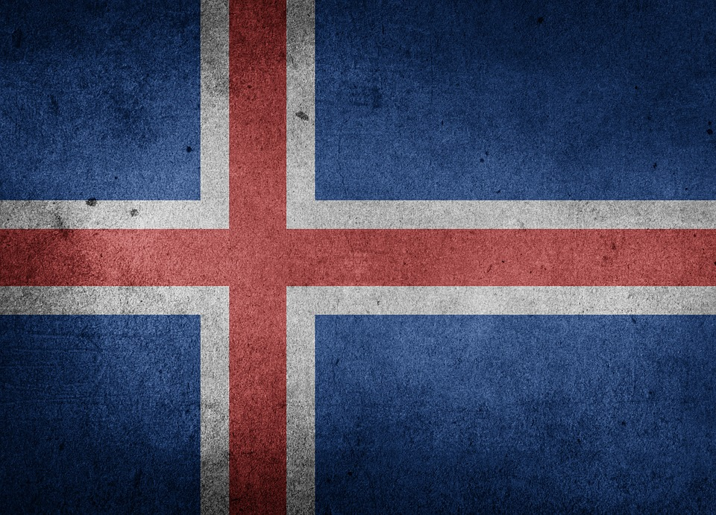
Tracker –
Project 4: Iceland Status: 1=Not Started; 2=Started;
3=Learning; 4=Proficient; 5=Can Teach)
(Resources: A=Article read; V=Video watched)

Goals / Choices Notes Status Resources Date
Goal 1: Learn about Icelandic research.
A: Learn about Icelandic genealogy.
B: Learn about Icelandic genealogy terms and names for research.
Goal 2: Learn about Iceland census records and the National Registry.
A: Learn about the Iceland census.
B: Explore the Iceland National Registry.
Goal 3: Learn about Iceland church and cemetery records.
A: Learn about Icelandic church records.
B: Explore Icelandic cemetery records.
Goal 4: Learn about Icelandic emigration.
A: Learn about Icelandic emigration.
Goal 5: Learn about Iceland maps.
A: Explore Iceland map resources.
Goal 6: Learn about Iceland newspapers.
A: Learn about Iceland newspapers.
Goal 7: Explore additional websites for Icelandic research.
A: Explore additional websites.
Goal 8: Search records from Iceland.
A: Use the QUIKLinks in the left side.
B: Explore additional record collections.
Goal 9: Get help with your Iceland research.
A: Use Facebook pages to get answers to your questions.
B: Join a mailing list or message board for Iceland research.

