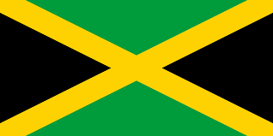

Tracker –
Project 4: Jamaica Status: N=Not Started; S=Started;
L=Learning; P=Proficient; T=Can Teach)
(Resources: A=Article read; V=Video watched)

Goals / Choices Notes Status Resources Date
Goal 1: Learn about Jamaica research and records.
A: Explore Jamaican research.
B: Explore Jamaican archives and libraries.
Goal 2: Learn about Jamaica church and cemetery records.
A: Learn about Jamaica church records.
B: Explore Jamaica cemetery records.
Goal 3: Learn about Jamaican emigration and immigration.
A: Learn about Jamaican emigration and immigration.
B: Explore Jamaica immigration resources.
Goal 4: Learn about Jamaica land and property.
A: Learn about Jamaica land and property.
B: Explore Jamaica almanacs that list landowners.
Goal 5: Learn about Jamaica maps.
A: Learn about Jamaica maps.
B: Explore Jamaica map resources.
Goal 6: Learn about Jamaican newspapers.
A: Explore Jamaican newspapers for ancestor research.
Goal 7: Search records from Jamaica.
A: Use the QUIKLinks links in the left side.
B: Explore additional record collections.
Goal 8: Get help with your Jamaica research.
A: Use Facebook pages to get answers to your questions.
B: Join a mailing list or message board.
C: Learn about Jamaica genealogy societies.

