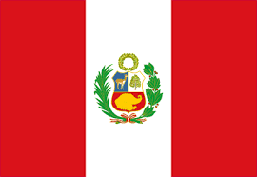
Tracker –

Project 4: Peru Status: N=Not Started; S=Started;
L=Learning; P=Proficient; T=Can Teach)
(Resources: A=Article read; V=Video watched)

Goals / Choices | Notes | Status | Resources | Date
Goal 1: Get started with Peruvian research.
A: Use effective research methods for your Peruvian ancestors.
Goal 2: Explore Peruvian archives and libraries.
A: Learn about Peruvian archives and libraries.
Goal 3: Learn about Peru church and cemetery records.
A: Learn about Peru church records.
B: Explore Peru cemetery records.
Goal 4: Explore Peruvian civil registration.
A: Learn about the Peruvian civil registration.
Goal 5: Learn about Peru emigration and immigration.
A: Learn about Peru emigration and immigration.
Goal 6: Learn about Peru maps.
A: Learn about Peru maps.
Goal 7: Learn about Peru newspapers.
A: Learn about Peru newspapers.
Goal 8: Explore additional websites.
A: Explore other websites.
Goal 9: Search records from Peru.
A: Use the search links in the left side.
B: Explore additional record collections.
Goal 10: Get help with your Peru research.
A: Use Facebook pages to get answers to your questions.
B: Join a mailing list or message board.

