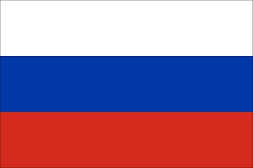

Tracker –
Project 4: Russia Status: N=Not Started; S=Started;
L=Learning; P=Proficient; T=Can Teach)
(Resources: A=Article read; V=Video watched)

Goals / Choices Notes Status Resources Date
Goal 1: Learn about Russia research and records.
A: Explore Russian research.
B: Explore Russian language resources for research.
C: Learn about Russian names and surnames.
D: Use effective research methods for your Russian ancestors.
Goal 2: Learn about Russia archives and libraries.
A: Learn about Russia archives and libraries.
Goal 3: Learn about Russia vital and census records.
A: Learn about Russian vital records.
B: Learn about Russia census records.
Goal 4: Learn about Russia church and cemetery records.
A: Learn about Russia church records.
B: Explore Russia cemetery records.
Goal 5: Learn about Russian emigration and immigration.
B: Explore Russia emigration and immigration resources.
Goal 6: Learn about Russia maps.
A: Learn about Russia maps.
B: Explore Russia map resources.
Goal 7: Learn about Russian newspapers.
A: Explore Russian newspapers for ancestor research.
Goal 8: Explore additional websites for research.
A: Explore additional website resources for Russian research.
Goal 9: Search records from Russia.
A: Use the QUIKLinks links in the left side.
B: Explore additional record collections.
Goal 10: Get help with your Russia research.
A: Use Facebook pages to get answers to your questions.
B: Join a mailing list or message board.

