
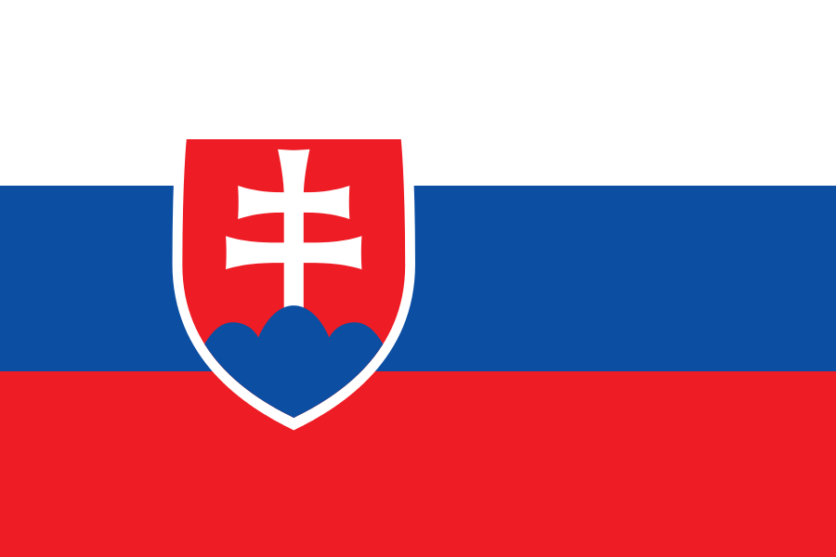
Tracker –
Project 4: Slovakia Status: 1=Not Started; 2=Started;
3=Learning; 4=Proficient; 5=Can Teach)
(Resources: A=Article read; V=Video watched)

Goals / Choices Notes Status Resources Date
Goal 1: Learn about Slovakian research.
A: Learn about Slovakian genealogy.
B: Learn about Slovakian language and genealogy terms.
Goal 2: Learn about Slovakia census records and civil registration.
A: Learn about Slovakia census records.
B: Learn about Slovakia civil registration.
Goal 3: Learn about Slovakia archives and libraries.
A: Learn about Slovakian archives and libraries.
Goal 4: Learn about Slovakia church records.
A: Learn about Slovakia church records.
Goal 5: Learn about Slovakia military records.
A: Learn about Slovakia military records.
Goal 6: Learn about Slovakia maps and gazetteers.
A: Explore Slovakia map resources.
Goal 6: Learn about Slovakia newspapers.
A: Learn about Slovakia newspapers.
Goal 7: Explore additional websites for Slovakian research.
A: Explore additional websites.
Goal 8: Search records from Slovakia.
A: Use the QUIKLinks in the left side.
B: Explore additional record collections.
Goal 9: Get help with your Slovakia research.
A: Use Facebook pages to get answers to your questions.
B: Join a mailing list or message board for Slovakia research.
C: Learn about Slovakia genealogy societies.

