
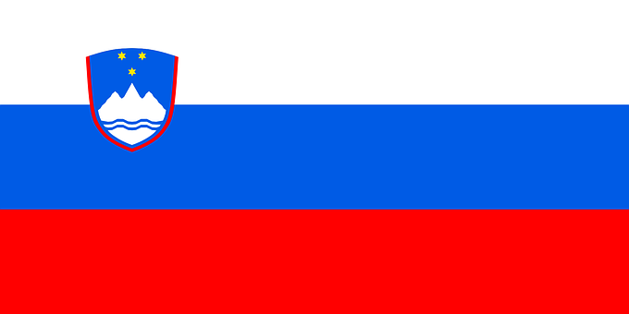
Tracker –
Project 4: Slovenia Status: 1=Not Started; 2=Started;
3=Learning; 4=Proficient; 5=Can Teach)
(Resources: A=Article read; V=Video watched)

Goals / Choices Notes Status Resources Date
Goal 1: Learn about Slovenian research.
A: Learn about Slovenian genealogy.
B: Find Slovenian language and name resources for your research.
Goal 2: Learn about Slovenia census records and civil registration.
A: Learn about Slovenia census records.
Goal 3: Learn about Slovenia archives and libraries.
A: Learn about Slovenian archives and libraries.
Goal 4: Learn about Slovenia church and cemetery records.
A: Learn about Slovenia church records.
B: Learn about Slovenia cemetery records.
Goal 5: Learn about Slovenia military records.
A: Learn about Slovenia military records.
Goal 6: Learn about Slovenia maps and gazetteers.
A: Explore Slovenia map resources.
Goal 6: Learn about Slovenia newspapers.
A: Learn about Slovenia newspapers.
Goal 7: Explore additional websites for Slovenian research.
A: Explore additional websites.
Goal 8: Search records from Slovenia.
A: Explore additional record collections.
Goal 9: Get help with your Slovenia research.
A: Use Facebook pages to get answers to your questions.
B: Join a mailing list or message board for Slovenia research.
C: Learn about Slovenia genealogy societies.

