
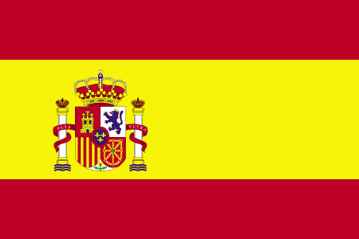
Tracker –
Project 4: Spain Status: N=Not Started; S=Started;
L=Learning; P=Proficient; T=Can Teach)
(Resources: A=Article read; V=Video watched)

Goals / Choices Notes Status Resources Date
Goal 1: Get started with Spanish research.
A: Use effective research methods for your Spanish ancestors.
B: Improve your skills in reading Spanish.
Goal 2: Explore Spanish census records.
A: Learn about the Spanish census.
Goal 3: Learn about Spain church and cemetery records.
A: Learn about Spain church and cemetery records.
B: Explore Spain cemetery records.
Goal 4: Explore Spanish civil registration records.
A: Learn about Spanish civil registration records.
Goal 5: Explore Spanish military records.
A: Learn about Spanish military records.
Goal 6: Learn about Spain maps.
A: Explore Spain maps.
Goal 7: Learn about Spain newspapers.
A: Explore Spain newspapers.
Goal 8: Explore additional websites for research.
A: Explore additional websites.
B: Visit additional websites for research.
Goal 9: Search records from Spain.
A: Use the search links in the left side.
B: Explore additional record collections.
Goal 10: Get help with your Spain research.
A: Use Facebook pages to get answers to your questions.
B: Join a mailing list or message board.
C: Learn about Spain genealogy societies.

