
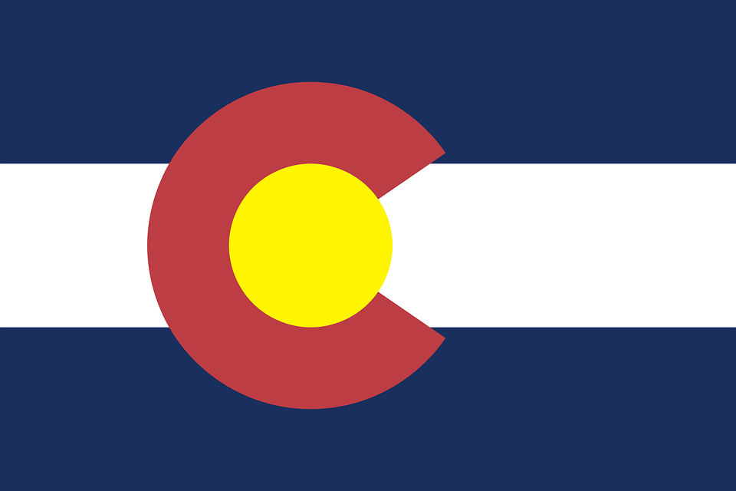
Tracker –
Project 4: Colorado Status: 0=Not Started; 1=Started;
2=Learning; 3=Proficient; 4=Can Teach)
(Resources: A=Article read; V=Video watched)

Goals / Choices Notes Status Resources Date
Goal 1: Learn about Colorado research and records.
A: Get started with research for your Colorado ancestors.
Goal 2: Learn about Colorado archives and libraries.
A: Learn about Colorado archives and libraries.
Goal 3: Explore Colorado vital and census records.
A: Learn about Colorado vital records.
B: Explore Colorado marriage and death records.
C: Explore Colorado census and voter records.
Goal 4: Learn about Colorado church and cemetery records.
A: Learn about Colorado church records.
B: Explore Colorado cemetery records.
Goal 5: Learn about Colorado emigration and immigration.
A: Learn about Colorado emigration and immigration.
Goal 6: Learn about Colorado military records.
A: Learn about Colorado military records.
Goal 7: Learn about Colorado probate, land, and court records.
A: Learn about Colorado probate and land records.
B: Learn about Colorado court records.
Goal 8: Learn about Colorado maps and gazetteers.
A: Learn about Colorado maps and gazetteers.
B: Explore Colorado maps and gazetteers.
Goal 9: Learn about Colorado newspapers.
A: Learn about Colorado newspapers.
B: Explore Colorado newspapers.
Goal 10: Explore additional websites for research.
A: Explore additional websites.
Goal 11: Search records from Colorado.
A: Use the search links in the left side.
B: Explore additional record collections.
Goal 12: Get help with your Colorado research.
A: Use Facebook pages to get answers to your questions.
B: Join a mailing list or message board.
C: Learn about Colorado genealogy societies.

