
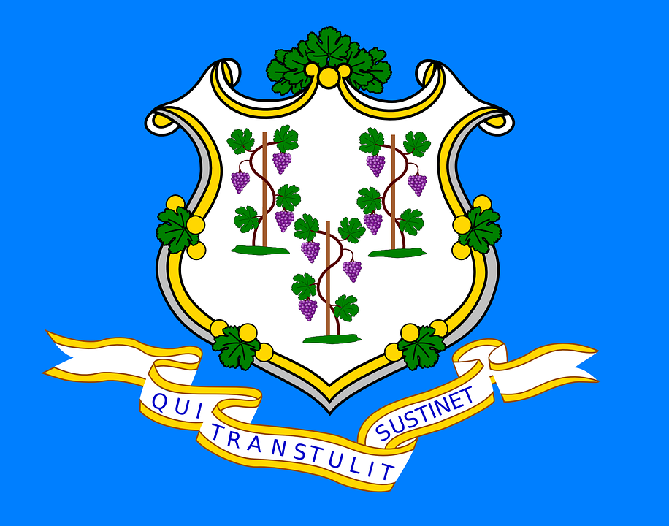
Tracker –
Project 4: Connecticut Status: 0=Not Started; 1=Started;
2=Learning; 3=Proficient; 4=Can Teach)
(Resources: A=Article read; V=Video watched)

Goals / Choices Notes Status Resources Date
Goal 1: Learn about Connecticut research and records.
A: Get started with research for your Connecticut ancestors.
Goal 2: Learn about Connecticut archives and libraries.
A: Learn about Connecticut archives and libraries.
Goal 3: Explore Connecticut vital and census records.
A: Learn about Connecticut vital records.
B: Explore Connecticut marriage and death records.
C: Explore Connecticut census and voter records.
Goal 4: Learn about Connecticut church and cemetery records.
A: Learn about Connecticut church records.
B: Explore Connecticut cemetery records.
Goal 5: Learn about Connecticut emigration and immigration.
A: Learn about Connecticut emigration and immigration.
Goal 6: Learn about Connecticut military records.
A: Learn about Connecticut military records.
Goal 7: Learn about Connecticut probate, land, and court records.
A: Learn about Connecticut probate and land records.
B: Learn about Connecticut court records.
Goal 8: Learn about Connecticut maps and gazetteers.
A: Learn about Connecticut maps and gazetteers.
B: Explore Connecticut maps and gazetteers.
Goal 9: Learn about Connecticut newspapers.
A: Learn about Connecticut newspapers.
B: Explore Connecticut newspapers.
Goal 10: Explore additional websites for research.
A: Explore additional websites.
Goal 11: Search records from Connecticut.
A: Use the search links in the left side.
B: Explore additional record collections.
Goal 12: Get help with your Connecticut research.
A: Use Facebook pages to get answers to your questions.
B: Join a mailing list or message board.
C: Learn about Connecticut genealogy societies.

