
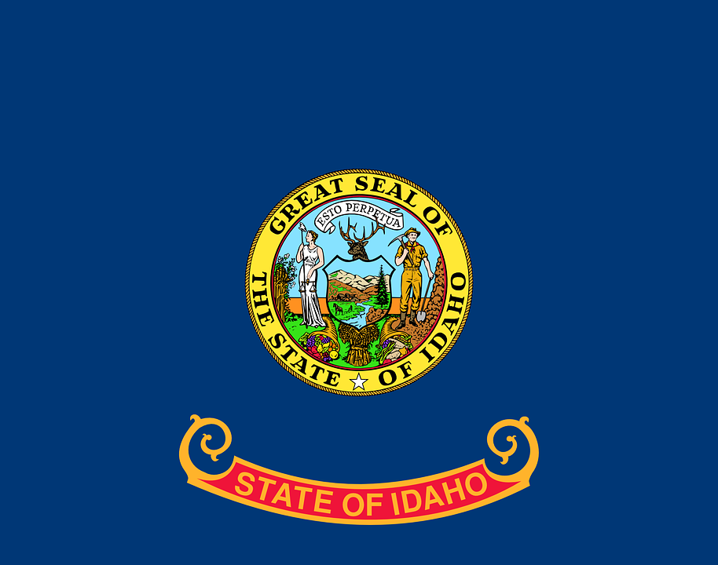
Tracker –
Project 4: Idaho Status: 0=Not Started; 1=Started;
2=Learning; 3=Proficient; 4=Can Teach)
(Resources: A=Article read; V=Video watched)

Goals / Choices Notes Status Resources Date
Goal 1: Learn about Idaho research and records.
A: Get started with research for your Idaho ancestors.
Goal 2: Learn about Idaho archives and libraries.
A: Learn about Idaho archives and libraries.
Goal 3: Explore Idaho vital and census records.
A: Learn about Idaho vital records.
B: Explore Idaho marriage and death records.
C: Explore Idaho census and voter records.
Goal 4: Learn about Idaho church and cemetery records.
A: Learn about Idaho church records.
B: Explore Idaho cemetery records.
Goal 5: Learn about Idaho emigration and immigration.
A: Learn about Idaho emigration and immigration.
Goal 6: Learn about Idaho military records.
A: Learn about Idaho military records.
Goal 7: Learn about Idaho probate, land, and court records.
A: Learn about Idaho probate and land records.
B: Learn about Idaho court records.
Goal 8: Learn about Idaho maps and gazetteers.
A: Learn about Idaho maps and gazetteers.
B: Explore Idaho maps and gazetteers.
Goal 9: Learn about Idaho newspapers.
A: Learn about Idaho newspapers.
B: Explore Idaho newspapers.
Goal 10: Explore additional websites for research.
A: Explore additional websites.
Goal 11: Search records from Idaho.
A: Use the search links in the left side.
B: Explore additional record collections.
Goal 12: Get help with your Idaho research.
A: Use Facebook pages to get answers to your questions.
B: Join a mailing list or message board.
C: Learn about Idaho genealogy societies.

