
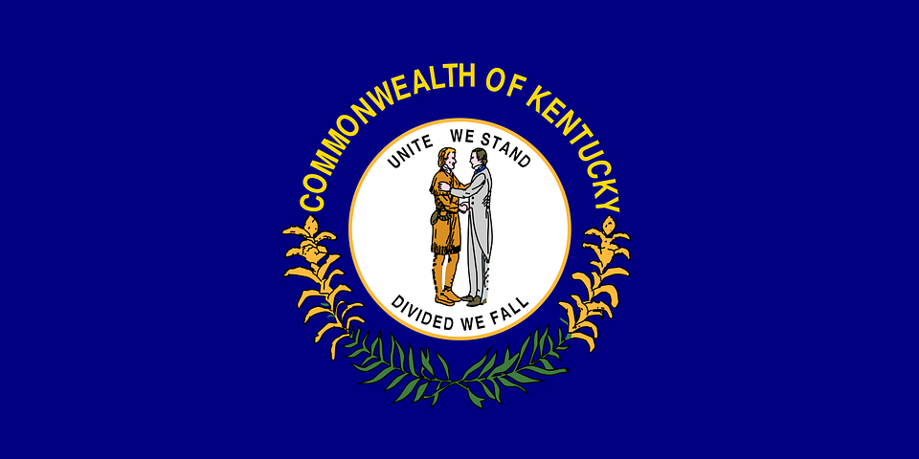
Tracker –
Project 4: Kentucky Status: 0=Not Started; 1=Started;
2=Learning; 3=Proficient; 4=Can Teach)
(Resources: A=Article read; V=Video watched)

Goals / Choices Notes Status Resources Date
Goal 1: Learn about Kentucky research and records.
A: Get started with research for your Kentucky ancestors.
Goal 2: Learn about Kentucky archives and libraries.
A: Learn about Kentucky archives and libraries.
Goal 3: Explore Kentucky vital and census records.
A: Learn about Kentucky vital records.
B: Explore Kentucky marriage and death records.
C: Explore Kentucky census and voter records.
Goal 4: Learn about Kentucky church and cemetery records.
A: Learn about Kentucky church records.
B: Explore Kentucky cemetery records.
Goal 5: Learn about Kentucky emigration and immigration.
A: Learn about Kentucky emigration and immigration.
Goal 6: Learn about Kentucky military records.
A: Learn about Kentucky military records.
Goal 7: Learn about Kentucky probate, land, and court records.
A: Learn about Kentucky probate and land records.
B: Learn about Kentucky court records.
Goal 8: Learn about Kentucky maps and gazetteers.
A: Learn about Kentucky maps and gazetteers.
B: Explore Kentucky maps and gazetteers.
Goal 9: Learn about Kentucky newspapers.
A: Learn about Kentucky newspapers.
B: Explore Kentucky newspapers.
Goal 10: Explore additional websites for research.
A: Explore additional websites.
Goal 11: Search records from Kentucky.
A: Use the search links in the left side.
B: Explore additional record collections.
Goal 12: Get help with your Kentucky research.
A: Use Facebook pages to get answers to your questions.
B: Join a mailing list or message board.
C: Learn about Kentucky genealogy societies.

