
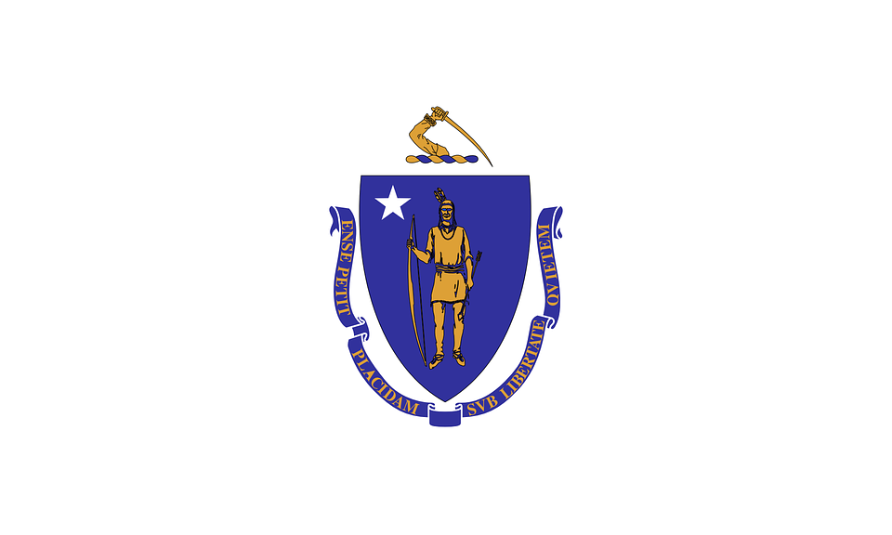
Tracker –
Project 4: Massachusetts Status: 0=Not Started; 1=Started;
2=Learning; 3=Proficient; 4=Can Teach)
(Resources: A=Article read; V=Video watched)

Goals / Choices Notes Status Resources Date
Goal 1: Learn about Massachusetts research and records.
A: Get started with research for your Massachusetts ancestors.
Goal 2: Learn about Massachusetts archives and libraries.
A: Learn about Massachusetts archives and libraries.
Goal 3: Explore Massachusetts vital and census records.
A: Learn about Massachusetts vital records.
B: Explore Massachusetts marriage and death records.
C: Explore Massachusetts census and voter records.
Goal 4: Learn about Massachusetts church and cemetery records.
A: Learn about Massachusetts church records.
B: Explore Massachusetts cemetery records.
Goal 5: Learn about Massachusetts emigration and immigration.
A: Learn about Massachusetts emigration and immigration.
Goal 6: Learn about Massachusetts military records.
A: Learn about Massachusetts military records.
Goal 7: Learn about Massachusetts probate, land, and court records.
A: Learn about Massachusetts probate and land records.
B: Learn about Massachusetts court records.
Goal 8: Learn about Massachusetts maps and gazetteers.
A: Learn about Massachusetts maps and gazetteers.
B: Explore Massachusetts maps and gazetteers.
Goal 9: Learn about Massachusetts newspapers.
A: Learn about Massachusetts newspapers.
B: Explore Massachusetts newspapers.
Goal 10: Explore additional websites for research.
A: Explore additional websites.
Goal 11: Search records from Massachusetts.
A: Use the search links in the left side.
B: Explore additional record collections.
Goal 12: Get help with your Massachusetts research.
A: Use Facebook pages to get answers to your questions.
B: Join a mailing list or message board.
C: Learn about Massachusetts genealogy societies.

