
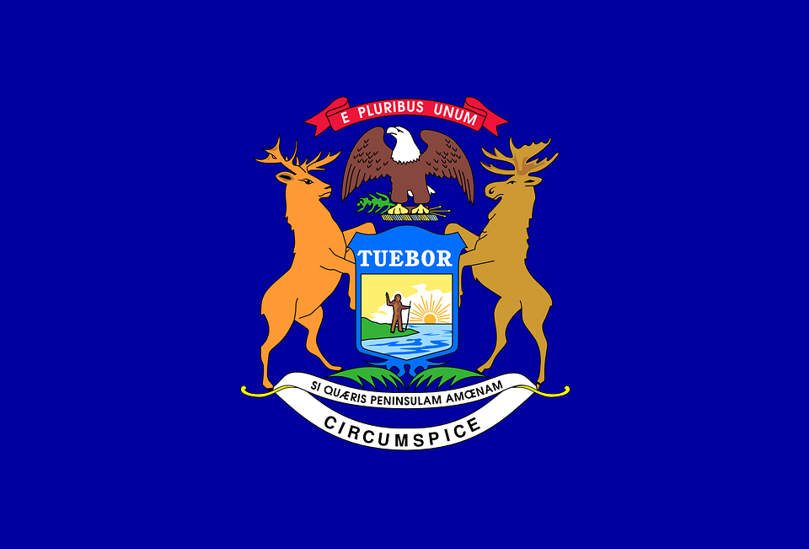
Tracker –
Project 4: Michigan Status: 0=Not Started; 1=Started;
2=Learning; 3=Proficient; 4=Can Teach)
(Resources: A=Article read; V=Video watched)

Goals / Choices Notes Status Resources Date
Goal 1: Learn about Michigan research and records.
A: Get started with research for your Michigan ancestors.
Goal 2: Learn about Michigan archives and libraries.
A: Learn about Michigan archives and libraries.
Goal 3: Explore Michigan vital and census records.
A: Learn about Michigan vital records.
B: Explore Michigan marriage and death records.
C: Explore Michigan census and voter records.
Goal 4: Learn about Michigan church and cemetery records.
A: Learn about Michigan church records.
B: Explore Michigan cemetery records.
Goal 5: Learn about Michigan emigration and immigration.
A: Learn about Michigan emigration and immigration.
Goal 6: Learn about Michigan military records.
A: Learn about Michigan military records.
Goal 7: Learn about Michigan probate, land, and court records.
A: Learn about Michigan probate and land records.
B: Learn about Michigan court records.
Goal 8: Learn about Michigan maps and gazetteers.
A: Learn about Michigan maps and gazetteers.
B: Explore Michigan maps and gazetteers.
Goal 9: Learn about Michigan newspapers.
A: Learn about Michigan newspapers.
B: Explore Michigan newspapers.
Goal 10: Explore additional websites for research.
A: Explore additional websites.
Goal 11: Search records from Michigan.
A: Use the search links in the left side.
B: Explore additional record collections.
Goal 12: Get help with your Michigan research.
A: Use Facebook pages to get answers to your questions.
B: Join a mailing list or message board.
C: Learn about Michigan genealogy societies.

