
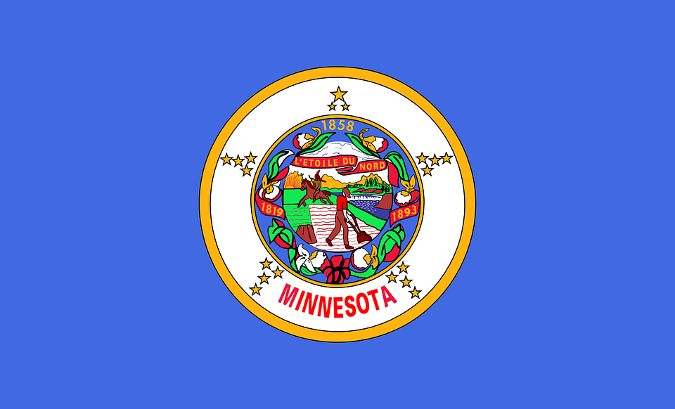
Tracker –
Project 4: Minnesota Status: 0=Not Started; 1=Started;
2=Learning; 3=Proficient; 4=Can Teach)
(Resources: A=Article read; V=Video watched)

Goals / Choices Notes Status Resources Date
Goal 1: Learn about Minnesota research and records.
A: Get started with research for your Minnesota ancestors.
Goal 2: Learn about Minnesota archives and libraries.
A: Learn about Minnesota archives and libraries.
Goal 3: Explore Minnesota vital and census records.
A: Learn about Minnesota vital records.
B: Explore Minnesota marriage and death records.
C: Explore Minnesota census and voter records.
Goal 4: Learn about Minnesota church and cemetery records.
A: Learn about Minnesota church records.
B: Explore Minnesota cemetery records.
Goal 5: Learn about Minnesota emigration and immigration.
A: Learn about Minnesota emigration and immigration.
Goal 6: Learn about Minnesota military records.
A: Learn about Minnesota military records.
Goal 7: Learn about Minnesota probate, land, and court records.
A: Learn about Minnesota probate and land records.
B: Learn about Minnesota court records.
Goal 8: Learn about Minnesota maps and gazetteers.
A: Learn about Minnesota maps and gazetteers.
B: Explore Minnesota maps and gazetteers.
Goal 9: Learn about Minnesota newspapers.
A: Learn about Minnesota newspapers.
B: Explore Minnesota newspapers.
Goal 10: Explore additional websites for research.
A: Explore additional websites.
Goal 11: Search records from Minnesota.
A: Use the search links in the left side.
B: Explore additional record collections.
Goal 12: Get help with your Minnesota research.
A: Use Facebook pages to get answers to your questions.
B: Join a mailing list or message board.
C: Learn about Minnesota genealogy societies.

