
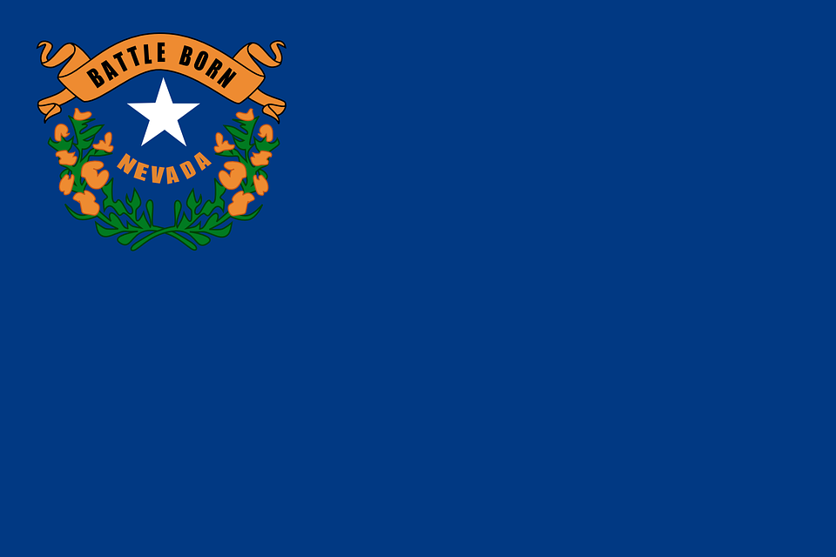
Tracker –
Project 4: Nevada Status: 0=Not Started; 1=Started;
2=Learning; 3=Proficient; 4=Can Teach)
(Resources: A=Article read; V=Video watched)

Goals / Choices Notes Status Resources Date
Goal 1: Learn about Nevada research and records.
A: Get started with research for your Nevada ancestors.
Goal 2: Learn about Nevada archives and libraries.
A: Learn about Nevada archives and libraries.
Goal 3: Explore Nevada vital and census records.
A: Learn about Nevada vital records.
B: Explore Nevada marriage and death records.
C: Explore Nevada census and voter records.
Goal 4: Learn about Nevada church and cemetery records.
A: Learn about Nevada church records.
B: Explore Nevada cemetery records.
Goal 5: Learn about Nevada emigration and immigration.
A: Learn about Nevada emigration and immigration.
Goal 6: Learn about Nevada military records.
A: Learn about Nevada military records.
Goal 7: Learn about Nevada probate, land, and court records.
A: Learn about Nevada probate and land records.
B: Learn about Nevada court records.
Goal 8: Learn about Nevada maps and gazetteers.
A: Learn about Nevada maps and gazetteers.
B: Explore Nevada maps and gazetteers.
Goal 9: Learn about Nevada newspapers.
A: Learn about Nevada newspapers.
B: Explore Nevada newspapers.
Goal 10: Explore additional websites for research.
A: Explore additional websites.
Goal 11: Search records from Nevada.
A: Use the search links in the left side.
B: Explore additional record collections.
Goal 12: Get help with your Nevada research.
A: Use Facebook pages to get answers to your questions.
B: Join a mailing list or message board.
C: Learn about Nevada genealogy societies.

