
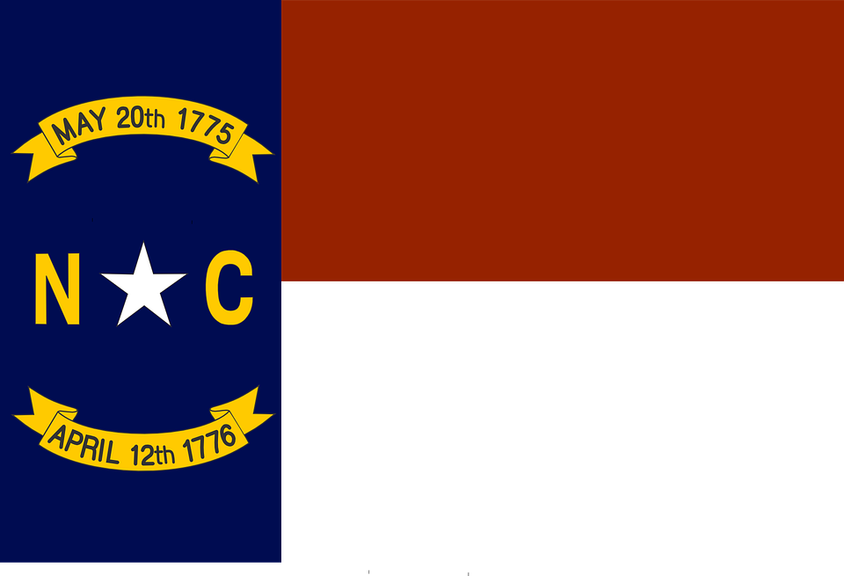
Tracker –
Project 4: North Carolina Status: 0=Not Started; 1=Started;
2=Learning; 3=Proficient; 4=Can Teach)
(Resources: A=Article read; V=Video watched)

Goals / Choices Notes Status Resources Date
Goal 1: Learn about North Carolina research and records.
A: Get started with research for your North Carolina ancestors.
Goal 2: Learn about North Carolina archives and libraries.
A: Learn about North Carolina archives and libraries.
Goal 3: Explore North Carolina vital and census records.
A: Learn about North Carolina vital records.
B: Explore North Carolina marriage and death records.
C: Explore North Carolina census and voter records.
Goal 4: Learn about North Carolina church and cemetery records.
A: Learn about North Carolina church records.
B: Explore North Carolina cemetery records.
Goal 5: Learn about North Carolina emigration and immigration.
A: Learn about North Carolina emigration and immigration.
Goal 6: Learn about North Carolina military records.
A: Learn about North Carolina military records.
Goal 7: Learn about North Carolina probate, land, and court records.
A: Learn about North Carolina probate and land records.
B: Learn about North Carolina court records.
Goal 8: Learn about North Carolina maps and gazetteers.
A: Learn about North Carolina maps and gazetteers.
B: Explore North Carolina maps and gazetteers.
Goal 9: Learn about North Carolina newspapers.
A: Learn about North Carolina newspapers.
B: Explore North Carolina newspapers.
Goal 10: Explore additional websites for research.
A: Explore additional websites.
Goal 11: Search records from North Carolina.
A: Use the search links in the left side.
B: Explore additional record collections.
Goal 12: Get help with your North Carolina research.
A: Use Facebook pages to get answers to your questions.
B: Join a mailing list or message board.
C: Learn about North Carolina genealogy societies.

