
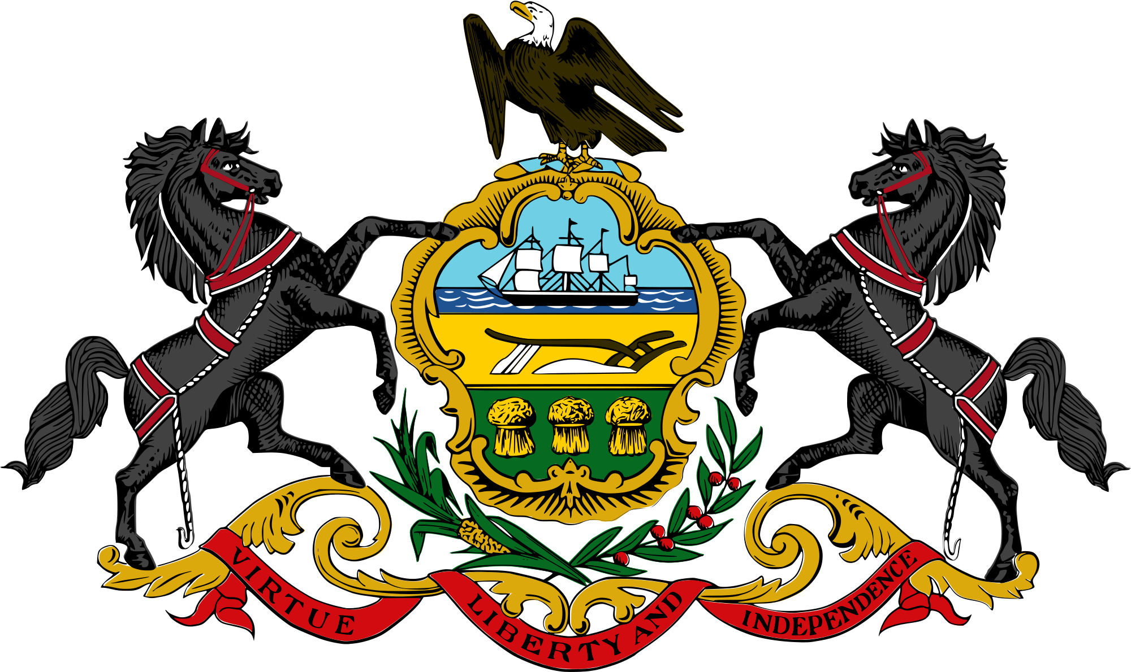
Tracker –
Project 4: Pennsylvania Status: 0=Not Started; 1=Started;
2=Learning; 3=Proficient; 4=Can Teach)
(Resources: A=Article read; V=Video watched)

Goals / Choices Notes Status Resources Date
Goal 1: Learn about Pennsylvania research and records.
A: Get started with research for your Pennsylvania ancestors.
Goal 2: Learn about Pennsylvania archives and libraries.
A: Learn about Pennsylvania archives and libraries.
Goal 3: Explore Pennsylvania vital and census records.
A: Learn about Pennsylvania vital records.
B: Explore Pennsylvania marriage and death records.
C: Explore Pennsylvania census and voter records.
Goal 4: Learn about Pennsylvania church and cemetery records.
A: Learn about Pennsylvania church records.
B: Explore Pennsylvania cemetery records.
Goal 5: Learn about Pennsylvania emigration and immigration.
A: Learn about Pennsylvania emigration and immigration.
Goal 6: Learn about Pennsylvania military records.
A: Learn about Pennsylvania military records.
Goal 7: Learn about Pennsylvania probate, land, and court records.
A: Learn about Pennsylvania probate and land records.
B: Learn about Pennsylvania court records.
Goal 8: Learn about Pennsylvania maps and gazetteers.
A: Learn about Pennsylvania maps and gazetteers.
B: Explore Pennsylvania maps and gazetteers.
Goal 9: Learn about Pennsylvania newspapers.
A: Learn about Pennsylvania newspapers.
B: Explore Pennsylvania newspapers.
Goal 10: Explore additional websites for research.
A: Explore additional websites.
Goal 11: Search records from Pennsylvania.
A: Use the search links in the left side.
B: Explore additional record collections.
Goal 12: Get help with your Pennsylvania research.
A: Use Facebook pages to get answers to your questions.
B: Join a mailing list or message board.
C: Learn about Pennsylvania genealogy societies.

