
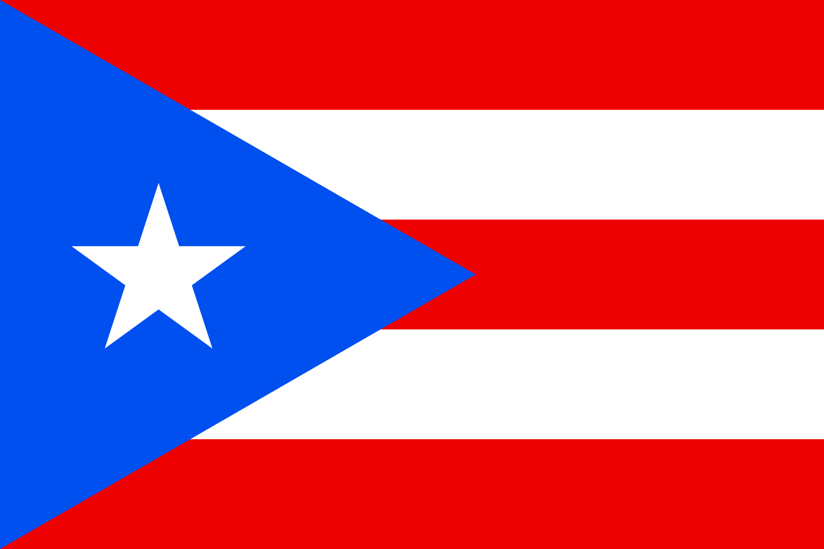
Tracker –
Project 4: Puerto Rico Status: 0=Not Started; 1=Started;
2=Learning; 3=Proficient; 4=Can Teach)
(Resources: A=Article read; V=Video watched)

Goals / Choices Notes Status Resources Date
Goal 1: Learn about Puerto Rico research and records.
A: Get started with research for your Puerto Rico ancestors.
Goal 2: Learn about Puerto Rico archives and libraries.
A: Learn about Puerto Rico archives and libraries.
Goal 3: Learn about Puerto Rico civil registration, vital records, and census records.
A: Learn about Puerto Rico civil registration and vital records.
B: Explore Puerto Rico census records.
Goal 4: Learn about Puerto Rico court and cemetery records.
A: Explore Puerto Rico court records.
B: Explore Puerto Rico cemetery records and obituaries.
Goal 5: Learn about Puerto Rico newspapers.
A: Explore Puerto Rico newspapers.
Goal 6: Learn about Puerto Rico maps.
A: Explore Puerto Rico maps.
Goal 7: Explore additional websites for research.
A: Explore additional websites.
Goal 8: Search records from Puerto Rico.
A: Use the QUIKLinks in the left side.
B: Explore additional record collections.
Goal 9: Get help with your Puerto Rico research.
A: Use Facebook pages to get answers to your questions.
B: Join a mailing list or message board.
C: Learn about Puerto Rico genealogy societies.

