
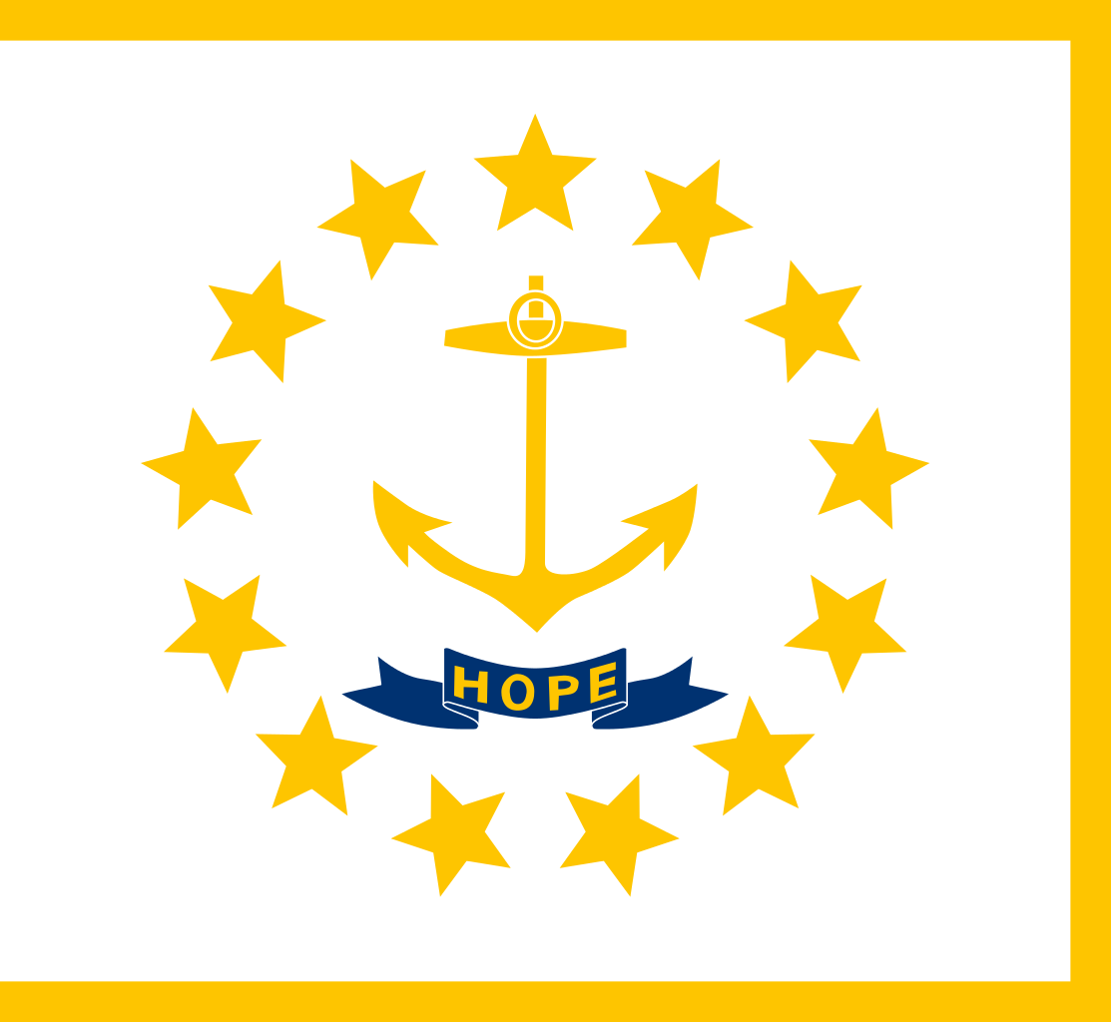
Tracker –
Project 4: Rhode Island Status: 0=Not Started; 1=Started;
2=Learning; 3=Proficient; 4=Can Teach)
(Resources: A=Article read; V=Video watched)

Goals / Choices Notes Status Resources Date
Goal 1: Learn about Rhode Island research and records.
A: Get started with research for your Rhode Island ancestors.
Goal 2: Learn about Rhode Island archives and libraries.
A: Learn about Rhode Island archives and libraries.
Goal 3: Explore Rhode Island vital and census records.
A: Learn about Rhode Island vital records.
B: Explore Rhode Island marriage and death records.
C: Explore Rhode Island census and voter records.
Goal 4: Learn about Rhode Island church and cemetery records.
A: Learn about Rhode Island church records.
B: Explore Rhode Island cemetery records.
Goal 5: Learn about Rhode Island emigration and immigration.
A: Learn about Rhode Island emigration and immigration.
Goal 6: Learn about Rhode Island military records.
A: Learn about Rhode Island military records.
Goal 7: Learn about Rhode Island probate, land, and court records.
A: Learn about Rhode Island probate and land records.
B: Learn about Rhode Island court records.
Goal 8: Learn about Rhode Island maps and gazetteers.
A: Learn about Rhode Island maps and gazetteers.
B: Explore Rhode Island maps and gazetteers.
Goal 9: Learn about Rhode Island newspapers.
A: Learn about Rhode Island newspapers.
B: Explore Rhode Island newspapers.
Goal 10: Explore additional websites for research.
A: Explore additional websites.
Goal 11: Search records from Rhode Island.
A: Use the search links in the left side.
B: Explore additional record collections.
Goal 12: Get help with your Rhode Island research.
A: Use Facebook pages to get answers to your questions.
B: Join a mailing list or message board.
C: Learn about Rhode Island genealogy societies.

