
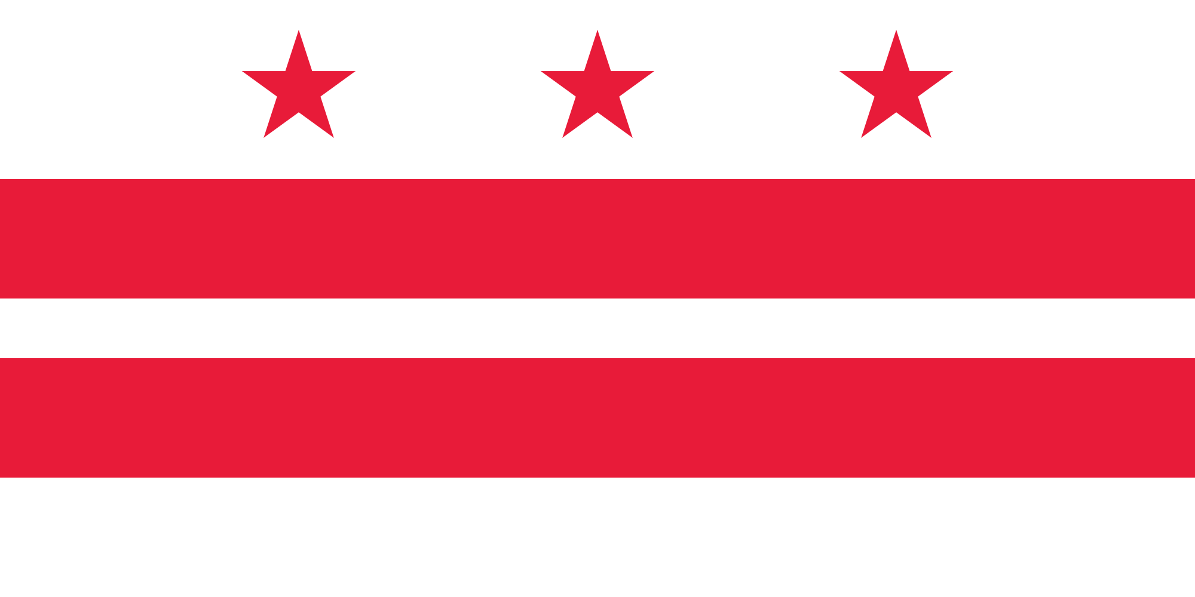
Tracker –
Project 4: Washington, D.C. Status: 0=Not Started; 1=Started;
2=Learning; 3=Proficient; 4=Can Teach)
(Resources: A=Article read; V=Video watched)

Goals / Choices Notes Status Resources Date
Goal 1: Learn about Washington, D.C. research and records.
A: Get started with research for your Washington, D.C. ancestors.
Goal 2: Learn about Washington, D.C. archives and libraries.
A: Learn about Washington, D.C. archives and libraries.
B: Learn about Washington, D.C. city directories.
Goal 3: Explore Washington, D.C. vital and census records.
A: Learn about Washington, D.C. vital records.
B: Explore Washington, D.C. marriage and death records.
C: Explore Washington, D.C. census and voter records.
Goal 4: Learn about Washington, D.C. church and cemetery records.
A: Learn about Washington, D.C. church records.
B: Explore Washington, D.C. cemetery records.
Goal 5: Learn about Washington, D.C. emigration and immigration.
A: Learn about Washington, D.C. emigration and immigration.
Goal 6: Learn about Washington, D.C. military records.
A: Learn about Washington, D.C. military records.
Goal 7: Learn about Washington, D.C. probate, land, and court records.
A: Learn about Washington, D.C. probate and land records.
B: Learn about Washington, D.C. court records.
Goal 8: Learn about Washington, D.C. maps and gazetteers.
A: Learn about Washington, D.C. maps and gazetteers.
B: Explore Washington, D.C. maps and gazetteers.
Goal 9: Learn about Washington, D.C. newspapers.
A: Learn about Washington, D.C. newspapers.
B: Explore Washington, D.C. newspapers.
Goal 10: Explore additional websites for research.
A: Explore additional websites.
Goal 11: Search records from Washington, D.C..
A: Use the QUIKLinks in the left side.
B: Explore additional record collections.
Goal 12: Get help with your Washington, D.C. research.
A: Use Facebook pages to get answers to your questions.
B: Join a mailing list or message board.
C: Learn about Washington, D.C. genealogy societies.

