
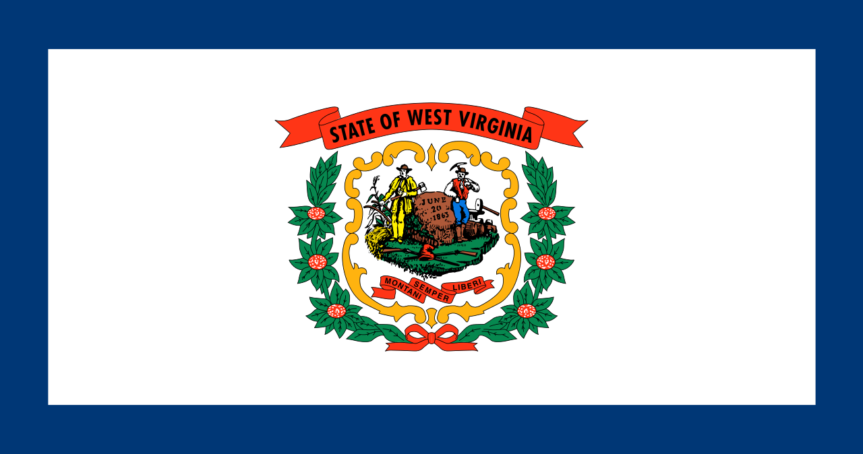
Tracker –
Project 4: West Virginia Status: 0=Not Started; 1=Started;
2=Learning; 3=Proficient; 4=Can Teach)
(Resources: A=Article read; V=Video watched)

Goals / Choices Notes Status Resources Date
Goal 1: Learn about West Virginia research and records.
A: Get started with research for your West Virginia ancestors.
Goal 2: Learn about West Virginia archives and libraries.
A: Learn about West Virginia archives and libraries.
Goal 3: Explore West Virginia vital and census records.
A: Learn about West Virginia vital records.
B: Explore West Virginia marriage and death records.
C: Explore West Virginia census and voter records.
Goal 4: Learn about West Virginia church and cemetery records.
A: Learn about West Virginia church records.
B: Explore West Virginia cemetery records.
Goal 5: Learn about West Virginia emigration and immigration.
A: Learn about West Virginia emigration and immigration.
Goal 6: Learn about West Virginia military records.
A: Learn about West Virginia military records.
Goal 7: Learn about West Virginia probate, land, and court records.
A: Learn about West Virginia probate and land records.
B: Learn about West Virginia court records.
Goal 8: Learn about West Virginia maps and gazetteers.
A: Learn about West Virginia maps and gazetteers.
B: Explore West Virginia maps and gazetteers.
Goal 9: Learn about West Virginia newspapers.
A: Learn about West Virginia newspapers.
B: Explore West Virginia newspapers.
Goal 10: Explore additional websites for research.
A: Explore additional websites.
Goal 11: Search records from West Virginia.
A: Use the search links in the left side.
B: Explore additional record collections.
Goal 12: Get help with your West Virginia research.
A: Use Facebook pages to get answers to your questions.
B: Join a mailing list or message board.
C: Learn about West Virginia genealogy societies.

