
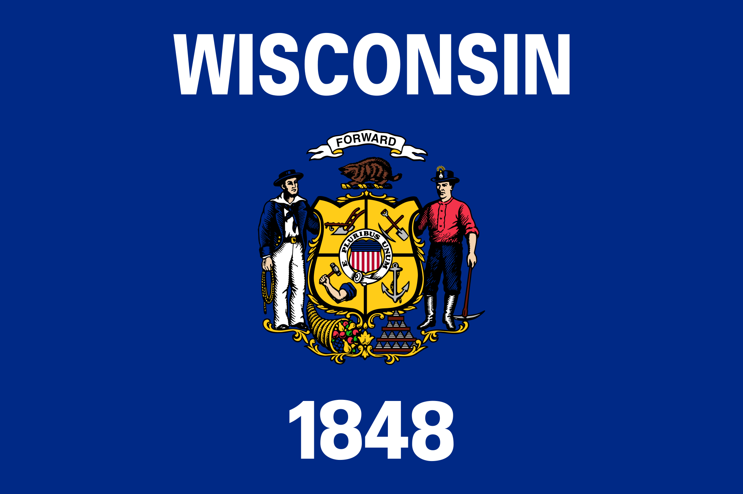
Tracker –
Project 4: Wisconsin Status: 0=Not Started; 1=Started;
2=Learning; 3=Proficient; 4=Can Teach)
(Resources: A=Article read; V=Video watched)

Goals / Choices Notes Status Resources Date
Goal 1: Learn about Wisconsin research and records.
A: Get started with research for your Wisconsin ancestors.
Goal 2: Learn about Wisconsin archives and libraries.
A: Learn about Wisconsin archives and libraries.
Goal 3: Explore Wisconsin vital and census records.
A: Learn about Wisconsin vital records.
B: Explore Wisconsin marriage and death records.
C: Explore Wisconsin census and voter records.
Goal 4: Learn about Wisconsin church and cemetery records.
A: Learn about Wisconsin church records.
B: Explore Wisconsin cemetery records.
Goal 5: Learn about Wisconsin emigration and immigration.
A: Learn about Wisconsin emigration and immigration.
Goal 6: Learn about Wisconsin military records.
A: Learn about Wisconsin military records.
Goal 7: Learn about Wisconsin probate, land, and court records.
A: Learn about Wisconsin probate and land records.
B: Learn about Wisconsin court records.
Goal 8: Learn about Wisconsin maps and gazetteers.
A: Learn about Wisconsin maps and gazetteers.
B: Explore Wisconsin maps and gazetteers.
Goal 9: Learn about Wisconsin newspapers.
A: Learn about Wisconsin newspapers.
B: Explore Wisconsin newspapers.
Goal 10: Explore additional websites for research.
A: Explore additional websites.
Goal 11: Search records from Wisconsin.
A: Use the search links in the left side.
B: Explore additional record collections.
Goal 12: Get help with your Wisconsin research.
A: Use Facebook pages to get answers to your questions.
B: Join a mailing list or message board.
C: Learn about Wisconsin genealogy societies.

