
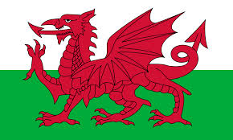
Tracker –
Project 4: Wales Status: N=Not Started; S=Started;
L=Learning; P=Proficient; T=Can Teach)
(Resources: A=Article read; V=Video watched)

Goals / Choices Notes Status Resources Date
Goal 1: Get started with Welsh research.
A: Get started with Welsh research.
B: Learn about Welsh names and terms.
Goal 2: Explore Welsh archives and libraries.
A: Learn about Welsh archives and libraries.
Goal 3: Explore Welsh census records.
A: Learn about the Welsh census.
Goal 4: Learn about Wales church and cemetery records.
A: Learn about Wales church records.
B: Learn about Wales cemetery records.
Goal 5: Learn about Wales emigration and immigration.
A: Learn about Wales emigration and immigration.
B: Explore Welsh emigration resources.
Goal 6: Explore Welsh land, property, and probate records.
A: Learn about Welsh land and property records.
B: Learn about Welsh probate records.
Goal 7: Learn about Wales military records.
A: Learn about Wales military records.
Goal 8: Explore Wales maps.
A: Learn about Wales maps.
B: Explore Wales maps.
Goal 9: Learn about Wales newspapers.
A: Learn about Wales newspapers.
B: Explore Wales newspapers.
Goal 10: Explore additional websites for research.
A: Explore additional websites.
B: Explore Wales newspapers for research.
Goal 11: Search records from Wales.
A: Use the search links in the left side.
B: Explore additional record collections.
Goal 12: Get help with your Wales research.
A: Use Facebook pages to get answers to your questions.
B: Join a mailing list or message board.
C: Learn about Wales genealogy societies.

