同济大学计算机系

数字逻辑课程实验报告



学 号 1852409
姓 名 李佳庚
专 业 计算机类
授课老师 郭玉臣

- 实验内容

- 硬件逻辑图
（实验步骤中要求用logisim画图的实验，在该部分给出logisim原理图，否则该部分在实验报告中不用写）

- 模块建模
（该部分要求对实验中建模的所有模块进行功能描述，并列出各模块建模的verilog代码）

6.5_1 4位比较器
module DataCompare4(
input [3:0] iData_a,
input [3:0] iData_b,
input [2:0] iData,
output reg [2:0] oData
);

always @ *
begin
if (iData_a == iData_b)
oData = iData;
else if (iData_a < iData_b)
oData = 3'b010;
else if (iData_a > iData_b)
oData = 3'b100;
else;
end

endmodule

6.5_2 8位比较器
module DataCompare8(
input [7:0] iData_a,
input [7:0] iData_b,
output [2:0] oData
);
wire [2:0] tmp;
DataCompare4 kk(.iData_a(iData_a[3:0]), .iData_b(iData_b[3:0]), .iData(3'b001), .oData(tmp));
reg [2:0] inputtmp;
always @ *
inputtmp = tmp;
DataCompare4 ll(.iData_a(iData_a[7:4]), .iData_b(iData_b[7:4]), .iData(inputtmp), .oData(oData));

Endmodule

6.5_3 1位加法器
module FA(
input iA,
input iB,
input iC,
output oS,
output oC
);

wire inputA1, inputB1;
wire inputA2, inputB2;
wire oxA1B1;
wire oaA1B1C;
wire oaA1B1;
assign inputA1 = iA;
assign inputA2 = iA;
assign inputB1 = iB;
assign inputB2 = iB;

// 0 1 1
xor xorA1B1(oxA1B1, inputA1, inputB1);
// 1 0 1
xor xorOA1B1C(oS, oxA1B1, iC);
// 0 0 1
and andA1B1C(oaA1B1C, oxA1B1, iC);
// 1 1 1
and andA1B1(oaA1B1, inputA2, inputB2);
// 1 1 0
or orA1B1A1B1C(oC, oaA1B1, oaA1B1C);

endmodule

6.5_4 8位加法器
module Adder(
input [7:0] iData_a,
input [7:0] iData_b,
input iC,
output [7:0] oData,
output oData_C
);

wire oC1;
FA FA1(.iA(iData_a[0]), .iB(iData_b[0]), .iC(iC), .oS(oData[0]), .oC(oC1));

wire oC2;
FA FA2(.iA(iData_a[1]), .iB(iData_b[1]), .iC(oC1), .oS(oData[1]), .oC(oC2));

wire oC3;
FA FA3(.iA(iData_a[2]), .iB(iData_b[2]), .iC(oC2), .oS(oData[2]), .oC(oC3));

wire oC4;
FA FA4(.iA(iData_a[3]), .iB(iData_b[3]), .iC(oC3), .oS(oData[3]), .oC(oC4));

wire oC5;
FA FA5(.iA(iData_a[4]), .iB(iData_b[4]), .iC(oC4), .oS(oData[4]), .oC(oC5));

wire oC6;
FA FA6(.iA(iData_a[5]), .iB(iData_b[5]), .iC(oC5), .oS(oData[5]), .oC(oC6));

wire oC7;
FA FA7(.iA(iData_a[6]), .iB(iData_b[6]), .iC(oC6), .oS(oData[6]), .oC(oC7));

FA FA8(.iA(iData_a[7]), .iB(iData_b[7]), .iC(oC7), .oS(oData[7]), .oC(oData_C));

endmodule
- 测试模块建模
（要求列写各建模模块的test bench模块代码）

6.5_1 4位比较器
`timescale 1ns / 1ns
module DataCompare4_tb(
);
reg [3:0] iData_a;
reg [3:0] iData_b;
reg [2:0] iData;
wire [2:0] oData;

DataCompare4 uul(.iData_a(iData_a), .iData_b(iData_b), .iData(iData), .oData(oData));

initial
begin
iData_a = 4'b0000;
iData_b = 4'b1010;
iData = 3'b000;

# 40
iData_a = 4'b1010;
iData_b = 4'b1010;
iData = 3'b010;

# 40
iData_a = 4'b1100;
iData_b = 4'b1010;
iData = 3'b100;

# 40
iData_a = 4'b1001;
iData_b = 4'b0010;
iData = 3'b010;

# 40
iData_a = 4'b1010;
iData_b = 4'b1010;
iData = 3'b010;
end
endmodule

6.5_2 8位比较器
module DataCompare8_tb();
reg [7:0] iData_a;
reg [7:0] iData_b;
wire [2:0] oData;

DataCompare8 uul(.iData_a(iData_a), .iData_b(iData_b), .oData(oData));

initial
begin
# 40
iData_a = 8'b0000_0000;
iData_b = 8'b0000_0000;

# 40
iData_a = 8'b0000_0001;
iData_b = 8'b0000_0000;

# 40
iData_a = 8'b0000_0000;
iData_b = 8'b0000_0010;

# 40
iData_a = 8'b1010_0101;
iData_b = 8'b0101_1010;

# 40
iData_a = 8'b1111_1111;
iData_b = 8'b0000_1111;

# 40
iData_a = 8'b1111_1111;
iData_b = 8'b1111_0000;

# 40
iData_a = 8'b0101_0110;
iData_b = 8'b1100_1001;
end
endmodule

6.5_3 1位加法器
module FA_tb();
reg iA,iB,iC;
wire oS, oC;

FA uul(.iA(iA), .iB(iB), .iC(iC), .oS(oS), .oC(oC));

initial
begin
iA = 0;
iB = 0;
iC = 0;

# 40
iA = 0;
iB = 0;
iC = 1;

# 40
iA = 0;
iB = 1;
iC = 1;

# 40
iA = 1;
iB = 1;
iC = 1;

# 40
iA = 1;
iB = 0;
iC = 1;

# 40
iA = 1;
iB = 1;
iC = 0;

# 40
iA = 0;
iB = 1;
iC = 0;
end
endmodule

6.5_4 8位加法器
module Adder_tb();

reg [7:0] iData_a;
reg [7:0] iData_b;
reg iC;

wire [7:0] oData;
wire oData_C;

Adder uul(.iData_a(iData_a), .iData_b(iData_b), .iC(iC), .oData(oData), .oData_C(oData_C));

initial
begin
iData_a = 8'b0000_0000;
iData_b = 8'b0000_0001;
iC = 0;

# 40
iData_a = 8'b0000_0000;
iData_b = 8'b0000_0001;
iC = 1;

# 40
iData_a = 8'b0000_0001;
iData_b = 8'b0000_0000;
iC = 1;

# 40
iData_a = 8'b0100_0101;
iData_b = 8'b1010_0110;
iC = 1;

# 40
iData_a = 8'b1010_1101;
iData_b = 8'b1011_0010;
iC = 0;

# 40
iData_a = 8'b0100_0101;
iData_b = 8'b1110_0010;
iC = 1;
end
endmodule
- 实验结果
（该部分可截图说明，要求logisim逻辑验证图、modelsim仿真波形图、以及下板后的实验结果贴图（实验步骤中没有下板要求的实验，不需要下板贴图））

6.5_1 4位比较器
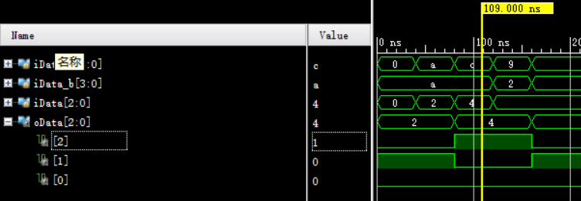
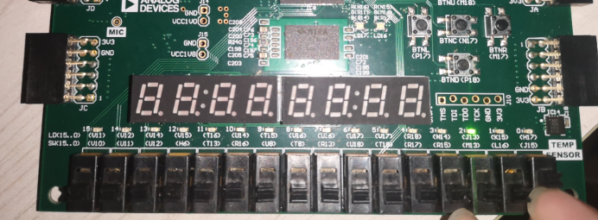
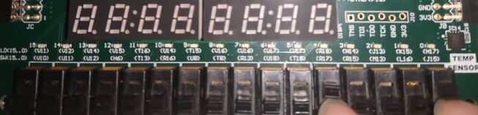
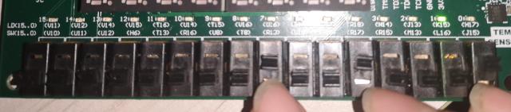
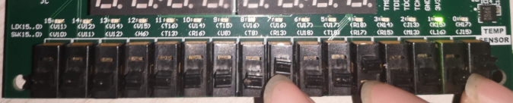
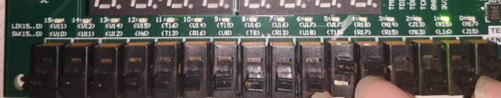

6.5_2 8位比较器
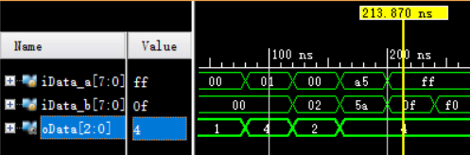
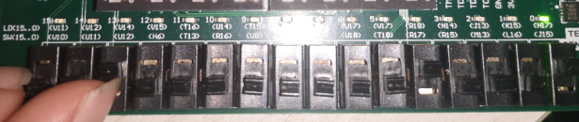
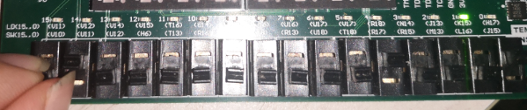
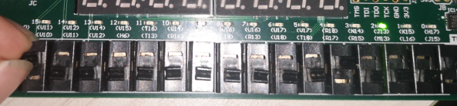

6.5_3 1位加法器
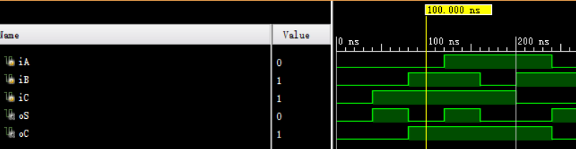
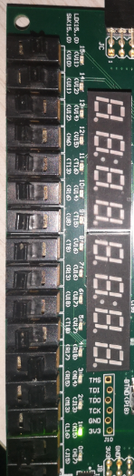
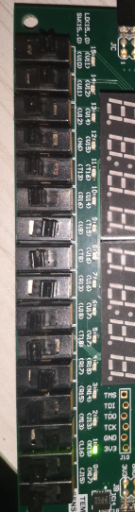
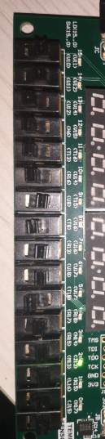
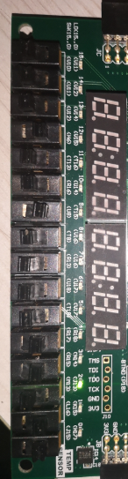
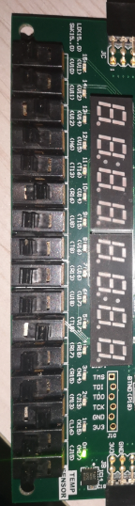
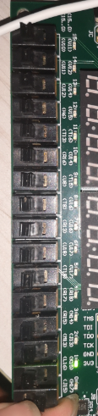

6.5_4 8位加法器
