同济大学计算机系

数字逻辑课程实验报告



学 号 1852409
姓 名 李佳庚
专 业 计算机类
授课老师 郭玉臣

- 实验内容

- 硬件逻辑图
（实验步骤中要求用logisim画图的实验，在该部分给出logisim原理图，否则该部分在实验报告中不用写）
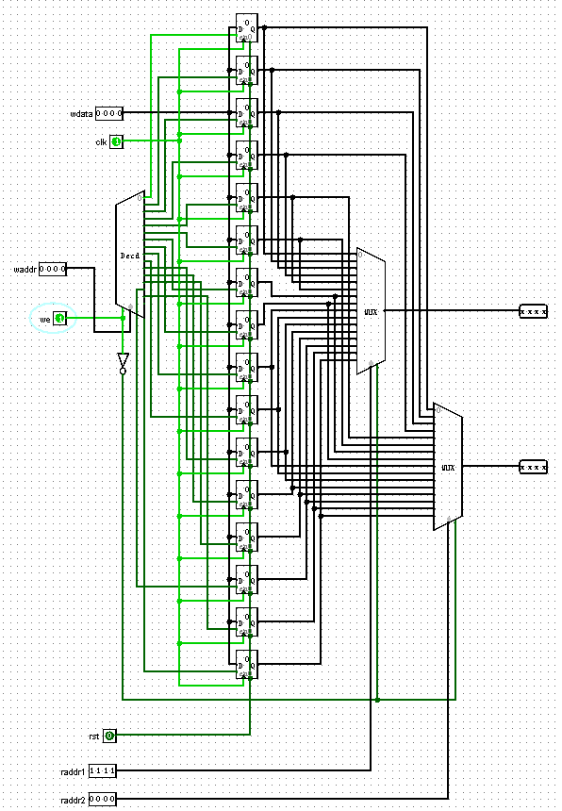

- 模块建模
（该部分要求对实验中建模的所有模块进行功能描述，并列出各模块建模的verilog代码）

8.1_ram
module ram(
input clk,
input ena,
input wena,
input [4:0] addr,
input [31:0] data_in,
output reg [31:0] data_out
);
reg [1023:0] register;
always @ (posedge clk) begin
if (ena) begin
if (wena)
register[addr * 32 +: 32] = data_in[0 +: 32];
else
data_out[0 +: 32] = register[addr * 32 +: 32];
end
else
data_out = 32'hzzzz_zzzz;
end
endmodule

8.2_ram2
module ram2(
input clk,
input ena,
input wena,
input [4:0] addr,
inout [31:0] data
);

reg register[0:1023];
reg [31:0] data_io;

localparam nodeNum = 1024;
localparam busWidth = 32;
integer index;

always @ (posedge clk) begin
if (ena == 1) begin
if (wena == 1) begin
for (index = 0; index < busWidth; index = index + 1)
register[addr * busWidth + index] = data[index];
end
else if (wena == 0) begin
for (index = 0; index < busWidth; index = index + 1)
data_io[index] = register[addr * busWidth + index];
end
else ;
end
else ;
end

assign data = ena ? data_io : 32'hzzzz_zzzz;

endmodule

8.3_Regfiles
module Regfiles(
input clk,
input rst,
input we,
input [4:0] raddr1,
input [4:0] raddr2,
input [4:0] waddr,
input [31:0] wdata,
output reg [31:0] rdata1,
output reg [31:0] rdata2
);

wire [31:0] out_decoder;
decoder5To32 decoder(waddr, we, out_decoder);

wire [31:0] out_reg0;
wire [31:0] out_reg1; wire [31:0] out_reg2; wire [31:0] out_reg3; wire [31:0] out_reg4; wire [31:0] out_reg5; wire [31:0] out_reg6; wire [31:0] out_reg7; wire [31:0] out_reg8; wire [31:0] out_reg9; wire [31:0] out_reg10; wire [31:0] out_reg11;
wire [31:0] out_reg12; wire [31:0] out_reg13; wire [31:0] out_reg14; wire [31:0] out_reg15; wire [31:0] out_reg16; wire [31:0] out_reg17; wire [31:0] out_reg18; wire [31:0] out_reg19; wire [31:0] out_reg20; wire [31:0] out_reg21; wire [31:0] out_reg22;
wire [31:0] out_reg23; wire [31:0] out_reg24; wire [31:0] out_reg25; wire [31:0] out_reg26; wire [31:0] out_reg27; wire [31:0] out_reg28; wire [31:0] out_reg29; wire [31:0] out_reg30; wire [31:0] out_reg31;

reg [31:0] register0; reg [31:0] register1; reg [31:0] register2; reg [31:0] register3; reg [31:0] register4; reg [31:0] register5; reg [31:0] register6; reg [31:0] register7; reg [31:0] register8; reg [31:0] register9; reg [31:0] register10;
reg [31:0] register11; reg [31:0] register12; reg [31:0] register13; reg [31:0] register14; reg [31:0] register15; reg [31:0] register16; reg [31:0] register17; reg [31:0] register18; reg [31:0] register19; reg [31:0] register20; reg [31:0] register21;
reg [31:0] register22; reg [31:0] register23; reg [31:0] register24; reg [31:0] register25; reg [31:0] register26; reg [31:0] register27; reg [31:0] register28; reg [31:0] register29; reg [31:0] register30; reg [31:0] register31;

always @ (*) begin
register0 = out_reg0; register1 = out_reg1; register2 = out_reg2; register3 = out_reg3; register4 = out_reg4; register5 = out_reg5; register6 = out_reg6; register7 = out_reg7; register8 = out_reg8; register9 = out_reg9; register10 = out_reg10;
register11 = out_reg11; register11 = out_reg11; register12 = out_reg12; register13 = out_reg13; register14 = out_reg14; register15 = out_reg15; register16 = out_reg16; register17 = out_reg17; register18 = out_reg18; register19 = out_reg19; register20 = out_reg20; register21 = out_reg21;
register22 = out_reg22; register23 = out_reg23; register24 = out_reg24; register25 = out_reg25; register26 = out_reg26; register27 = out_reg27; register28 = out_reg28; register29 = out_reg29; register30 = out_reg30; register31 = out_reg31;
end

reg32 r0(clk, rst, out_decoder[0], wdata, out_reg0);
reg32 r1(clk, rst, out_decoder[1], wdata, out_reg1);
reg32 r2(clk, rst, out_decoder[2], wdata, out_reg2);
reg32 r6(clk, rst, out_decoder[3], wdata, out_reg3);
reg32 r3(clk, rst, out_decoder[4], wdata, out_reg4);
reg32 r4(clk, rst, out_decoder[5], wdata, out_reg5);
reg32 r5(clk, rst, out_decoder[6], wdata, out_reg6);
reg32 r7(clk, rst, out_decoder[7], wdata, out_reg7);
reg32 r8(clk, rst, out_decoder[8], wdata, out_reg8);
reg32 r9(clk, rst, out_decoder[9], wdata, out_reg9);
reg32 r10(clk, rst, out_decoder[10], wdata, out_reg10);
reg32 r11(clk, rst, out_decoder[11], wdata, out_reg11);
reg32 r12(clk, rst, out_decoder[12], wdata, out_reg12);
reg32 r13(clk, rst, out_decoder[13], wdata, out_reg13);
reg32 r14(clk, rst, out_decoder[14], wdata, out_reg14);
reg32 r15(clk, rst, out_decoder[15], wdata, out_reg15);
reg32 r16(clk, rst, out_decoder[16], wdata, out_reg16);
reg32 r17(clk, rst, out_decoder[17], wdata, out_reg17);
reg32 r18(clk, rst, out_decoder[18], wdata, out_reg18);
reg32 r19(clk, rst, out_decoder[19], wdata, out_reg19);
reg32 r20(clk, rst, out_decoder[20], wdata, out_reg20);
reg32 r21(clk, rst, out_decoder[21], wdata, out_reg21);
reg32 r22(clk, rst, out_decoder[22], wdata, out_reg22);
reg32 r23(clk, rst, out_decoder[23], wdata, out_reg23);
reg32 r24(clk, rst, out_decoder[24], wdata, out_reg24);
reg32 r25(clk, rst, out_decoder[25], wdata, out_reg25);
reg32 r26(clk, rst, out_decoder[26], wdata, out_reg26);
reg32 r27(clk, rst, out_decoder[27], wdata, out_reg27);
reg32 r28(clk, rst, out_decoder[28], wdata, out_reg28);
reg32 r29(clk, rst, out_decoder[29], wdata, out_reg29);
reg32 r30(clk, rst, out_decoder[30], wdata, out_reg30);
reg32 r31(clk, rst, out_decoder[31], wdata, out_reg31);

wire [31:0] wrdata1;
wire [31:0] wrdata2;
selector32To1 select1(out_reg0, out_reg1, out_reg2, out_reg3, out_reg4, out_reg5, out_reg6, out_reg7, out_reg8, out_reg9, out_reg10, out_reg11,
out_reg12, out_reg13, out_reg14, out_reg15, out_reg16, out_reg17, out_reg18, out_reg19, out_reg20, out_reg21, out_reg22,
out_reg23, out_reg24, out_reg25, out_reg26, out_reg27, out_reg28, out_reg29, out_reg30, out_reg31,
raddr1, ~we, wrdata1);
selector32To1 select2(out_reg0, out_reg1, out_reg2, out_reg3, out_reg4, out_reg5, out_reg6, out_reg7, out_reg8, out_reg9, out_reg10, out_reg11,
out_reg12, out_reg13, out_reg14, out_reg15, out_reg16, out_reg17, out_reg18, out_reg19, out_reg20, out_reg21, out_reg22,
out_reg23, out_reg24, out_reg25, out_reg26, out_reg27, out_reg28, out_reg29, out_reg30, out_reg31,
raddr2, ~we, wrdata2);
always @ * begin
rdata1 = wrdata1;
rdata2 = wrdata2;
end
endmodule

- 测试模块建模
（要求列写各建模模块的test bench模块代码）

8.1_ram
module ram_tb();

reg clk, ena, wena;
reg [4:0] addr;
reg [31:0] data_in;
wire [31:0] data_out;

initial begin
clk = 0;
ena = 1;
wena = 0;
addr = 0;
data_in = 32'hffff_ffff;
end

always
#20 clk = ~clk;

ram uul(clk,ena,wena,addr,data_in,data_out);

initial begin
addr = 1;
#50 wena = 1;
#70 addr = 10; data_in = 32'hab10_4588;
#50 wena = 0;
#130 ena = 1;
#50 addr = 8; data_in = 32'h0000_0010;
#10 ena = 0;
#30 addr = 7;
#20 wena = 0;
#30 addr = 6; data_in = 32'h7896_1255;
#20 wena = 1;
#100 ena = 1;
end

endmodule

8.2_ram2
module ram2_tb(
);
reg clk;
reg ena;
reg wena;
reg [4:0] addr;
wire [31:0] data_io;
reg [31:0] data_in;

initial begin
clk = 0;
ena = 1;
wena = 0;
addr = 0;
data_in = 32'hffff_ffff;
end

always
#20 clk = ~clk;

//assign data_io = (ena==1) ? data_in : 32'hzzzz_zzzz;
assign data_io = data_in;
ram2 uul(clk, ena, wena, addr, data_io);

initial begin
addr = 1;
#50 wena = 1;
#70 addr = 10; data_in = 32'hab10_4588;
#50 wena = 0;
#130 ena = 1;
#50 addr = 8; data_in = 32'h0000_0010;
#10 ena = 0;
#30 addr = 7;
#20 wena = 0;
#30 addr = 6; data_in = 32'h7896_1255;
#20 wena = 1;
#100 ena = 1;
end

endmodule

8.3_Regfiles
module Regfiles_tb(
);
reg clk, rst, we;
reg [4:0] raddr1;
reg [4:0] raddr2;
reg [4:0] waddr;
reg [31:0] wdata;
wire [31:0] rdata1;
wire [31:0] rdata2;

initial begin
clk = 0; rst = 0; we = 1;
raddr1 = 0; raddr2 = 0;
waddr = 0;
end

always
#20 clk = ~clk;

Regfiles uul(clk, rst, we, raddr1, raddr2, waddr, wdata, rdata1, rdata2);

initial begin
#10
wdata = 32'h0a2e_5486;
#20 waddr = 10; wdata = 32'h5894_a5ff;
#20 waddr = 7; wdata = 32'hffff_ffff;
#20 waddr = 1; wdata = 32'h0000_0000;

#20 we = 0;
#20 raddr1 = 1; raddr2 = 7;
#20 raddr1 = 10; raddr2 = 0;
#5 rst = 0;
#20 raddr1 = 5; raddr2 = 4;
#5 rst = 0;
#20 raddr1 = 5; raddr2 = 4;
end
endmodule
- 实验结果
（该部分可截图说明，要求logisim逻辑验证图、modelsim仿真波形图、以及下板后的实验结果贴图（实验步骤中没有下板要求的实验，不需要下板贴图））
Logisim：
一开始是再往里面写：
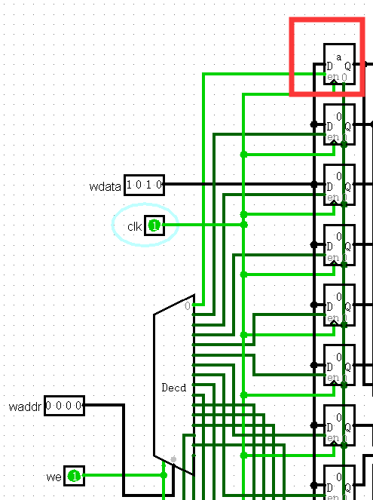
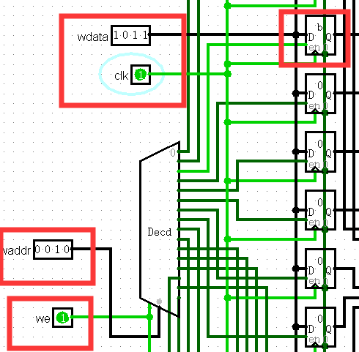
接下来是读取:
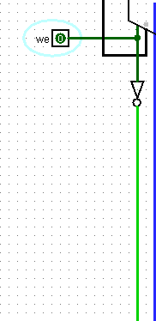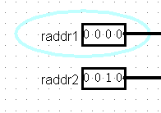
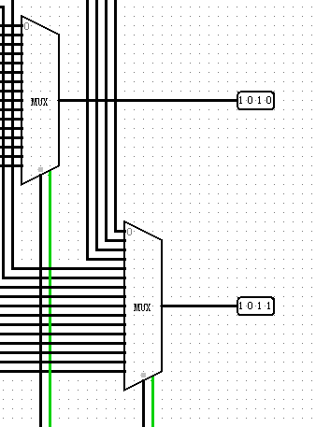
分别得到两个寄存器中的值

8.1_ram
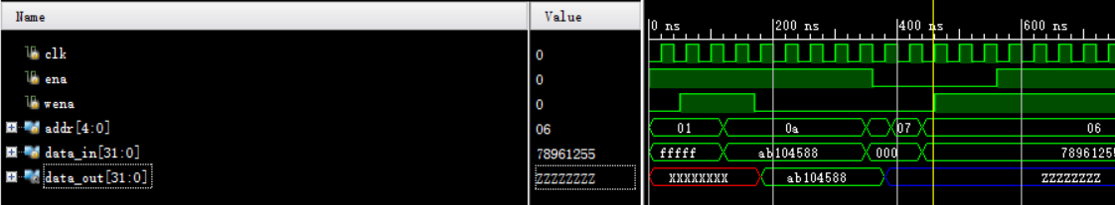

8.2_ram2
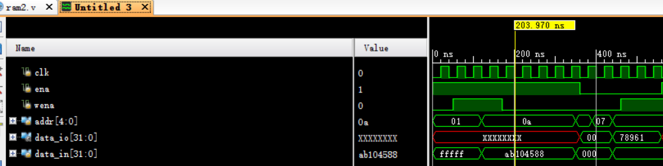

8.3_Regfiles
测试了读写。
另外还测试了rst，但是没有截图了。也是好用的。
