ISYE 6740 Homework 2

# Q1-1

|  |
| --- |
|  |

|  |
| --- |
|  |

# Q1-1

I used both my Kmeans and the Kmeans from scikit-learn package. In both cases the false classification rate was close to 5.2%. For details please check the Jupyter file attached to this report.

# Q2-1

|  |
| --- |
|  |

# Q2-2

|  |
| --- |
|  |

|  |
| --- |
|  |

# Q2-3

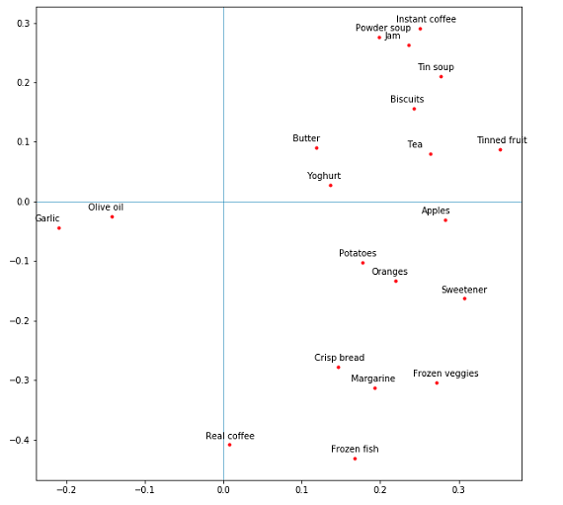

This figure shows the correlation between various foods in the reduced data components.

Tea and biscuits are positively correlated therefore, countries (such as England) uses biscuits and tea, the more biscuits are consumed, the more team is also consumed.

It also shows that places that consumes foods such as olive oil which is the opposite to for example apple, they consume less apple. Similarly, if the food are opposite each other from Y axis.

## Q2-4

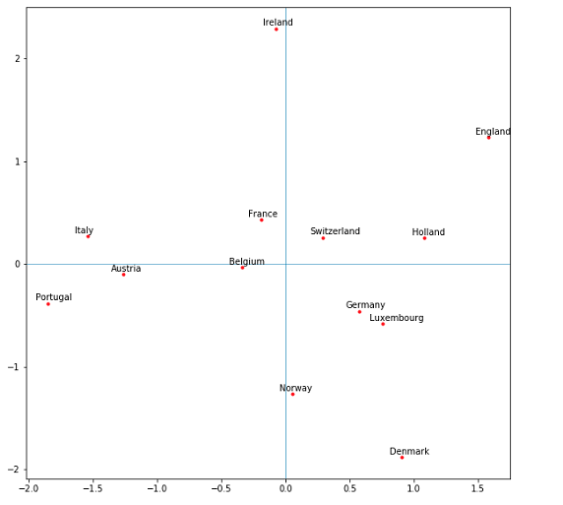

This figure shows the reduced data to two components. Countries close to each other, has similar daily diet. For example, Norway Denmark or Switzerland and Holland.

Countries far from each other has different diets. For example, Italy compared to Denmark. Italy consumes more garlic and olive oil while Denmark consumes more frozen fish and frozen veggie.