Homework 3

I am using Jupiter notebook to do the HWs. The code and the data are in the directory called “codes”. In this report I answer to the questions of the HW and the implementation is in the Jupiter notebook.

Question 1

# Q1-a

ISOMAP algorithm consists of few steps. In step one, I used the k-nearest neighbor to define the 100 neighbors and create the similarity graph. I used networkx to visualize the graph. I also used Louvain method to define areas of adjacency matrix that similar or close to each other. The results of both matrices are shown here.

|  |  |
| --- | --- |
|  |  |

On the left is the adjacency matrix visualization by networkx package. Clearly, we can identify four area of clump nodes. The clump is an indication of similarity. On the right is the graph visualization for adjacency matrix using Louvain method. Here too we can clearly see 4 similar areas. Though we can distinguish the four sections in both figures, but it does not provide details on what are the similarities and what let them to be clump together.

# Q1-b

In this section of the question, we implement the ISOMAP algorithm, which are the step 2 and 3 from our class. The results of the ISOMAP algorithm can be seen below. Clearly, we see that ISOMAP managed to categorize a non-linear data (pictures of various poses of faces). The faces around each section have similar poses.

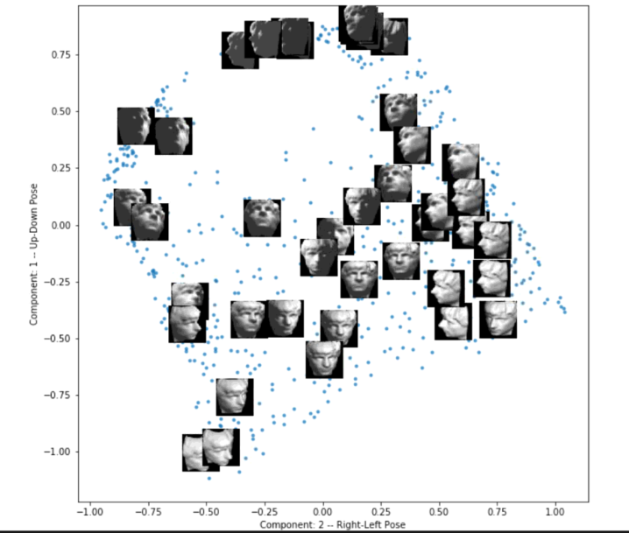

# Q1-c

In this section, we will use Manhattan distance to define the similarities. The graph by networkx is a bit different but still identifies 4 sections of similarities. Similar results can be seen with Louvain method.

|  |  |
| --- | --- |
|  |  |

And the results of ISOMAP is not identical but similar. Faces with similar poses are gathered close to each other.

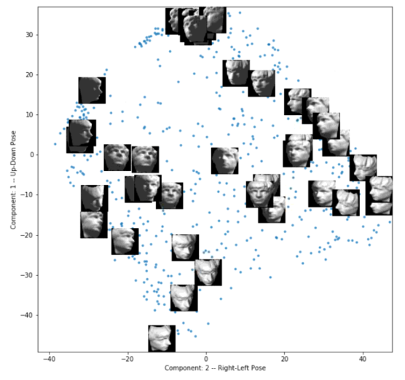

Question 2

In this question, we are trying to find out the relationship between the brain size (acc and amygdala in particular) and humans’ behavior in standing to political issues.

# Q2-a

In this question, we plot a 2D histogram of (amygdala, acc) versus (political position). We have provided three histograms. From left to right, first histogram is for bin size 5, second one is 10 and third one is 15. From the graphical points, we see there is a increase of height close to (-1,0) normalized values of amygdala and (-1,1) normalized values of acc.

|  |  |  |
| --- | --- | --- |
|  |  |  |

In my opinion, the histogram with bin size 5 is closer to our problem and it provides enough information on where we stand with respect to data. The other two histograms provide more granular details which in our problem, we may not need them.

We can see similar situation with different histogram figures. Here we use hist2d function from matplotlib. (more detailed conclusion in section c answer)

|  |  |  |
| --- | --- | --- |
|  |  |  |

# Q2-b

In this section, we use kernel density estimator (KDE) to smooth the histogram figure. Here we use Gaussian kernel. With smoothing technique, we can identify where exactly the density of the data is. Compare to histogram in which we needed several bins to get to a conclusion, here we clearly see that the hump is in range (-1, 0) for amygdala and (-1, 1) for acc. (more detailed conclusion in section c answer)

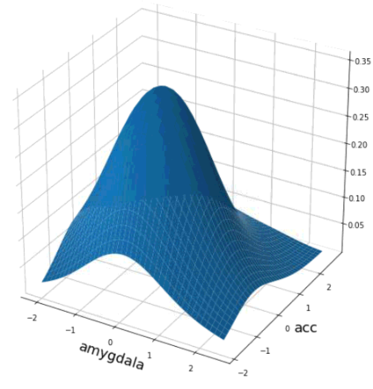

# Q2-c

In this section of the question, we plot the condition distribution of the volume of amygdala and acc as a function of political orientation. We used seaborn library to plot both histogram and KDE results. The results (below) also confirms our conclusion we provided in both section a and b.

It also provides us some more details on how conservative and liberal orientation are related to amygdala and acc. First let’s see what the functions of amygdala and acc are.

**Amygdala** is part of the limbic system of the brain. It is the integrative center for emotions and emotional behavior and motivation. **Anterior cingulate cortex** is for complex cognitive functions empathy, impulse control, emotion, and decision making.

*Based on results below, looks like the more liberal the orientation is the larger the amygdala area is. And the more conservative a person is, the larger the acc area.*

|  |
| --- |
|  |
|  |